June 2022

Job Application Pack for Finance Officer Post, Part-Time, Permanent

Dear Applicant,

Thank you for your interest in applying for the Finance Officer post at JustRight Scotland (JRS).

We are recruiting for a part-time Finance Officer to join JustRight Scotland - Scotland’s legal centre for justice and human rights. This is an exciting opportunity to contribute to JustRight Scotland’s continuing success and high standards of performance by developing and delivering excellent financial administration and management.

At JustRight Scotland, we use the law to defend and extend people’s rights. We provide advice and representation directly to individuals . We also engage in policy and influencing work by contributing evidence from our legal expertise and the lived experience of people affected by the issues we work on. We build innovative collaborations, and deliver public legal education, professional training and outreach. We believe in sharing our skills, and what we learn, with others along the way.

We are looking for an experienced finance professional to take a lead role in establishing an efficient and effective in-house finance function for the charity, managing day-to-day financial operations, and putting systems in place to ensure the organisation can sustain and grow into the future.

You will be a skilled finance professional, who is comfortable with maintaining and developing internal financial controls, monitoring and reporting on financial performance against budgets, maintaining and reviewing records, preparing payroll, and liaising with outsourced payroll, cashiering and accountancy services.

This is a new role working as part of a small team at the heart of the charity’s operations. You will work closely with our Head of Operations and Chief Executive, and have regular contact with our Board of Trustees.

We are committed to flexible working. This role is part-time and could be worked in a range of different working patterns. Although some office contact will be required, we are also happy to support remote and hybrid working where possible.

The closing date for applications is 11:59pm Sunday 17th July 2022.

Interviews will take place during the week commencing 25th July 2022, preferably in person, and you will be asked to prepare a presentation in advance of this interview.

Please email completed applications to Jenny Cook at recruitment@justrightscotland.org.uk with the header PRIVATE AND CONFIDENTIAL.

If you require to receive this information in a different format, or have any other questions about applying, please contact Jenny on 0141 406 5350.

Yours sincerely,
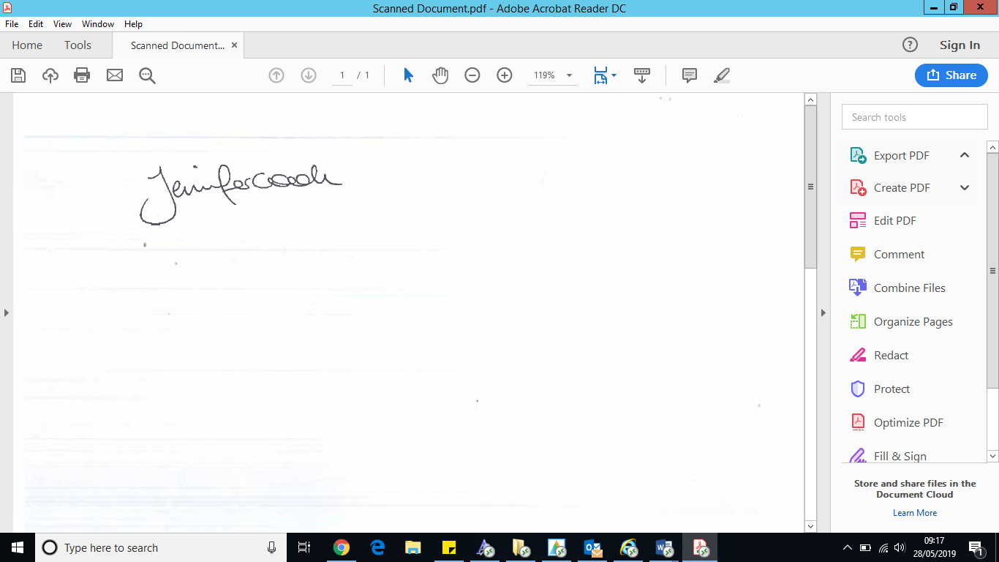

Jennifer Cook
Head of Operations
JustRight Scotland

JustRight Scotland
The successful candidate will be employed by JustRight Scotland (JRS) which is Scotland’s legal centre for justice and human rights. We use the law to defend and extend people’s rights.
We believe in inclusion and social justice collaboration, which means that all our projects work in areas in which gaps in access to justice lead to discrimination and disadvantage. We aim to tackle those issues by sharing resources, and working with non-lawyers, to explore models for providing expert legal advice and information, efficiently and effectively.
We do this by providing legal services directly to individuals as well as working to improve outcomes for our clients by contributing to policy and research, and delivering training and outreach. We aim to test new models for leveraging our legal expertise within these collaborations, and sharing what we learn along the way.
We operate four centres of legal excellence:
- Scottish Refugee and Migrant Centre;

- Scottish Women’s Rights Centre;
- Scottish Anti-Trafficking and Exploitation Centre; and
- Scottish Just Law Centre
Our legal services are delivered through JustRight Scotland LLP (as required by Scottish solicitor regulation).

Our policy, research and training hub, JustRight for All, responds to policy consultations and writes policy briefings on issues that matter to our clients. We also offer public legal education and speak at outreach events, contribute to academic research and to joint monitoring and policy reports, as well as to best practice resources in the areas in which we work.

Finally, our new social enterprise, JRS Knowhow, aims to increase public understanding of equalities and human rights issues by creating accessible, inclusive, engaging and fun digital learning experiences.

Everything we do is driven by our core values:

- Bringing expert legal skills and bringing the lived experience of our clients and others to all our work
- Being inclusive, and communicating and delivering our services in ways tailored for our clients
- Being strategic and finding new ways to use the law to increase social justice
- Building relationships of trust with our clients and partners, and making principled decisions about what we do, and how we do it

You can find further information about our vision, our values and our work at www.justrightscotland.org.uk.

Job Description

Job title: Finance Officer
Reports to: Head of Operations
Length of contract: Permanent, Part-time.
Hours: 0.6 FTE - 21 hours per week
Salary: £28,000 – £30,000 per annum (pro rata, 8% employer pension contribution)
Leave: 37.5 days (pro rata, inclusive of public holidays and flexible working)
Location: Home-based & JRS Offices – Glasgow

Job Purpose and Context:

To contribute to JustRight Scotland’s continuing success and high standards of performance by developing and delivering excellent financial administration and management.

Overview of role:

You will take a lead role in establishing an efficient and effective in-house finance function for the charity, managing day-to-day financial operations, and putting systems in place to ensure the organisation can sustain and grow into the future.

Your day-to-day responsibilities will include maintaining and developing internal financial controls, monitoring and reporting on financial performance against budgets, maintaining and reviewing records, preparing payroll, and liaising with outsourced payroll, cashiering and accountancy services.

This is a new role working as part of a small team at the heart of the charity’s operations. You will work closely with our Head of Operations and Chief Executive and have regular contact with our Board of Trustees.

JustRight Scotland is a young, rapidly evolving and energetic organisation. We are looking for someone who can help us consolidate our successes to date and grow with us into the future.

Key Responsibilities - Specific:

- Operational
  - Maintain and control manual and computerised accounting systems in a satisfactory manner.
  - Process payments, manage creditors and debtors
  - Work with colleagues to develop and improve systems as appropriate
  - Prepare payroll information for external accounting agency
  - Manage pension contributions

- Executive & Board Reporting

  - Prepare financial information to assist the CEO & Executive Team with key financial decisions
  - Provide the Audit, Finance and Risk Committee of the Board with regular financial reports

- Maintaining & Reviewing Records

  - Review monthly management accounts
  - Monitor performance against budget
  - Maintain and review weekly cashflow reports
  - Maintain records of expenditure

- Budget

  - Work with the CEO and Executive Team to prepare the annual budget
  - Perform mid-year reforecasts and variance analysis

- Funding

  - Ensure grants and claims are submitted on time and drawn down correctly
  - Prepare financial reports for funders as required
  - Process and keep a record of donations

- Compliance

  - Work with the CEO and Executive Team to prepare the Annual Accounts in accordance with statutory requirements
  - Liaise with external auditors during the performance of audits
  - Ensure that statutory returns are prepared and submitted timeously to HMRC, Companies House, and OSCR.

- Organisational Development

  - Contribute to organisational planning and the preparation of an annual operational plan.
  - Support the development of financial strategies and accounting systems and procedures
  - Review and develop internal controls, processes, and policies with a focus on continuous improvement

Key Responsibilities - General:

- Work independently but also collaboratively with other members of the JRS team and our external partners

- Complete other tasks necessary to contribute to the operational management, sustainability, and development of JRS in the pursuit of its strategic goals

- Prioritise work effectively and ensure that work is completed professionally and to high standards

- Carry out responsibilities in line with an inclusive, human rights-based approach

- Conduct all work in line with JRS policies and procedures, including our Equalities and Diversity Policy

The duties and responsibilities highlighted in this Job Description are indicative and may vary over time. Job holders are expected to undertake other duties and responsibilities relevant to the nature, level and scope of the role.

Person Specification – Finance Officer

 |  | Essential | Desirable
Knowledge &  Qualifications | Degree to Bachelor Standard in a relevant subject, equivalent relevant professional qualification, or more than 5 years’ experience in equivalent role | X
 | Proven I.T. skills - Proficiency in working with Microsoft 365 packages, including Outlook, Word, Sharepoint, and Excel. | X
 | Proficient in the use of accounting software | X
Skills and Experience | Experience in a finance function within an organisation, including processing payments, managing debtors, effective budget setting, monitoring and including regular reporting | X
 | Experience in an organisational audit, and liaising with accountants, auditors and tax advisors. | X
 | Experience in developing and implementing financial policies and procedures |  | X
 | Experience of a grant-giving organisation and the management of restricted and designated funds. | X
 | Excellent written and verbal communication skills | X
 | Highly organised with excellent attention to detail and success in working accurately to tight deadlines | X
 | Ability to work in a small team in a cooperative, flexible and supportive manner |  | X
 | Demonstrable interest in human rights, and working to achieve social justice |  | X
Qualities | A commitment to the values and principles of human rights and justice | X
 | Understanding, awareness of, and commitment to, the principles and practice of equal opportunities and diversity | X

Application Form

Please read this application form and the application pack carefully before you start to complete this form. Please complete each section, demonstrating how your skills, knowledge and experience meet the person specification for the post. You may find it helpful to illustrate with examples from your previous professional or voluntary work, or studies. Do not include a separate CV or other background material, as we will only use the information in this form when deciding whether to shortlist applicants.
Please email completed applications to Jenny at jenny@justrightscotland.org.uk with the header PRIVATE AND CONFIDENTIAL or post them marked “private and confidential” to Jenny Cook, JustRight Scotland, Room 1, 1st Floor, Libertas House, 39 St Vincent Place, Glasgow, G1 2ER.

The closing date for applications is midnight on Sunday 17th July 2022. Interviews will take place during week commencing 25th July 2022 (please note this is a provisional date) online, via Zoom, and candidates will be expected to complete an exercise pre-interview.

CONTACT DETAILS

Name
Address
Postcode Email address
Phone numbers (Day) (Evening)
I understand that JRS will hold the information I have given in this form, solely for purposes of considering my application, and as part of my contract record, if successful. I consent to this, and understand that I can ask JRS to produce for me, or delete this information at any time, on my request.
I confirm that to the best of my knowledge the information given in this application is correct, that I am lawfully able to undertake this work, and that any information given can be treated as part of any subsequent contract.

Signed: Date:

EDUCATION AND TRAINING

Please list any education and training courses undertaken that are relevant to the post.

Dates | School/College/Other | Course/Qualifications

Date | Training (Training Providers)

WORK EXPERIENCE

Please list all your work experience, both paid and unpaid, since leaving full time education. Start with your current or most recent employment and list the remainder in reverse order.

Dates | Name/Address of Employer | Post or Activity & Main Duties/Responsibilities

INFORMATION IN SUPPORT OF YOUR APPLICATION

In this section, we would like you to demonstrate how you meet the requirements for this role.
Please outline the reasons why you are interested in this position, and demonstrate that you meet the person specification by giving specific examples which show that you have the necessary skills, knowledge and experience for the role.

REFEREES

Please give the names, addresses, telephone numbers and email addresses of two referees. One of these should be your current or most recent employer. If you are shortlisted for the post, we may contact one of your referees before your interview. You may indicate that you would prefer us not to contact one particular referee at this stage.

First Referee

Name
Title or Position
Organisation
Address
Telephone number
Email address
In what capacity is this person known to you?

Second Referee

Name
Title or Position
Organisation
Address
Telephone number
Email address
In what capacity is this person known to you?

