
Information and Support Manager

Reports To: Head of Wellbeing

Role Purpose:

The Information and Support Manager will establish a new national service which will provide responsive, person-centred services and support to veterans struggling with sight loss. The service aims to provide information and support when veterans need it most in their sight loss journey and the role will be integral to the creation and effective delivery of this.

Leading a team of practitioners who will provide a multi-faceted approach to support, the role will be varied, dynamic and driven. The role will lead on a variety of services including Sight Scotland Veterans new national information service, financial and emotional wellbeing support, alongside offering opportunities for physical activity and digital and telephone support.
You will develop a culture of innovation and continuous improvement, whilst ensuring high quality customer service approaches. You will ensure continuous review of service delivery, working within a culture of co-production, impact frameworks and outcome focussed approaches which will guide and tailor future service offerings.

All roles within Sight Scotland and Sight Scotland Veterans are expected to work to our values and Our Ways of Working framework:

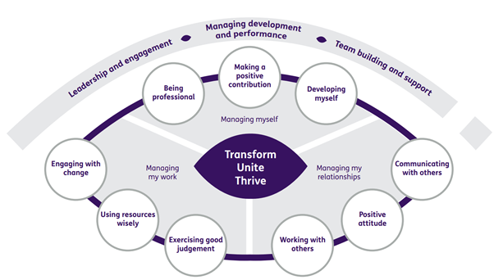
Our Ways of Working - Managing my Work
The main responsibilities and accountabilities of this role are that you will:

- Lead in the creation of, and manage the day-to-day delivery of, Sight Scotland Veterans Information Service Information Line, ensuring the highest standard of customer care is delivered in a person-centred way.
- Lead the development of a range of trusted information resources, including digital resources, to support our veterans and their families
- Lead in the creation of, and manage the day-to-day delivery of, Sight Scotland Veterans Financial Wellbeing service providing oversight of the charities grants and financial support provision.
- Lead in the creation of, and manage the day-to-day delivery of, Sight Scotland Veterans digital service offering, including the phone and virtual information and support groups.
- Lead in the creation of, and manage the day-to-day delivery of, Sight Scotland Veterans provision of opportunities to get involved in social and physical activity, external to the charities two activity hubs.
- Ensure the effective and efficient running of the Veterans Support Hub to high professional standards that are in line with the strategic vision, ethos, and values of Sight Scotland Veterans.
- Ensure the creation and delivery of relevant information in accessible formats
- Manage the recruitment, development and performance of the teams, ensuring high quality delivery and consistent customer service.
- Ensure the Veterans Support Hub teams are provided with consistent and dynamic leadership and coaching, given guidance and support as required and co-ordinated effectively.
- Develop and ensure person centred, asset based and outcome focused practices which are responsive to individual needs and encourage a self-management approach.
- Develop and deliver innovative approaches to service delivery which align with the strategic vision.
- Ensure a culture of continuous review and improvement of service provision and team performance to maintain best practice and quality services.
- Provide relevant and regular reports on service delivery, service performance and quality assurance.
- Create and maintain sustainable partnerships that positively support service impact and allow for variety of service interventions.
- Develop a volunteering community which will complement our staff teams and further enhance service delivery.
- Ensure high quality supervision is regularly undertaken which strengthens skills, practice and knowledge and encourages a culture of staff development which maximises potential.
- Be involved in the creation of and ensure Sight Scotland Veterans policies and procedures are adhered to, and that service delivery is balanced alongside thorough assessment of risk.
- Be a role model to the staff team and a positive representative of Sight Scotland Veterans.
- Maintain service and delivery in line with pre-defined KPIs, report against these and manage any under or over performance
- Manage services in line with GDPR requirements

Our Ways of Working – Managing Myself and Managing my Relationships

To do this role, you will:

- Be educated to degree level in a relevant field or equivalent experience.
- Have substantial experience of creating/managing a forward facing information and support service preferably within the Health or Social Care field
- Have project and/or service management experience, ideally in the set-up and operation of a helpline/call centre type environment and be flexible and adaptable to meet evolving needs whilst being able to deliver to fixed deadlines.
- Have an understanding and experience of safeguarding and ability to manage safeguarding concerns effectively
- Have an awareness of GDPR compliance and ability to maintain confidentiality sensitively and appropriately.
- Be able to process information quickly, assess and make decisions effectively and appropriately in a person-centred manner.
- Have evidenced ability of leading, managing & developing effective teams
- Have experience of working in a person centred, asset based and outcome focused way and an understanding of the impact of this approach.
- Be able to build constructive relationships and engage sensitively with people who Sight Scotland Veterans supports, their families and friends.
- Be able to evidence successful operational resource management.
- Be able to demonstrate a strong approach to performance management with the ability to define and measure outcomes of success
- Have previous experience of managing and working within set budgets
- Have strong problem-solving skills and an ability to work calmly under pressure
- Have a proven ability to establish and work in partnerships with third, statutory and business sectors with proven skills in communicating and influencing a range of stakeholders.
- Demonstrate excellent inter-personal and communication skills, including report writing and presentation skills
- Have the ability to inspire enthusiasm and motivation in others
- Ability to meet objectives, being a highly motivated self-starter, who is outcome focussed, positive and thrives on challenges and can work independently and as part of a team.
- Be IT proficient and able to support staff and volunteers in this area

To do this role, it is desirable if you have:

- Experience of working with people with visual impairments.
- Awareness of Veterans issues.
- Evidence of professional development beyond initial training.

On a day to day basis you will work with different people and teams, these could be:

- Families
- Colleagues and Volunteers
- Other Sight Scotland Veterans services
- Other Sight Scotland services
- Senior Staff
- Outside Agencies

Requirements of this role are that:

- You are a member of the PVG scheme (paid for by Sight Scotland Veterans)
- You will have a 6 month probation period
- That you participate in all staff training and development and maintain your own professional development
- You have a commitment to empowering visually impaired people to have choice and control over their lives.
- You will promote equality for all of our members
- You have an understanding of the support needs of visually impaired people flexible approach to working hours is expected to reflect business needs
- You will wear the appropriate PPE in accordance with current guidance for the role.

What we can offer you:

- Generous annual leave entitlement
- Generous pension scheme
- Discounts for Carers
- Access to learning and development opportunities
- Employee Perks through the Employee Assistance Programme
- Cycle to Work scheme
- And many more, please visit our website for more information

This job profile is not exhaustive. The duties of the post holder may be reviewed from time to time and the employee may be called upon to work in other locations within Sight Scotland Veterans.

