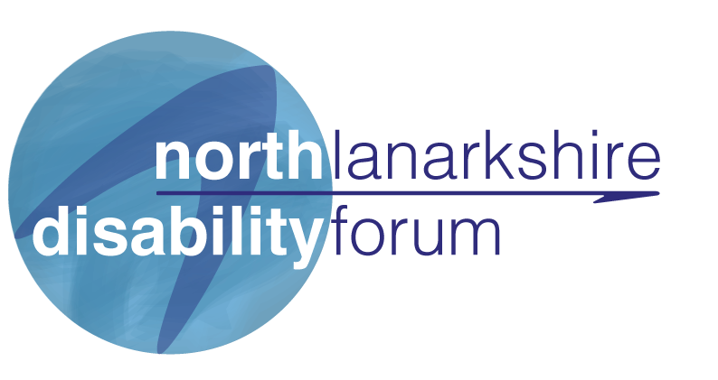

**ADMINISTRATOR POST**

**The role**

We are seeking an experienced administrator, whose role will be essential to the smooth running of the 3 projects under the NLDF umbrella. You will be a versatile worker who can work autonomously and as part of our team. You will be aware of disability issues in North Lanarkshire and the adversities people face. It is important to have a person-centred approach and a belief in disabled people’s rights.

**Responsibilities:**

• To carry out the collation and organisation of the projects and the facilitation and booking of sessional work both internally and externally.

• To keep NLDF Membership and Community resource databases up to date and the associated administration tasks, sending out welcome letters and badges to new members, promotion on social media sites and ensuring it is topical and up to date.

• To work as part of the team you will be supporting other staff members to enable them to spend more time on core project work. This will help our organisation grow and develop its services, increasing awareness and support for those living with a disability in North Lanarkshire.

• Liaising with members to ensure they are supported regarding the application process and promoting the organisation when the opportunity arising.

**General:**

Adhere to the organisation’s policies and procedures and values Work within agreed budgets and timescales. Carry out other duties as may be reasonably assigned from time to time. This job description is non-contractual and subject to change as the needs of the organisation change.

**Salary is £16,000, 21 hours per week (negotiable at interview)**

**This role will be office based (41-42 Civic Square, Motherwell) but home working may be required depending on government Covid – 19 guidelines.**

|  |  |  |
| --- | --- | --- |
|  | Essential | Desirable |
| **Qualifications:**  Qualification in health / social care or ability to demonstrate relevant experience. |  | Desirable |
| Driving License and own vehicle | Essential |  |

|  |  |  |
| --- | --- | --- |
| **Knowledge/Experience** |  |  |
| * Organisational skills | Essential |  |
| * Excellent communication skills | Essential |  |
| * Plan and manage workload | Essential |  |
| * Working with a diverse range of partners | Essential |  |
| * MS365 packages Word, Excel, Outlook, Powerpoint. Use of social media platforms. | Essential |  |
| * Event management and facilitation |  | Desirable |
| * Demonstration of ability to work collaboratively across health and social care and with service users and carers. | Essential |  |
| * Ability to work as part of a team, share knowledge and benefit from experience of others | Essential |  |
| * Understanding of disabilities and how people can be affected | Essential |  |
| * Proactive approach to problem solving | Essential |  |
| * Working knowledge of Canva |  | Desirable |
| * Knowledge of North Lanarkshire and available community resources |  | Desirable |

NLDF (North Lanarkshire Disability Forum) are a Disabled People’s Organisation (DPO) funded by NLC to provide information and advice on disabilities and services available within North Lanarkshire and to represent the voice of disabled people and their carers.

Our projects focus on

* Independent Living
* Participation
* Control
* Choice of empowerment

Core Services include

* Financial information on disability related benefits.
* Knowing your rights, promotion of local consultations and supporting people to have their say
* Self-Directed Support (Community focussed)
* Identifying gaps in service and looking for ways to support individuals and/or carers in innovative ways

We offer opportunities to access free training to support skills development.

To apply please us the application form attached and send to[**lorraine@nldforum.org.uk**](mailto:lorraine@nldforum.org.uk)