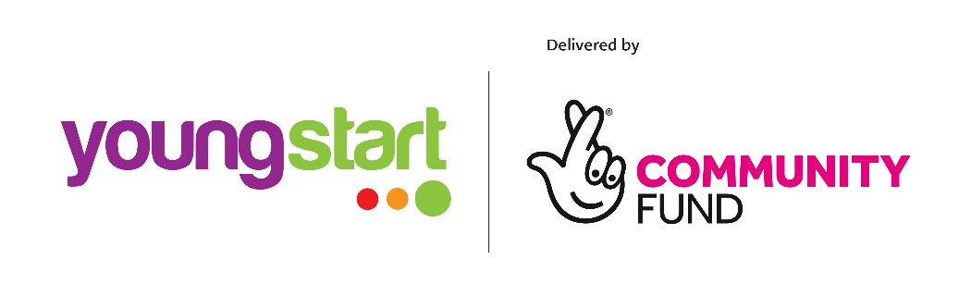

Funded by Young Start through the Big Lottery Fund
Peer wellbeing Project Coordinator
The Peer wellbeing project is a lottery funded programme, providing support to young people through activities with a strong Youth Mental Health & Emotional Well-being focus.
The Peer Wellbeing project coordinator will develop and deliver a programme of workshops to work on the issues young people are experiencing. They will work with them to develop coping mechanisms and strategies to enable them to work through these and cope better in their daily lives. The programme would consist of groupwork sessions and 1-2-1 support for the young people attending while linking them into any support services they require. The Project Coordinator will work closely with young people who are keen to develop and progress by becoming peer mentors. Peer mentors will use their own learning to support new members coming through the project in a peer to peer role while being supported by the project coordinator. The Project Coordinator will work closely with the staff team and attendees to ensure a universal message is delivered during all drop in sessions and support is available for all young people.
The Project coordinator will be responsible for developing the programme alongside young people in response to the information received on a regular basis due to hot topic issues arising at any given time. They will also work in partnership with the local housing, schools and other agencies to map opportunities and support in the area and to keep abreast of local and national practice & policy development in relation to youth mental health & wellbeing support.
They will provide training opportunities for both the staff and volunteers while building capacity of the young people in the programme. Additionally, they would support the young people to participate in existing drop in programmes and opportunities available for them. They will be responsible for using our online monitoring tool to ensure they are inputting date to ensure we are meeting the necessary outcomes for the programme.

Expected Outcomes:
- Improved knowledge of mental health and wellbeing resources for young people

- Decrease in young people participating in negative behaviours due to poor mental health

- Young people develop coping mechanisms to deal with issues

- More young people being supported with mental health and wellbeing issues
- Increase in self-esteem
- Increased confidence
- Young people more informed about what support is available from the health service and other organisations in the wider community
- Young people engaging in volunteering opportunities to improve their overall wellbeing
- Young people gaining certified accreditation for their involvement in the project
- Young people develop to become peer educators and progress to delivering workshops and supporting peers

The Project Coordinator will be expected to be available to plan and deliver the peer wellbeing sessions, providing a level of support through 1-2-1s and make referral connections where appropriate for young people in need of further support. They will work closely with other staff to ensure a level of support is offered throughout the various sessions that we offer in The Pavillion.
The use of Upshot® monitoring and evaluation system is required to measure the changes we expect this programme to make. This ensures data is provided for each young person attending the programme and their journey with The Pavillion is available.

Young Start aims to create opportunities for Scotland’s children and young people aged eight to 24 to help them realise their full potential.
Young Start is a grants programme run by the Big Lottery Fund, which is distributing money from dormant bank accounts. Dormant accounts are deposits of money in bank and building society accounts where there has been no activity for 15 years or more.

Job Description
Job Title: Peer wellbeing Project Coordinator
Place of Work: The Pavillion (Greater Easterhouse)
Salary: 25 hours per week (£24,500 pro rata & pension)
Contract: 1 years fixed term until August 2023
Responsible to: Manager

Funded by: Funded by the Young Start through the Big Lottery Fund
Job Role:
- Develop and deliver a package of support with a specific focus on youth mental health & well-being through a range of activities such as group work, 1-2-1s, information sessions, development sessions and team building sessions.
- Build relationships with young people in their own environment in the drop-in sessions whilst providing support and expertise in youth mental health to existing staff.
- Develop a programme with the input of the young people to support them in the ever changing issues they face.
- Be able to work with initiative and respond with immediacy to issues young people are facing and/or any child protection concerns
- Ability to manage staff members, volunteers, and possible student placements.
- Promote and encourage participation in other activities in The Pavillion such as cooking, exercise, drama, music, art projects and any other throughout the life of the project.
- Liaise with external organisations such as Barnardos, local housing associations, Schools and other youth organisations who operate locally to promote our service to young people who are not existing members.
- Develop referral pathways to support individuals who may require support out with our expertise
- Attendance at events, training and meetings to represent The Pavillion and this project
- Develop good practice and complement existing activity
- Adheres to the organisational Child Protection policy and guidelines and actively support the organisation to work within GIRFEC framework and the UN Convention on the Rights of the Child.
- Inputting information to the Upshot® monitoring and evaluation system.
- Use Upshot® to accurately collate service user information, inputting qualitative data and produce quantitative reports on numbers of young people engaged in the programme as well as substantive evidence to demonstrate impact of the project.
- To produce timely reports when required for team meetings or to the Board of Directors or to meet funding deadlines.
- Participate in regular supervision and appraisal reviews with line Manager
- To participate in staff training and development
- Any other duties as requested by the manager for the benefit of the organisation

Person Specification
Essential
- Recent experience of working in a youth mental health role or similar.
- Can demonstrate experience in development of youth steering groups.
- A strong understanding and up to date knowledge of Youth Mental Health issues and current working guidelines e.g. completion of Youth Mental Health First Aid training or similar NHS training
- Can demonstrate strong management skills offering ability to effect change and evaluate results.
- Ability to develop personal development plans, action plans or similar.
- Experience of using a similar online monitoring and evaluation programme.
- Competent in using Microsoft Office to produce reports.
- A working knowledge of Child Protection in Scotland.
- Strong communication and listening skills both written and oral.
- Strong organisational skills.
- Ability to work well with a diverse group of people.
- Ability to act in a calm and professional manner even during busy situations or when dealing with a diverse range of tasks.
- Ability to manage own tasks, projects and responsibilities.

Desirable

- A professional qualification e.g. Degree level

- Knowledge of Health and safety
- Previous report writing experience
We are an equal opportunities employer and welcome applications from all suitably qualified persons regardless of their race, sex, disability, religion/belief, sexual orientation or age.

