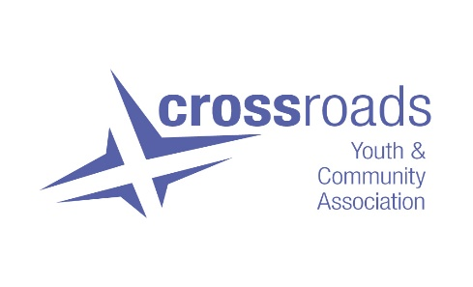

JOB DESCRIPTION

Job Title : Youth Support Worker (17.5 hpw)

Working Week : Evenings and occasional weekends

Salary: : SJC Pt.18 – 22
FT (35hpw) Equivalent £21,892 - £24,152
plus 7.5% unsocial hours payment
plus 6% employer pension contribution

Location : The Barn Youth & Community Centre
37 Abbotsford Place, Gorbals, Glasgow G5 9QS

Contract : Until end March 2023 – however funding is being sought to continue the post beyond this date.

Probationary Period : Three months

Accountability : Staff Teams, Charity Manager and Board of Directors

Purpose:

To support the delivery of youth work for Crossroads Youth & Community Association. The aim of this work is:

- To make room for young people to shine, where they can discover themselves and something of their own aims and purpose and can enjoy just being themselves.

- Young people will learn new skills, be involved with community, learn to analyse their own situation and solve their own problems and experience moments of unconditional joy.

The objective of this work is for young people to be more confident, healthier, better informed, more creative, and more connected to their communities.

We deliver an open and integrated approach to youth work combining locally based youth work programmes from the Barn Youth & Community Centre and residential/outdoors experiences in venues and areas throughout Scotland.

Main Duties:

- To set-up, participate in and review weekly evening youth work sessions.

- To attend residential and camping trips as required (approx. six per year).

- To engage young people in the planning, delivery and evaluation of projects and advocate on young people’s behalf.

- To work as part of a team and develop and maintain positive trusting relationships with young people.

- To participate in staff meetings and training sessions where appropriate.

- To foster collective decision-making processes within the youth work team

General Duties:

- To attend outings and trips with young people, providing relevant support.

- To assist in the smooth running of youth work sessions in conjunction with other youth work staff.

- To participate in staff meeting and training sessions when required.

- Assist with and undertake day to day administration to ensure the smooth running of sessions.

- Adhere to and implement all Crossroads Procedure & policies including equal opportunities.

- To undertake any other appropriate tasks, as identified by the team and Charity Manager.

This list of duties is not exhaustive and will be reviewed periodically, in consultation with the post holder.

PERSON SPECIFICATION

ESSENTIAL:

- Experience of working in a youth work environment including overnight and residential trips.
- Understanding of and commitment to the voluntary sector.
- Skills in empowering young people/groups to develop ideas, address issues and avail of opportunities on their own.
- Experience of empathising and communicating with young people in different situations including typically ‘hard to reach’ groups within communities.
- Ability to be innovative and creative in engaging and communicating with young people as well as in approaching work issues.
- Understanding of monitoring & evaluation of youth work.
- Ability to learn from experience.
- Ability to be highly organised, work on own initiative and also as part of a team.
- Efficient time management.

DESIRABLE:

- Ability to drive a minibus and be MiDAS trained.
- Experience of Outdoors (camping, Duke of Edinburgh Awards expeditions etc.)
- Experience of writing reports for youth work.
- Sound working knowledge of Microsoft Office applications.

