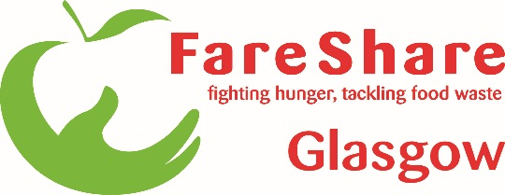

Job Title: FareShare Depot Development Worker
Department: FareShare Glasgow and the West of Scotland (FSGWS)
Responsible to: FareShare Operational Manager

Job Purpose
To structure, plan and manage the flow of surplus food, in and out of our depot and around our network, while at all times, maintaining and ensuring that the FSGWS Depot is a safe, efficient, and welcoming place to train, work and volunteer.

To support the development of our volunteers, trainees and service users, ensuring that they are fully supported and motivated to provide a high-quality service for all of FSGWS’s stakeholders.

Key Tasks / Responsibilities

- Ensure the distribution of surplus food to all our Community Food Members (CFMs) is safe and monitored in accordance with legislation and Move On policy.
- Maintain and develop excellent relationships with CFMs
- Support, train, motivate and develop depot volunteers and trainees
- Build excellent working relationships with volunteers, suppliers, CFMs and the wider FareShare network
- Maintenance of delivery, processing, despatch, and storage area of operations
- Maintenance of food receipts, delivery, and replenishments
- Ensure adherence to / review of operational systems and procedures and suggestion of continuous improvements where necessary
- Oversee maintenance and use of equipment
- Ensure the safe operation of organisational machinery/equipment
- Comply with Health and Safety responsibilities and/or as applicable to the nature of your role / people management responsibilities.
- Managing petty cash system, ensuring volunteers are receiving accurate travel expenses.
- Ensuring adherence to company policy, systems and procedures with particular reference to safety, food hygiene, security, the environment and employment legislation
- Driving the FSGWS vans to deliver food to CFMs

This job description describes the main responsibilities of the post holder but is not intended to cover in detail all the tasks required of the post. The post holder may be required to carry out other duties as requested by management; however, these will not be unreasonable and will be appropriate to the level of post.

Person Specification

Essential

- Driving Licence
- Good numeracy and literacy, verbal and written communication skills.
- Awareness of Health and Safety and/or food hygiene legislation
- Food and/or logistics industries
- Understanding of Stock control systems
- Basic IT Literacy / Microsoft Packages
- Ability to liaise with a diverse range of people
- Excellent planning and organisational skills
- Flexible approach to covering other roles within the organisation
- Flexible and open approach to development

Desirable

- Experience of Working in a busy depot environment
- Food Hygiene Certificate (Training will be made available)
- Forklift Licence (Training will be made available)
- Working with vulnerable groups, particularly young people and volunteers

