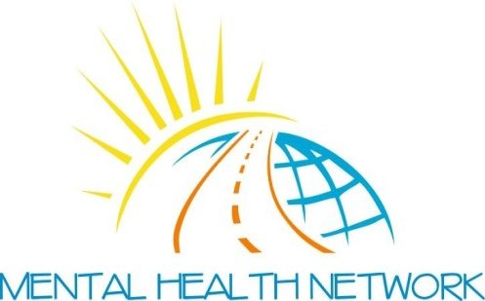

July 2022

Dear Applicant,

GROUP ENGAGEMENT WORKER
Thank you for showing interest in applying for the above post with Mental Health Network Greater Glasgow.
Please find attached an Application Pack and Application Form which you should complete and return to us as soon as possible, but before the deadline of FRIDAY 12TH AUGUST 2022 . Please note CV’s are not accepted.
Please mark your e-mail:
Strictly Private & Confidential for the attention of Anna Barclay anna@mhngg.org.uk
Interviews will be held ON WEDNESDAY 31ST AUGUST 2022. If your application is successful, you will be notified before that date.
However, if you have not heard from us by this date, you have been unsuccessful with your application.
Please note the successful candidate will be subject to a Criminal Conviction Check through the Protection of Vulnerable Groups (PVG) Scheme/relevant level of disclosure and satisfactory references.

If you would like to have an informal chat regarding this post, please contact the Manager, Mrs Ann Jones on 0141 550 8417 or ann@mhngg.org.uk
May we take this opportunity to thank you for your interest in the post of Capacity Building Worker and wish you success in your application.
Yours faithfully,

ANN JONES MANAGER

ENCLS: Application Form
Group Engagement Worker - Job Description
Group Engagement Worker - Person Specification

