**Person Specification:** Children and Women’s Support worker

|  |  |  |
| --- | --- | --- |
|  | **Essential** | **Desirable** |
| **Knowledge** |  |  |
| Knowledge of the causes and effects of domestic  abuse and an understanding of a feminist approach to domestic abuse | **E** |  |
| Knowledge & understanding of the issues and  support needs of children & young people who are experiencing domestic abuse and their mothers / carers | **E** |  |
| Knowledge of adult & child protection procedures |  | **D** |
| Knowledge of child development |  | **D** |
| Knowledge of the issues, policies and legislation within Scotland affecting women who experience domestic abuse |  | **D** |
| Knowledge of Housing Support and Welfare system |  | **D** |
| Knowledge of Children’s Hearing systems |  | **D** |

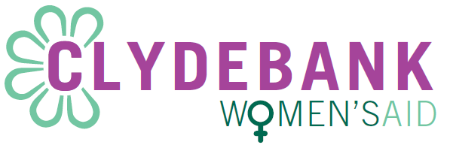

|  |  |  |
| --- | --- | --- |
| **Experience** |  |  |
| Experience of providing support to and working with women experiencing domestic abuse |  | **D** |
| Experience of working with programmes and materials that support WCYPEDA |  | **D** |
| Experience of developing and facilitating one to ones  and group work with women, children & young people |  | **D** |
| Experience of interagency work when providing support to WCYPEDA |  | **D** |
| Experience of child protection work |  | **D** |

|  |  |  |
| --- | --- | --- |
| **Abilities – skills and aptitudes** |  |  |
| Able to work in ways that engender a trusting relationship with women, children and young people | **E** |  |
| Able to work with women, children and young people to identify their needs and support in fulfilling these | **E** |  |
| Able to engage with and develop relationships with women, children & young people within professional boundaries | **E** |  |
| Able to communicate effectively both orally and in writing | **E** |  |
| Able to work with confidential material appropriately | **E** |  |
| Able to produce written reports as required | **E** |  |
| Able to work with women, children and young people to identify their needs and support in fulfilling these | **E** |  |
| Able to work on own initiative and as part of a feminist collective | **E** |  |
| Able to maintain accurate and up to date records of work | **E** |  |
| Able to build and maintain good relationships with external agencies, practitioners, partners and other collective managers | **E** |  |
| Ability to maintain up to date information on legal, housing and welfare relevant to domestic abuse | **E** |  |
| To work collectively in producing statistical information and other reports on work done with women to meet the requirements of funders and the collective | **E** |  |
| Adequate use of Microsoft packages | **E** |  |

|  |  |  |
| --- | --- | --- |
| **Requirements** |  |  |
| Commitment to promoting women, children and young people’s rights | **E** |  |
| Commitment to feminism and working within a feminist management structure | **E** |  |
| Commitment to working in an inclusive and anti-oppressive manner | **E** |  |
| Commitment to maintaining and updating a range of support materials for WCYPEDA | **E** |  |
| Willingness to undertake appropriate and relevant training | **E** |  |
| Commitment to working as part of a feminist collective in fulfilling collective responsibilities | **E** |  |
| Ability to work flexibly taking into consideration the ages of children and young people. | **E** |  |
| Driving license with the use of own car |  | **D** |