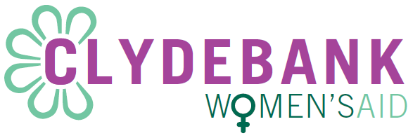
Person Specification: Collective Manager

Experience, Training and Qualifications | Essential | Desirable
Knowledge of the issues, policies and legislation within Scotland affecting women, children and young people subjected to domestic abuse |  | D
Have a feminist understanding of collective management/working at a theoretical level and a willingness to learn how this is applied operationally | E
Have a commitment to women, children and young people who have experienced domestic abuse | E
Have a feminist understanding of issues and barriers affecting women who have been subjected to domestic abuse including but not limited to; dependencies, child sexual abuse, racism, disabilities, sexuality, prostitution/trafficking etc., | E
An understanding of and commitment to Clydebank Women’s Aid vision and mission | E
Support work experience (paid or unpaid) within a work setting |  | D
An understanding of non-directive counselling and ability to provide a non-judgemental service | E
Have an understanding, or willingness to learn, of employment and management issues | E
Willing to work towards or hold a qualification that ensures that you meet SSSC and collective requirements | E
Experience of strategy development and operational management, and applying this to collective working |  | D
Experience of completing funding applications |  | D
Experience of working effectively and consulting with a wide range of partners at a strategic and operational level |  | D
Basic level of IT competence across all Microsoft office applications | E

Competencies | Essential | Desirable
Excellent communication and interpersonal skills | E
Good organisational skills appropriate to the role | E
Ability to prioritise tasks and meet deadlines | E
A sound knowledge, understanding and commitment of a feminist analysis of domestic abuse and the impact on women, children and young people | E
Experience of, or a willingness to, develop and deliver training | E

Personal Qualities | Essential | Desirable
Able to make decisions as part as a collective | E
To be able to take direction from the collective and also be able to apply this when working on your own initiative | E
To be able to be flexible and responsive with the ability to meet the needs of the collective, women, children and young people | E
Identify as a feminist | E
Commitment to the principles of equality and diversity | E

Special Requirements | Essential | Desirable
Able to work flexibly including some evenings and weekends | E
Have a drivers licence and access to a car |  | D
Ability to be on-call | E

