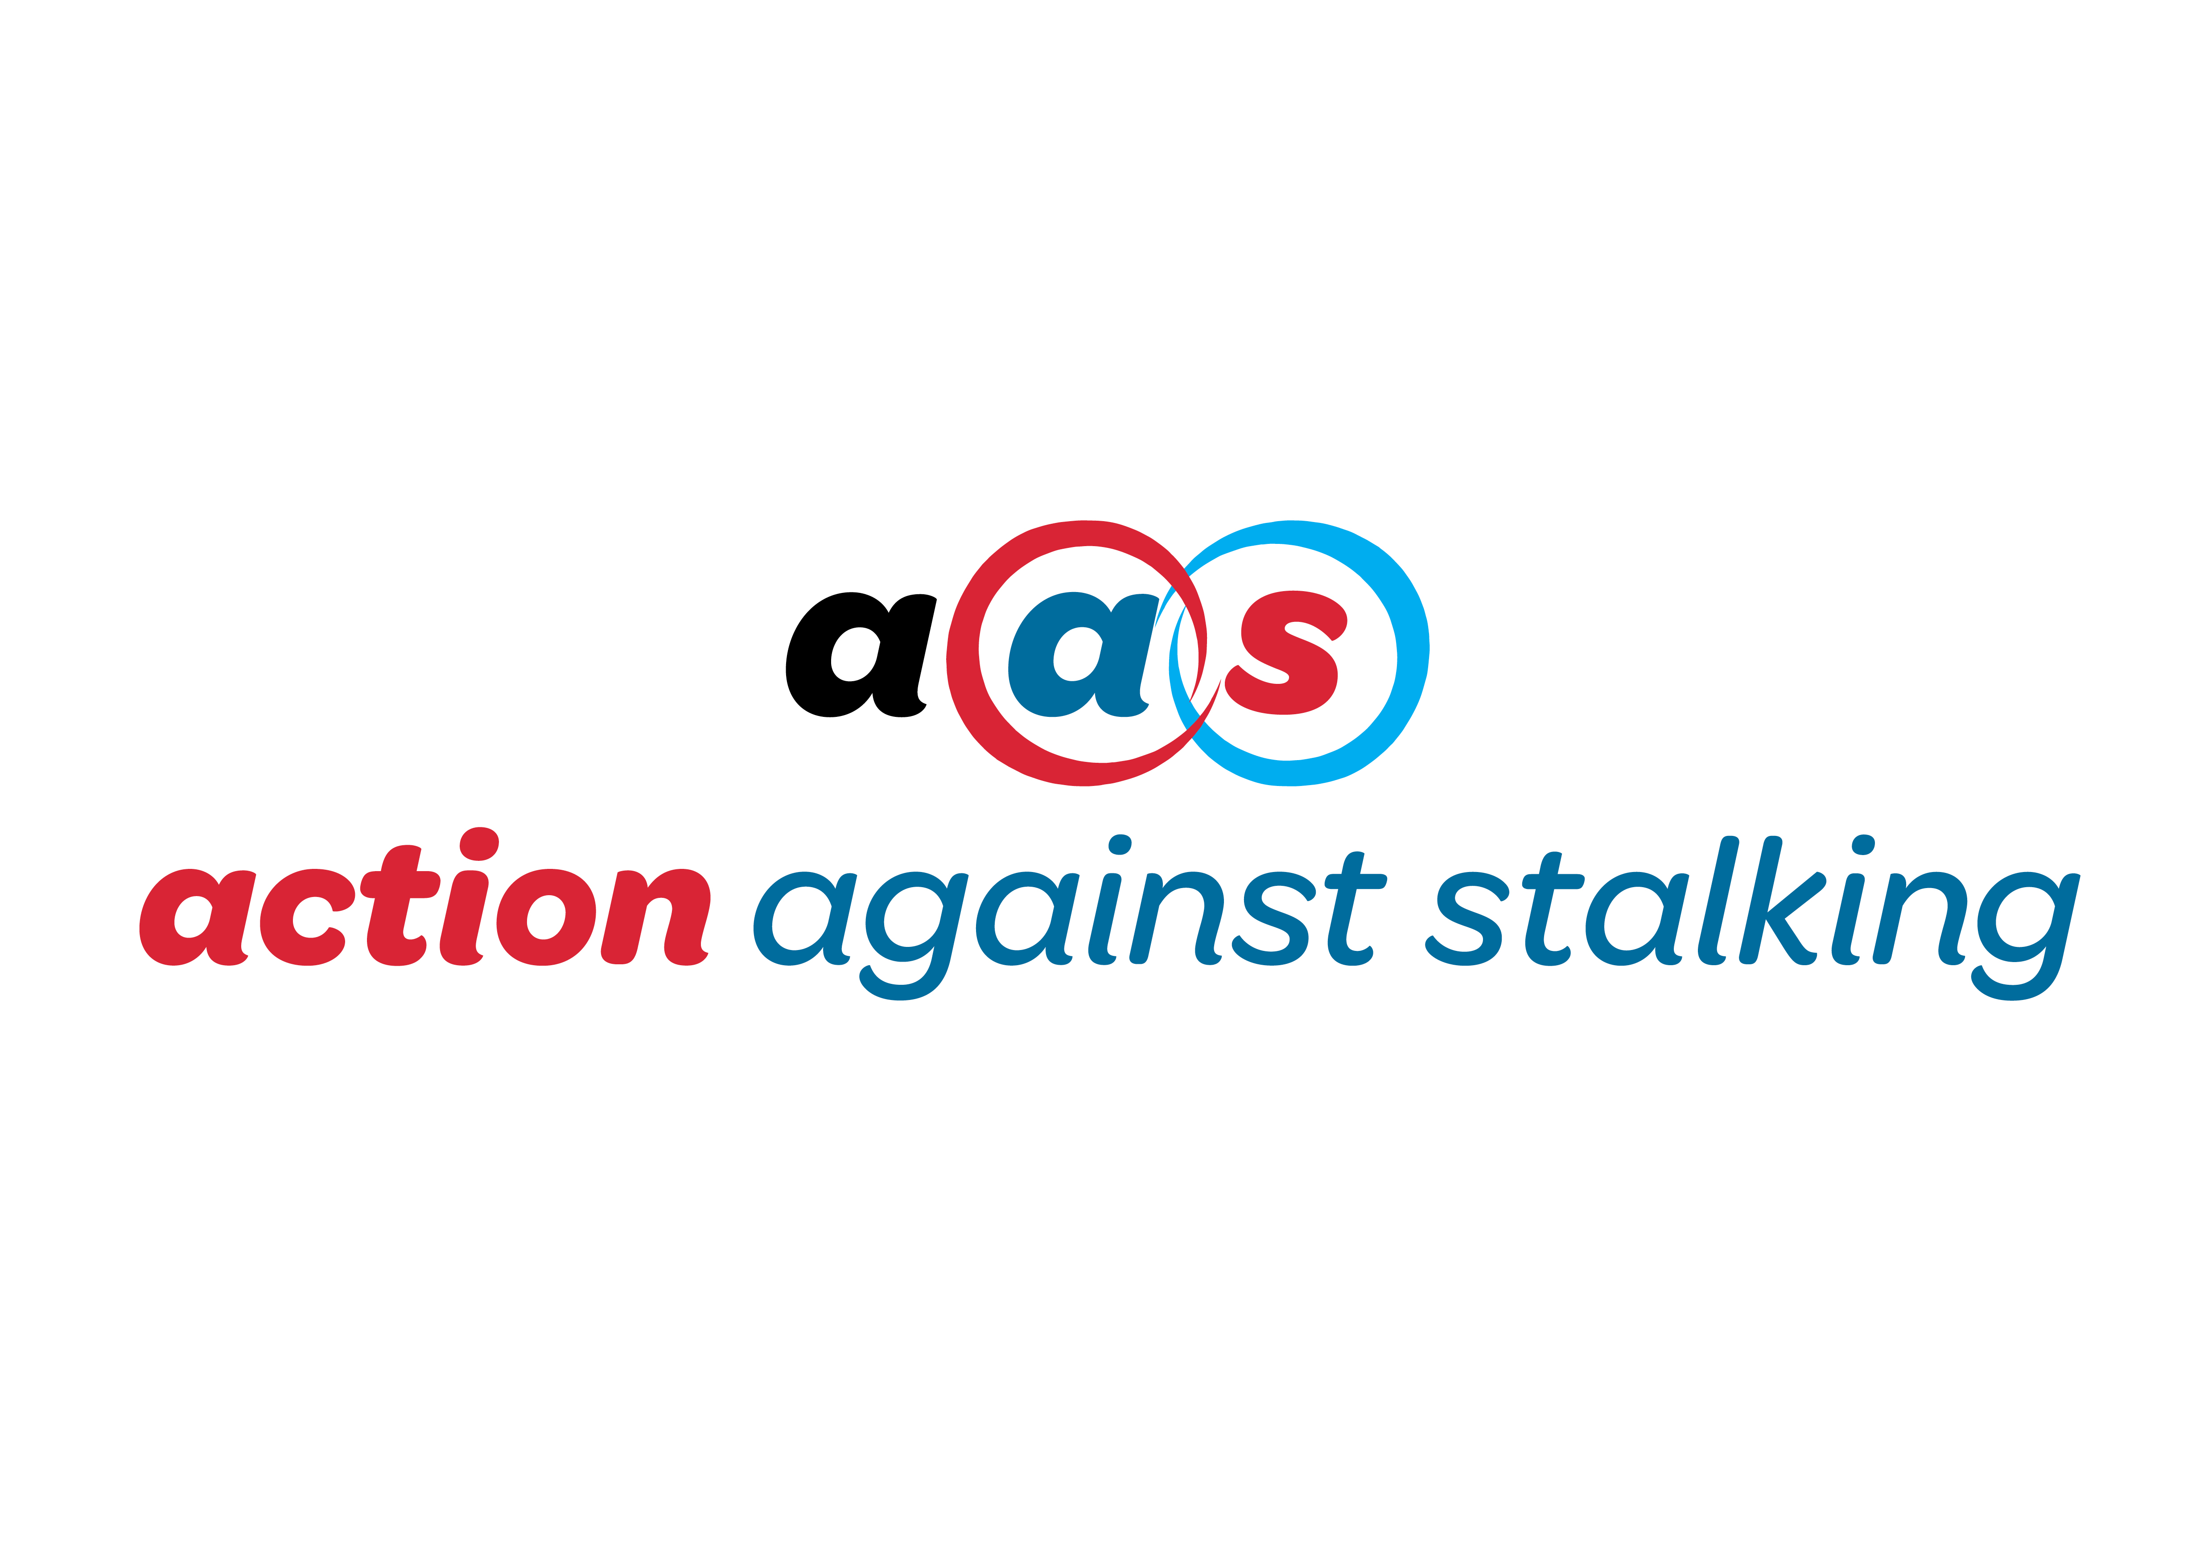

Action Against Stalking - Application Form

SECTION A - PERSONAL INFORMATION

The information provided by you in Section A will be kept separate from your application form and will not be considered as part of the short-listing process.

1. PERSONAL INFORMATION

Title |  | NI No.
Surname
Forename
Address
(correspondence)
Postcode
Phone - Home
Phone - Personal
Phone - Mobile
Email

Do you know anyone who currently works with Action Against Stalking  (Please 'X' the appropriate box) |  | Yes |  | No
If yes, please give name and relationship

2. ELEGIBILITY TO WORK IN THE UK

If your application is successful you may be required to provide proof of your eligibility.

Are you eligible to work in the UK (Please 'X' as appropriate) | Yes |  | No

3. PVG MEMBERSHIP

It is a requirement for individuals carrying out 'regulated work' with children and/or protected adults to be members of the PVG Scheme. (Please 'X' the appropriate box.)

Not currently a member of the PVG Scheme
Member of the PVG Scheme for regulated work with children
Member of the PVG Scheme for regulated work with protected adults
PVG Membership No. (if applicable)

SECTION B - EDUCATION DETAILS AND RELEVANT EXPERTISE

Position Applied For

The information provided by you in Section B will be made available to the short-listing panel and will be considered as part of the short-listing process.

4. EDUCATION

Examining  Body  Eg. SQA | Subject/Module |  | Please indicate grade achieved
 |  | Higher | Ordinary | Standard | Other

5. FURTHER EDUATION

College or University | Qualifications Gained

6. DETAILS OF FORMAL TRAINING OR APPRENTICESHIP(S)

Organisation | Qualifications Gained | Subject

7. DETAILS OF PROFESSIONAL DEVELOPMENT IN THE PAST 2 YEARS

Date(s) | Details of CPD

SECTION C - FURTHER INFORMATION

8. MEMBERSHIP OF PROFESSIONAL ASSOCIATIONS

Name of Association | Class of  Membership | Method of Entry  Eg. examination, formal qualification

9. INTEREST AND MOTIVATION

Please explain why you would like to apply for a position with Action Against Stalking.

10. RELEVANT EXPERTISE

Please briefly provide any further information, including relevant memberships, board level positions, voluntary work or other relevant expertise which you feel may be relevant to your application.

11. CURRENT EMPLOYMENT

(1) Employer Name & Address

Job Title |  | Start Date
Salary | Period of Notice
Other Benefits

Main duties & responsibilities:

Reason for leaving:

12. PREVIOUS EMPLOYMENT

(2) Employer Name & Address:

Job Title: | From | To
Duties undertaken:

(3) Employer Name & Address:

Job Title: | From | To
Duties undertaken:
(4) Employer Name & Address:

Job Title: | From | To
Duties undertaken:

Please continue on a separate sheet for employment history - if required - and use the same format.

13. ADDITIONAL INFORMATION

Please use this section to provide any other relevant information - from work or outside of work - particularly relevant to your application (Maximum 500 words).

For Throughcare Practitioner applicants – please also state the number of hours post qualification working with clients.

14. APPLICATION MONITORING

Please indicate how you became aware of this position.
Application Source | Please 'X' relevant box(s) | Please specify (if applicable)
Newspaper
AAS Website
Recruitment Website
Social Media
Word of Mouth
Other

15. REFERENCES

Please supply us with the names and contact details of two referees that we may contact.

Name, Job Title and Address: | Name, Job Title and Address:
Company: | Company:
Phone (daytime): | Phone (daytime:)
Email: | Email:
In what work capacity do you know this person: | In what work capacity do you know this person:
Do not contact prior to interview? | Do not contact prior to interview?

16. DATA PROTECTION AND DECLARATION

The information provided by you in the application will be used for purposes of considering your application, will be processed securely and will be retained in accordance with our retention schedule. Please 'X' the below to confirm your acceptance. Failure to do so may result in your application not being considered.

I certify that all information provided in this  application is true and correct to best of my knowledge |  | I realise that false information or omission may lead to dismissal without notice

I declare that: (* please delete as appropriate):

- I am not* an undischarged bankrupt
- I have not* previously been removed from trusteeship of a charity by a Court or the Charity Commission
- I am not* under a disqualification order under the Company Directors’ Disqualification Act 1986
- I have not* been convicted of an offence involving deception or dishonesty (unless the conviction is spent)

I certify that all information provided is true and correct to the best of my knowledge and false information may lead to dismissal without notice.

Date
Signature

Please return your completed form - marked confidential in the subject box - to email: enquiries@actionagainststalking.org

