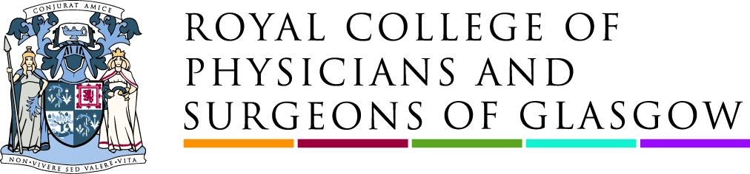

National Co-ordinator (Diet and Healthy Weight Early Adopters) – Obesity Action Scotland
(Fixed term contract to 31st March 2023)
(secondments would be considered if your current employer agreed)

Salary Scale – Grade 6A - £36,504.52 - 35 hours per week
Fixed reduced hours paid pro-rata will be considered

The College supports hybrid working practices including working from home, however, regular attendance at meetings in Glasgow city centre would also be a requirement of the role.

The Role

Obesity Action Scotland (OAS) is hosted and supported by the Royal College of Physicians and Surgeons of Glasgow. The post holder will be employed within Obesity Action Scotland and will provide support and input to Scotland’s early adopters programme on a whole system approach to diet and healthy weight.

Reporting to the Programme Lead of OAS, the National Co-ordinator will play a key role in the development and championing of a whole systems approach to diet and healthy weight being led by early adopter areas including North Ayrshire, Dundee, Dumfries and Galloway and the East Region.
The programme is a key commitment within Scottish Government’s Diet and Healthy Weight Delivery Plan. A national steering group support and oversee the early adopter activity and the post holder will work closely with the national steering group, national partners and appointed leads within the early adopter areas.

The post holder will provide practical support to the nominated programme leads at local level including:

- Be the first point of contact for national, strategic input
- Support the direction and development of local programmes
- Support capacity building at local level
- Facilitation support for engagement workshops and planning sessions for local partners
- Assisting them to establish contacts and connections
- Supporting local leads to establish local political buy in and cross organisational support
- Gathering and sharing learning on whole systems approach and other good practice from external sources – Scotland, England, international
- Gather, share and publish progress reports and good practice examples from each area
This post may require extensive travel across Scotland for which suitable expenses will be paid.

About You

The post-holder will require the following:

Essential

- Educated to degree level or equivalent in a relevant subject
- Ability to analyse and interpret empirical evidence
- Demonstrable coaching or active learning skill set
- Facilitation skills
- Experience of collaborative working and managing complex relationships
- Strong project management skills
- Self-motivated personality
- Strong attention to detail
- Excellent communication skills
- Experience of influencing and engaging colleagues and senior managers
- Excellent problem-solving skills

Desirable

- Knowledge of whole systems approach
- Knowledge of obesity or public health landscape
- Experience of change management processes

As well as a competitive salary we offer the following benefits:

- 40 days holiday
- Pension
- Life Assurance Benefit
- Enhanced Sick Pay, Maternity, Paternity and Adoption pay
- Wellbeing Benefit
- Cycle to Work Scheme

The closing date is Friday 12th August 2022 at 1700 hours. It is anticipated that interviews will be held during week commencing 29th August 2022. However, we will assess applications as they are received and the closing date may be brought forward without notice.

Application is by covering letter, CV and Equal Opportunities Monitoring form via HR@rcpsg.ac.uk

If you have any queries please contact HR@rcpsg.ac.uk or access the recruitment package at http://rcp.sg/careers .

A Charity Registered in Scotland: Charity Registration Number SC000847

