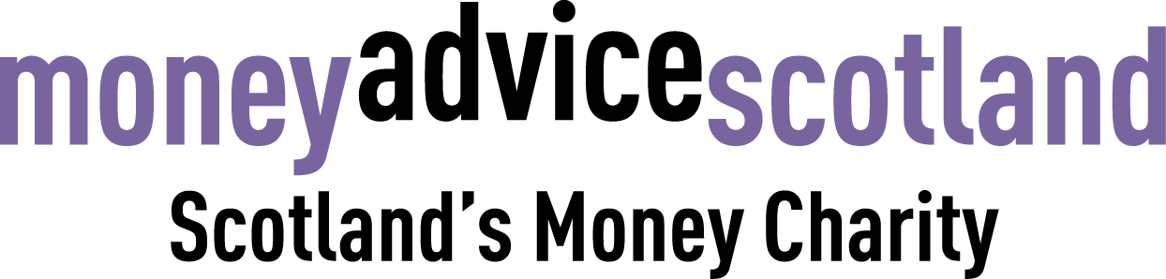

Role: Financial Capability Officer (maternity cover)
Responsible to: Financial Wellbeing Manager
Salary: £20,062 per annum (£32,100 pro-rata) + 6% pension
Hours: Part time (22.5 hours per week). We are a flexible working employer
Terms and conditions: Initially this is to cover maternity leave for 12 months, but may be extended subject to funding
Location: Mainly working from home, but some travel around Scotland and to our office in Glasgow will be required

About Money Advice Scotland
The times we live through are frequently described as unprecedented.
A century pandemic has magnified and entrenched inequality.
But it has also shown that change can happen rapidly and can make a real difference.
We need change. We need new ideas when old solutions cannot solve new problems.
Our plan sets out our approach towards securing a new different at a time when our purpose is more essential than ever.
Money Advice Scotland is Scotland’s money charity. Our mission is to be the driving force towards financial wellbeing for the people of Scotland.
We believe we will achieve this by supporting the advice workforce, empowering citizens to get help and support, and advocating for fairer policy.
About the role
Our financial capability team works towards the strategic aim of improving financial health and wellbeing.
We do this by delivering evidence-based money guidance to a number of audiences, including schools, colleges and workplaces.
We also deliver financial capability training to professionals, administer our e-learning modules and create a wide range of digital resources so that people can access financial information in a format that is most suited to their needs.

Job description and key responsibilities
- Support the financial education of young people by creating resources and delivering workshops to schools, colleges, universities and community groups, both online and in person.
- Create and deliver financial wellbeing sessions to the wider population including employees across Scotland.
- Develop and deliver open access online workshops on various personal finance related topics.
- Design and develop financial wellbeing resources using a variety of formats.
- Deliver financial capability training to professionals.
- Help to create a resource bank on our website.
- Work with the Financial Wellbeing Manager to plan activities in line with our strategic aim.
- Other relevant tasks as required.

 | Essential | Desirable
Qualifications and experience | - Degree or equivalent professional experience  - Experience of developing and delivering training and/or education  - Experience of supporting, building and strengthening relationships with partner organisations | - Experience of financial inclusion and debt prevention  - Community engagement experience
Knowledge and understanding | - Ability to create high-quality, engaging content in a variety of formats  - Interest in financial wellbeing topics  - Willingness to learn about new subjects  - Ability and passion to work directly with people to create content and present complex information in a way that best fits their needs | - Knowledge of the money advice sector  - Knowledge of creating video content and video editing skills
Communication and IT skills | - Excellent with Microsoft Office products  - Excellent written and verbal communication skills | - Experience using online platforms such as Zoom
Evaluation and analysis | - Strong attention to detail  - Strong analytical skills | - Knowledge of evaluation techniques, particularly capturing tangible outcomes
Autonomy and accountability | - Ability to work using own initiative  - A focused and motivated approach to achieving our strategic aim  - Organisational and time management skills, with the ability to work on a wide range of tasks, often working to a deadline  - Confidence and adaptability to work flexibly in a team as well as individually
Values and attitudes | - A commitment to our purpose  - A passion for tackling inequality
Other | - Eligible for membership of Protection Vulnerable Groups (PVG) Scheme | - Possession of a full, clean driving licence as travel throughout Scotland may be required

What you will get from the role
You’ll be part of a progressive organisation which aims to challenge the stigma and misconceptions that often surround how people manage their money. Your work will help to support people in Scotland to build financial resilience and improve financial wellbeing.
Your role will be varied, fast paced and will allow you to embrace creativity and innovation.
Application process
Please submit a CV and cover letter (no more than one page) by email to jenny@moneyadvicescotland.org.uk by Wednesday 17th August 2022. Shortlisted candidates will be invited to attend an online interview w/c 22nd August 2022.

