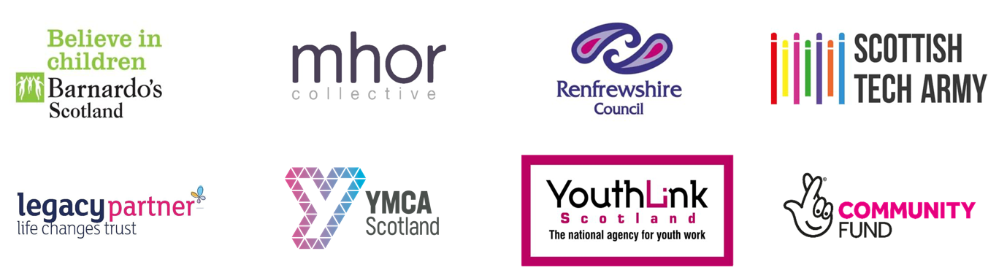

TEK CARE

NATIONAL DIGITAL PROJECT LEAD
Job Description & Person Profile

Job title : | National Digital Project Lead
Responsible to : | YMCA Scotland Chief Executive
Salary : | £42,602 – £46,015 (starting salary expected to be at bottom of scale)
Hours : | 35 hours per week including evening and weekend work
Holiday entitlement :  Place of Work: | 25 days annual leave plus 10 public holidays  YMCA Scotland’s National Office is based in Edinburgh, but the place of work will be negotiated with the successful candidate.

Imagine a well-equipped and attractive activity space kitted out with a range of digital technology. The space is called a digital makerspace. Groups of care experienced young people who meet in the makerspace are able to make, create, experiment and explore. They do things that they love - gaming, music, video making, virtual reality. As they do, they develop the digital skills they need for life. They learn to code so that they can create in the digital world. They develop the resilience they need to stay safe online. They learn skills that prepare them for the world of work - specifically digital skills alongside more general skills such as the ability to work in teams and develop confidence to contribute ideas.

Although we ask you to imagine, digital makerspaces already exist and our TEK CARE project will co-create new digital makerspaces and for care experienced young people right across Scotland.

YMCA Scotland is the national office of the YMCA movement in Scotland, working in over 100 local communities across Scotland. We are a Life Changes Trust Legacy partner, leading the TEK CARE partnership with 5 other organisations: Barnardos Scotland, Mohr Collective, Renfrewshire Council, Scottish Tech Army and Youthlink Scotland.

The Project lead will be responsible for day-to-day delivery of the project, working with a project Steering group that is led and guided by care experienced young people.

Main responsibilities

- Co-create and deliver two new Digital Maker spaces for and with care experienced young people (one in Renfrewshire and one in the North East - likely to be Aberdeenshire/Moray area)
- Co-create and deliver an online Maker space for care experienced young people across Scotland
- Consult with the Steering group on all major aspects of the project development
- Create and maintain an integrated project plan summarising the activities of all workstreams within the programme
- Liaise with all project partners to ensure timely delivery of their workstreams
- Create project reports on a monthly basis to keep members of the Steering Group and other stakeholders well-informed on progress and any issues that arise
- Ensure that the project offers new opportunities for care experienced young people to engage creatively with digital technology
- Deliver STEM & STEAM awards (S= Science, T=Technology, E= Engineering, A=Arts & M= Maths) and other qualifications as determined by the interests and needs of young people
- Manage the project within the financial budget and actively seek opportunities to enhance the budget with additional fundraising and in-kind support
- Recruit and manage a project apprentice
- Promote project opportunities to care experienced young people across Scotland
- Link up with project partners to provide training and support for carers and workers supporting young people
- Work with project partners and the steering group to develop a project evaluation framework
- Work with external suppliers to deliver communication projects and campaigns, as appropriate

These key tasks are not intended to be exhaustive, but they highlight a number of major tasks that the post-holder may be reasonably expected to undertake.

Person Specification | Essential | Desirable
Qualifications
Degree or equivalent relevant experience in community development, youth work or other related field

Full driving license

Experience

Care experienced*
Proven track recording in delivering digital youth work

Experience of working collaboratively with others

Experience of project development and budget management

Experience of working with care experienced young people

Experience of attracting funding
Experience of working in diverse youth work settings
Experience of delivering digital qualifications
Competencies
Excellent oral and written communication skills

Excellent digital skills including coding and creative digital developments

Ability to respond quickly to tight deadlines and emerging opportunities

Strong organisational skills including time management and an ability to prioritise competing demands

Ability to lead, support and encourage others to develop their use of digital
Willingness to travel nationally in Scotland

A flexible working approach with an ability to take initiative, problem-solve and make decisions

Ability to work within the ethos and value base of the YMCA

* Care experience can be direct (i.e. you have spent time in residential care, kinship care, foster care or been looked after at home for any length of time). Care experience can also be indirect for example, you may have been adopted at birth, you may be a foster carer, or have fostered or adopted siblings.

This post is a three year fixed term contract and will be subject to PVG Check

Application details:
Application packs are available from jillian@ymca.scot
Application is by application form and CVs will not be considered.
Closing date: Friday 19 August 2022 at 5pm

