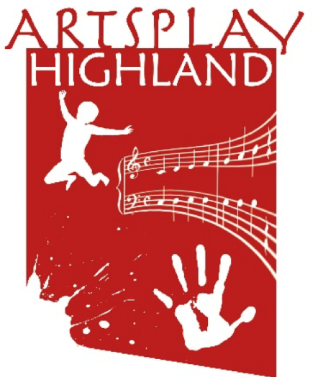

**Artsplay Highland**

**Development Officer**

**(Part-time – 16 hours per week, fixed term for 26 weeks)**

**Salary: £20 per hour (£36,400 per annum pro rata)**

**(Freelance contract may also be possible.)**

**Job description**

## **About Artsplay Highland**

Artsplay Highland is a company limited by guarantee with charitable status. We have been providing specialist early years music and arts activities in nurseries and primary school infant classes in the Highlands since 2003.

We are passionate about providing young children with opportunities to experience and enjoy music and the arts because we believe that music and the arts makes life better, and that people introduced to them at an early age will enjoy and benefit from them throughout their lives. We also want to support families, nursery staff and school staff with training and support so that they can share the joy and benefits of music and arts activities with the young children in their care, hopefully on a daily basis.

We love music and the arts in their own right and want to share the joy. However, we also know – and science backs this up – that they help the development of young children’s communication skills, social skills and self-confidence as well as giving them other vital skills which will help in their future learning.

We are currently at a crucial point in our organisation’s development. We believe that there are opportunities to make our organisation more resilient and to expand our activities. We would like to appoint a suitably qualified person, who shares our passion for bringing music and arts activities to young children, to help us achieve our objectives.

## **Post responsibilities**

1. To work with the trustees of Artsplay Highland to develop and implement an income generation strategy and detailed action plan to help achieve the company’s vision and objectives over the next five years. This will include identifying a range of target outputs and outcomes for the company over the life of the strategy.
2. To identify potential sources of income for our existing activities from a wide range of sources, including public agencies, trusts and foundations, business sponsorship, chargeable activities, and financial and voluntary contributions from the general public.
3. To scope new projects and activities which are in line with Artsplay Highlands’ vision and objectives, and to prepare and submit funding applications for these.
4. To build links with the Highland business community, identifying opportunities for financial and in-kind support and working to bring these to fruition.
5. To identify new markets for Artsplay Highland music activities in which we can generate income by providing our services on a chargeable basis.
6. To explore opportunities for us to provide new digital resources and CPD services for families and early years practitioners/teachers, and to identify how these can be funded/charged for.
7. To compile a monthly progress report for the trustees, identifying what is going well and also flagging up any problems along with recommended solutions.
8. To carry out other duties as may reasonably be required by the trustees.

## **Attributes, skills and experience**

#### **Essential:**

* Previous successful experience of undertaking a development role in the arts/education/Gaelic language and arts sectors and/or in a social enterprise/charity setting.
* Proven experience of developing new projects and achieving funding for them.
* Understanding and experience of attracting business sponsorship.
* Good commercial awareness, including the ability to spot gaps in the market which Artsplay Highland could fill, and to develop products/services to fill these and generate income for the company.
* Proven experience of costing and of budget preparation.
* Ability to work effectively on your own
* Ability to work positively and effectively as part of a team
* Excellent communication skills (written and spoken)
* Good presentation skills
* .Ability to plan time effectively and meet deadlines.
* Computer literate, including experience of creating/using spreadsheets and databases, social media, email etc.
* Driving licence.

#### **Desirable:**

* Passionate about the benefits music and the arts can bring for young children and want to widen access to this
* Marketing and PR skills, including in traditional media and online
* Basic design skills (posters, leaflets etc)

**Salary, leave etc**

Salary: £20.00 per hour (£36,400 per annum pro rata)

Hours: 16 hours per week. Some evening or weekend work may be required from time to time. Time off in lieu will apply for any evening or weekend work undertaken.

Contract: This is a fixed term contract which will run for 26 weeks from the date of commencement.

Location: Primarily home-based but the postholder will need to be able to attend Artsplay Highland board meetings (generally held every 1-2 months in Inverness or surrounding area) and also be available to meet as required with potential project partners, funders, sponsors and customers etc.

Travel: Public transport should be used if possible but the postholder will also need to have access to their own transport for meetings and other work-related events, for which a mileage rate (currently 45p per mile) will be paid.

Equipment: Artsplay Highland will lend the successful applicant a laptop and mobile phone with calls/texts package for work use, and a workstation and office chair if needed. A small payment will also be made towards the costs of working from home (eg additional heating costs, broadband costs).

Annual leave: 28 days pro rata including public holidays.

Start date: By mutual arrangement and preferably no later than 1st September 2022

The trustees of Artsplay Highland will identify a trustee who will act as the postholder’s line manager.

*Please note that although we are advertising this post as a salaried position, we would also be pleased to hear from people who might like to undertake the work on a freelance basis.*

Artsplay Highland would like to thank Creative Scotland for providing financial assistance for this post.