Role Profile – HR Advisor
Reports To:
HR Manager
Role Purpose:
You will provide proactive, efficient and professional HR support to all services within Sight Scotland and Sight Scotland Veterans across a number of areas including casework, HR project work and management and organisational development. The People team comprises an HR Manager, two HR Advisors, and two HR Assistants, as well as a Learning and Development Manager, a Learning and Development Officer and a Volunteer Development Manager, all reporting to the Head of People.
All roles within Sight Scotland and Sight Scotland Veterans are expected to work to our values and Our Ways of Working framework:
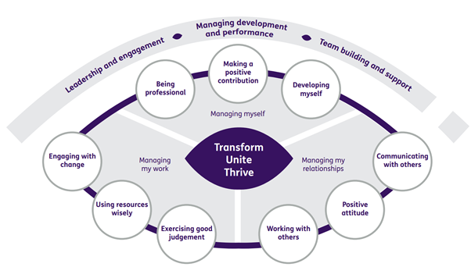

Our Ways of Working - Managing my Work
The main responsibilities and accountabilities of this role, are that you will:
- Work closely with managers and colleagues in designated service areas to provide a comprehensive HR service. You will coach, support and advise on a range of HR activities including undertaking investigations and formal proceedings under the Discipline, Grievance, Absence and Performance Improvement policies and procedures
- Take a lead role in the design and delivery of HR projects which will include management development, Employee Wellbeing, Diversity and Inclusion, Reward and Recognition and Performance Management
- Proactively support wider Organisational Development initiatives including initiating and influencing change management programmes, ensuring day to day activities are aligned with our strategic priorities and our values and ways of working. This will include providing support to any organisational restructures.
- Work with managers across the organisation to advise, support and develop their people management skills
- Mitigate organisational risk by promoting fair, consistent and equitable practices in line with terms and conditions of employment, organisational policies, current employment legislation case law and best practice
- Support all policy implementation and application, including maternity, paternity adoption, parental leave and flexible working requests
- Support the management of the recruitment and selection process from advert to appointment, including workforce planning with managers, preparing job profiles and participating in interviewing and selection processes as required and advising on pre employment checks
- Work closely with HR Assistants to ensure employee lifecycle changes for designated services are processed accurately and on time
- Compile and analyse HR management information reports, identifying trends and action planning as required
- Contribute to the development and implementation of Sight Scotland’s Equality Schemes and promoting equality and diversity through the staff Diversity and Inclusion Forum, staff training and other initiatives
- Support organisation-wide staff communication and staff engagement initiatives.
- In collaboration with the Learning and Development Manager, plan, monitor and deliver staff/management training, including training and guidance on HR policies and procedures
- Contribute to the continuous improvement of HR systems and practices.
- Contribute to development of HR policies and procedures to raise awareness of and ensure compliance with best practice
- Work closely with HR colleagues to ensure a consistently high level of customer service is provided to our internal and external stakeholders
- Maintain and develop own professional knowledge and expertise
- Undertake any other tasks as reasonably requested by the HR Manager or Head of People.

Our Ways of Working – Managing Myself and Managing my Relationships

To do this role, you will:

- Be CIPD qualified to Level 5 or above
- Have substantial relevant work experience within HR in a business partnering role
- Be able to demonstrate good communication and interpersonal skills, including strong influencing and negotiation skills and being able to challenge where necessary
- Have demonstrable experience of initiating and leading HR projects
- Have demonstrable experience of implementing HR policy and procedure
- Have demonstrable experience of working with a range of management functions and building productive working relationships
- Have experience of management reporting for HR
- Have demonstrable experience of developing and implementing HR processes, practices or initiatives
- Demonstrate and practice excellent standards of teamwork both with HR colleagues and across departments in particular during periods of homeworking
- Have demonstrable experience of change management, including culture change programmes
- Have a commitment to high standards of performance for both yourself and others.
- Have a good working knowledge of employment law which you are committed to ensuring is up to date
- Be able to demonstrate a good understanding of equality of opportunity and diversity and how to deliver this from an HR perspective
- Be able to demonstrate strong planning and organisational skills, attention to detail
- Be self reliant and able to work independently with effective time management skills in particular during periods of homeworking
- Be able to respond positively to a variety of situations and people to meet changing priorities
- Be committed to continuing personal and professional development
- Good working knowledge of Microsoft Office applications and HR systems.

It would be desirable for this role if you have:

- Degree qualification in Human Resource Management
- CIPD Qualification at Level 7 or working towards
- Experience of Equality Act reporting and implementation of diversity and inclusion initiatives
- Experience of working in the non-profit sector
- Experience of HR work in education or care sectors
- Good understanding of Equality Act 2010 (Specific Duties) (Scotland) Regulations and Gender Pay Gap reporting
- Full driver’s licence

On a day to day basis you will work with different people and teams, these could be:
- Colleagues across the People Team
- Colleagues across both charities
- Senior Staff
- External providers

Requirements of this role are:
- You are a member of the PVG scheme (paid for by Sight Scotland)
- You will have a 6 month probation period
- That you participate in all staff training and development and maintain your own professional development
- You will have the ability and willingness to undertake travel to other sites to support services as required
- You will wear the appropriate PPE in accordance with current guidance for the role
- You will follow Sight Scotland’s guidance, policies and procedures relating to your own health and safety and that of colleagues and service users at all times
- You will uphold the principles of Sight Scotland’s Dignity at Work and Equal Opportunities policies at all times, working in a way which supports an inclusive work environment that is respectful of differences.

What we can offer you:
- Generous annual leave entitlement which increases after 4 years’ service
- Generous pension scheme
- Access to learning and development opportunities
- Employee Perks through the Employee Assistance Programme
- Cycle to Work scheme
- And many more, please visit our website for more information.

This job profile is not exhaustive. The duties of the post holder may be reviewed from time to time and the employee may be called upon to work in other locations within Sight Scotland and Sight Scotland Veterans.

