****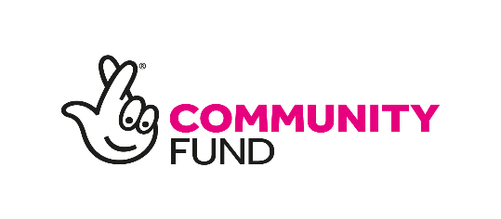

**Digital Inclusion Officer**

**JOB DESCRIPTION**

**NUMBER OF HOURSE** 14 hrs per week until 31 March 2024.

**SALARY**: £27,601 (pro rata).

**RESPONSIBLE TO**: **SCOREscotland’s Manager.**

**RESPONSIBLE FOR**: Volunteers.

**PURPOSE OF THE JOB**

* Support local black and minority ethnic (BME) families to become/remain digitally connected with the organisation and the wider world.
* Manage SCOREscotland’s presence on social media sites including but not limited to Webpage, Facebook, Twitter, Instagram, YouTube and LinkedIn.

**Responsibilities and Duties**

* Identify and support SCOREscotland’s families who are in need of IT support.
* Offer learning opportunities based on service user request where possible including one-to-one sessions, as well as group work activities to upskill parents/carers to access essential online information such as their child's home learning, social benefits and other advice services.
* Ensure that SCOREscotland’s social media platforms are up to date, user friendly and engaging.
* Compile regular Newsletters.
* Administer WhatsApp groups.
* Schedule regular social media posts.
* Maintain social media security including issuing of access permissions to staff.
* Monitor record and analyse engagement in SCOREscotland’s social media.
* Identify staff, and volunteer IT training needs.
* Assist in drafting a social media and communications strategy.
* Communicate with Prospect Housing Association and identify actions to take forward from the original ‘Digital Inclusion’ project.
* Network with other organisations, partners and professionals to enhance IT engagement.
* Research and source donations of IT equipment for community members.
* Attend and participate in meetings and events relating to the project when required.
* Ensure that Data protection and GDPR requirements are met.
* Ensure that required levels of consent are obtained.
* Adhere to SCOREscotland’s safeguarding practices and policies.
* Acknowledge The National Lottery support in all publicity material in line with their brand guidelines.
* Assist in the monitoring, evaluation and reporting of the project.
* Participate in other activities as directed by the Manager.

**Person Specification**

**Qualifications and Experience**

* A relevant qualification at HNC/HND level in IT, Computing or Social Media.
* Good understanding of social media platforms.
* Experience of using Microsoft Office, Mailchimp and WordPress, Zoom and Teams.
* Experience of working on a one-to-one basis with a vulnerable and isolated client group.
* Experience of facilitating training.

**Skills and Abilities**

**Essential**

* Confident with a wide range of social media platforms.
* Excellent verbal and written communication skills.
* Well-developed inter-personal skills.
* Ability to work in a mixed team of staff and volunteers.
* Ability to engage with diverse communities and partners.
* Ability to work as part of a team.
* Commitment to equal opportunities and anti-discriminatory practice.
* Understanding confidentiality policy and practice.
* Planning, reflection and evaluation skills.

**Desirable**

* Knowledge of Wester Hailes community, local organisations and services.
* Knowledge about issues affecting the local BME communities.
* Community language skills (e.g. Arabic, Urdu, Bengali or Polish).
* A willingness to learn and develop.