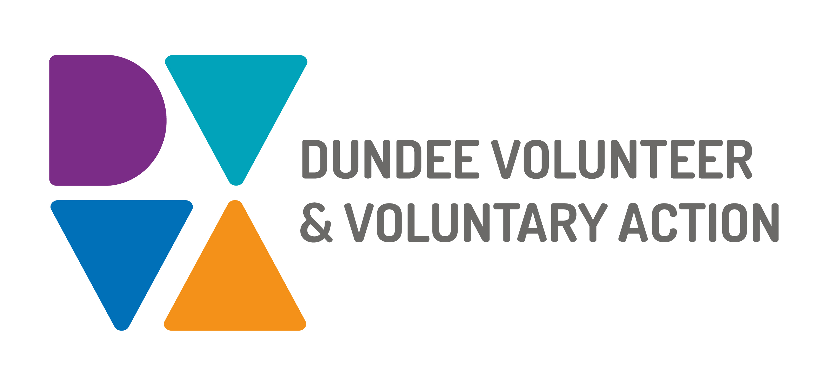
Job Description and
Person Specification

POST TITLE: PA to Chief Executive Officer

DURATION: Permanent

HOURS OF WORK: 25 hours per week, to be worked over at least 4 days and in accordance with DVVA Conditions of Service

SALARY: Grade 3 (£21,757 to £24,174) pro rata

PURPOSE OF POST: To provide high level confidential support to the Chief Executive by providing a full secretarial and administrative service. Ensuring that effective planning and administrative systems are in place and maintained efficiently and effectively.

MAIN DUTIES:

- To act as a first point of contact dealing with correspondence and phone calls
- To proactively manage and coordinate the diary of the Chief Executive by prioritising and arranging internal and external meetings, ensuring appropriate briefing papers are prepared and provided.
- Plan and organise travel and accommodation if and when required
- Maintain effective filling and data storage including emails and retrieval systems ensuring the needs of the Chief Executive are met.
- To provide full personal assistant support by dealing with all correspondence and calls, drafting routine letters to a high standard, minute meetings, taking messages and other administrative tasks as required to support the Chief Executive.
- Supporting the Chief Executive to keep the Board of Trustees updated as and when required.
- Undertake any other appropriate duties as required to support the Chief Executive to enable them to fulfil their role.

OTHER DUTIES
The job description is a broad picture of the post at the date of preparation. It is not an exhaustive list of all possible duties as it is recognised that jobs change over time. Should the duties change radically then the post and grading will be reviewed.

CONDITIONS OF SERVICE
- These are set out in the organisation’s staff handbook.
- All staff meeting the qualifying criteria may join a defined contribution pension scheme provided by TPT Retirement Solutions.
- The organisation has an equal opportunities policy and seeks to be an equal opportunities employer.

ANNUAL LEAVE: 21 days per annum on appointment increasing each year by 1 day to a maximum of 25 days, plus 6 public holidays, plus 5 days Christmas closedown. Pro-rata for part-time staff.

LOCATION: There may be an option for the post to be a blend of home and office working. Our main office is based in Dundee city centre and we also have community locations in Lochee and Whitfield.

TRAINING: Staff may make application to pursue appropriate training.

JOB DESCRIPTIONS are reviewed from time to time.

Person Specification

 | Essential | Desirable

Professional/Educational Qualifications
Educated to higher level/be able to demonstrate equivalent experience | X
Business Administration or similar qualifications |  | X
Experience of working within third sector |  | X
Knowledge and Experience
Experience of providing high-level administrative support in a senior role | X
Experience of providing support to a Board of Directors or similar high-level committee | X
Ability to convey information to people clearly and simply | X
Ability to forward plan and manage a complex and busy diary | X
Excellent, administrative skills including the ability to identify administrative needs and develop and maintain appropriate systems to meet them | X
Experience of managing and planning projects, conferences and events | X
Ability to take accurate minutes, including being able to interpret and sum up complex discussions concisely | X
Ability to draft routine correspondence and reports | X
Ability to maintain accuracy and attention to detail | X
Good negotiation skills | X
Excellent interpersonal and communication skills, including diplomacy | X
Excellent time management skills with the ability to manage multiple priorities and deadlines | X
Excellent knowledge of Microsoft Office | X
Previous experience of working at Executive level |  | X
Experience of working with a Board of trustee |  | X

Skills and Abilities
Ability to work effectively with colleagues at all levels and a wide range of senior external contacts in a high-pressure environment | X
Confident and determined with the ability to work on own initiative and as a team member when required | X
Ability to prioritise, meet deadlines and manage the conflicting demands of a busy workload | X
Ability to work flexibly and occasionally out with office hours | X
Complete discretion and an understanding of the need for confidentiality and GDPR | X

