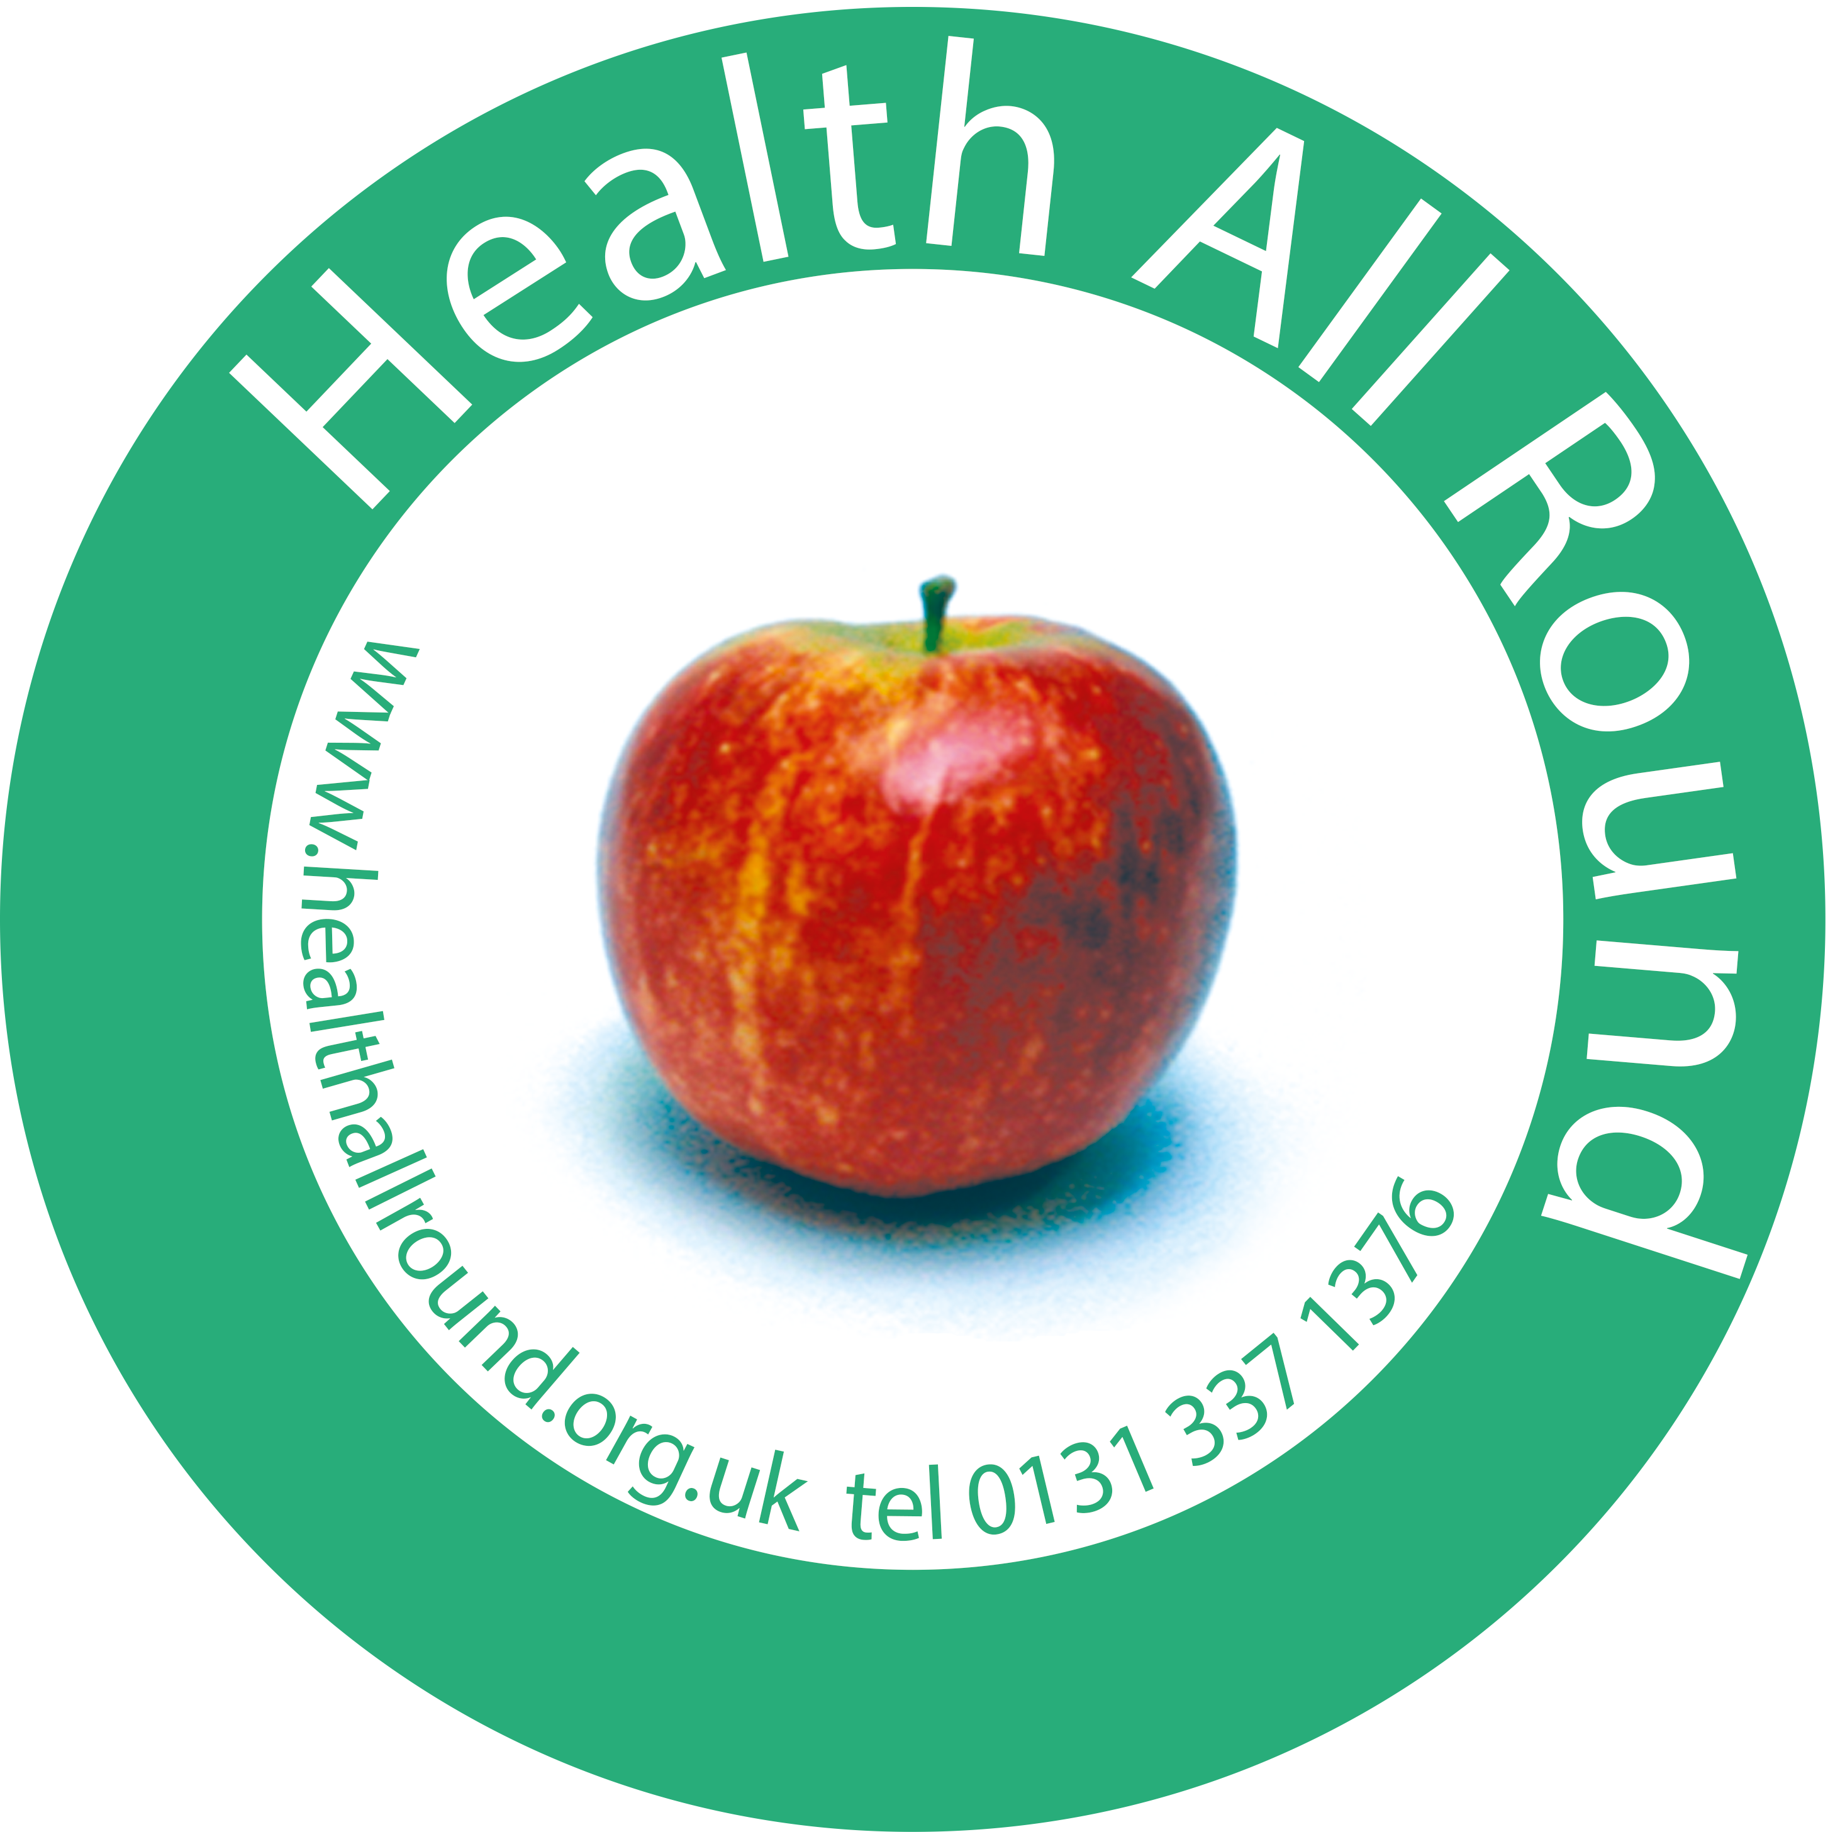

Health All Round
Healthy Lifestyles Co-ordinator

JOB DESCRIPTION

Post | Healthy Lifestyles Co-ordinator
Employing organisation | Health All Round (HAR)
Responsible to | Deputy Chief Executive Officer (DCEO)
Contract | 18 - 21 hrs per week negotiable, for one year initially but may be continued.
Salary | £24,195 pro rata

Purpose of job:

HAR has been delivering a range of high quality services for over 26 years in order to improve the health and wellbeing of local people and reduce health inequalities within South West and South Central Edinburgh.

Using a community development approach HAR works with local GP’s and other allied professionals to promote the social model of health and support the most vulnerable people in our community to improve their health outcomes. An average of 250 people per week access HAR services.

The Healthy Lifestyles Co-ordinator (HLC) will have responsibility for the delivery of the HAR physical activity and healthy eating service which includes a variety of programmes to suit high risk individuals.

Direct services:

- To deliver/ develop a range of opportunities for increased physical activity/ healthy eating for local people in order to improve health outcomes.
- To support and work alongside session workers and volunteers to deliver: Exercise classes; Walking groups; Healthy Living programmes etc.
- To support participants on a one to one basis to reach their personal health goals.
- To ensure the HAR annual targets for physical activity/ healthy eating are met.

Working with the wider team:

- To maintain, in all aspects of your job, a culture in which everyone feels valued and respected (service users, colleagues, contracted workers, volunteers.)
- Working with the HAR team to ensure a joined up approach to individual participant’s needs, supporting people to access the wide range of HAR services on offer.
- To work with other members of the HAR team to develop and deliver activities which promote a holistic approach to health (eg. physical activity for mental health.)
- To participate in HAR registration systems as required: Drop-in; Health needs assessments etc (You will always be working with a colleague for this work)
- Maintaining a safe and welcoming environment for service users, particularly those arriving in distress, and managing crisis situations accordingly (again, you will always be working with a colleague).
- To report any concerns regarding individual service users to the CEO or DCEO or a member of the Heads Up team as required.
- To participate in fundraising activities including training to external organisations (Health at Work) as required.
- Representing HAR at events, conferences, forums etc as required
- Attending: Team meetings; Supervision; Training etc

Risk management:

- The post holder will complete First Aid training and will be a designated First Aider for the physical activities/ healthy eating services.
- To work in accordance with risk assessments and ensure health and safety requirements are met.
- To report any risks/ potential risks/ accidents to the DCEO/ CEO.

Administrative tasks:

- To carry out routine tasks as required eg. recording payments for exercise classes, HAR therapies etc
- To maintain a database and other information systems in order to track individual service users and maintain statistical records.
- To ensure that quality standards are met through participation in monitoring and evaluation systems.
- To work in accordance with General Data Protection Regulation as per HAR policies.

Partnership work:

- To participate in partnership initiatives and encourage or support local organisations to incorporate physical activity/ healthy eating into existing services.

Other key activities:

- Any other reasonable activities to ensure safe, smooth, continuous delivery of services to meet the community’s needs.

