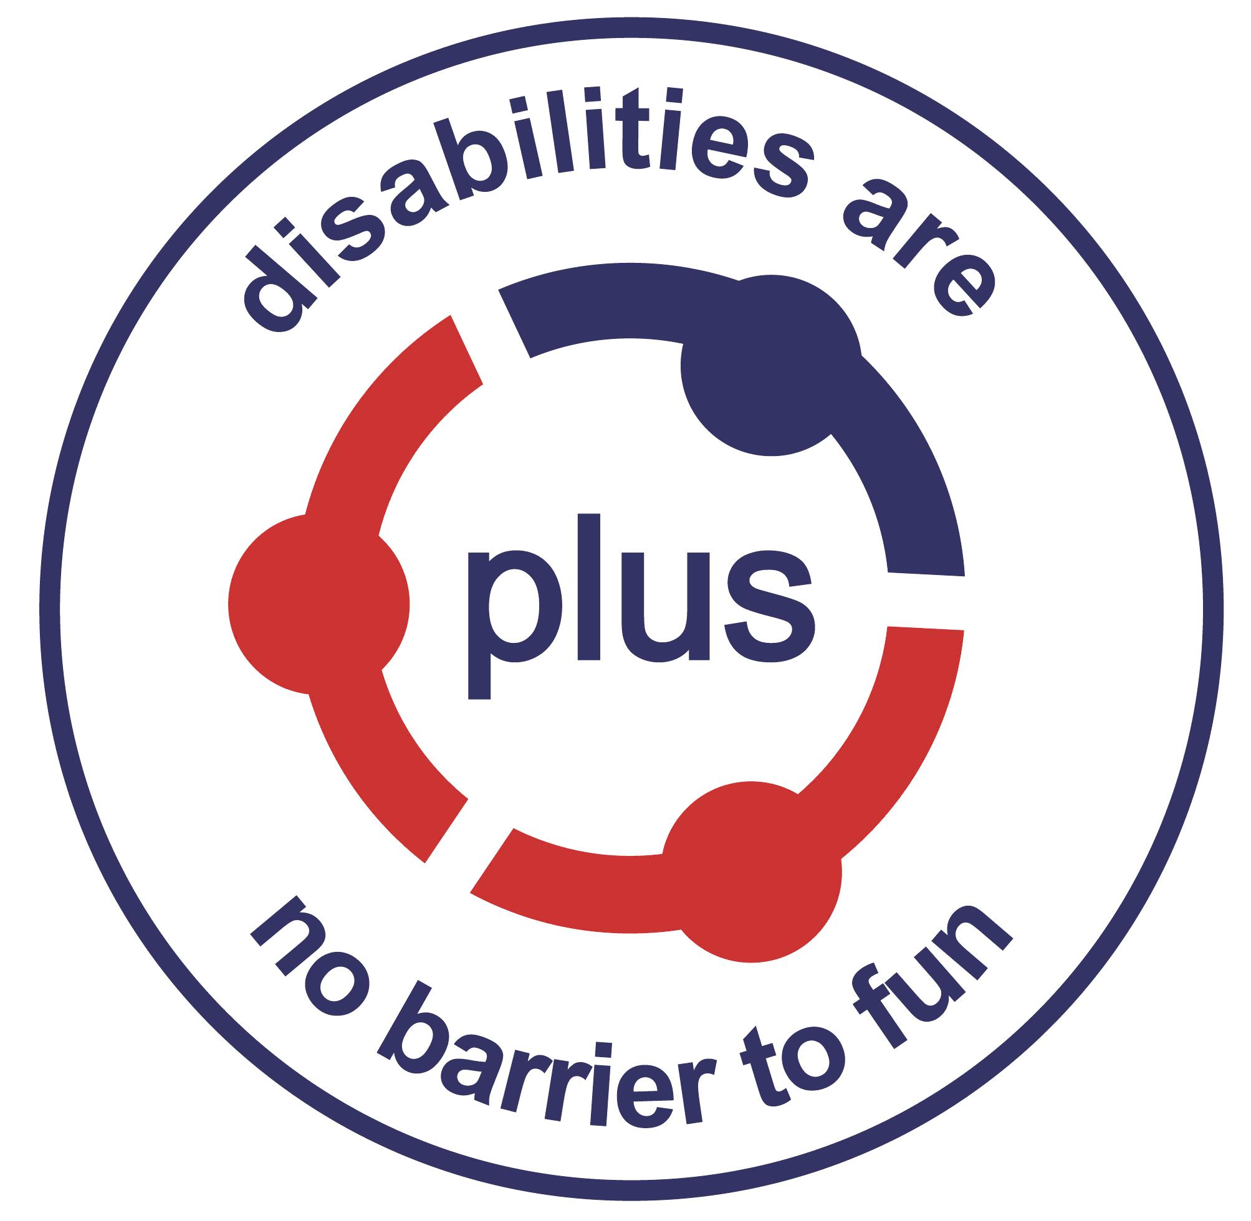
Notes for Applicants for the post of
Project Coordinator – 1:1 Support

Thank you for your interest in this post.

The Organisation
PLUS has worked with children and young people with disabilities and their families for over thirty years and continues to grow and develop. PLUS provides individualised support and opportunities for service users to get out and have fun with people of their own age. This also gives parents and carers some time for themselves. It is a registered Charity, Company Limited by Guarantee and is registered with the Care Inspectorate. Further information about PLUS is available on our website - www.plusforthvalley.org.uk or by visiting our Facebook page at PLUS88.

The Vacancy
Following a change in funding and a colleague moving to a new opportunity, we are looking to recruit a 2 year fixed term Project Coordinator position, which will be leading with our 1:1 support service. This service supports children and adults across the wider Forth Valley area, in a combination of home and community based support, on a 1:1 basis, but also bringing small groups together to support some shared outcomes.

This post is one of six Project Coordinators (part time and full time) within the charity, which allows for opportunities for peer support and development. These positions are guided by 2 Managers, with support from the Operations Manager and CEO. As a close-knit team, we encourage independence within roles and opportunities for staff to make their mark – whilst providing support and guidance along the way.

Like many organisations, we have adopted a hybrid approach to our work, however we would be looking for this post to be office based for a minimum of 3 days per week. It has been our experience that relationships are much stronger when our team, young people and families are able to meet in person and we wish to continue to promote the strengthening of our team, particularly when welcoming a new member of staff.

Priorities
This post offers an exciting opportunity to develop and lead a project, primarily providing support to children, young people and adults in Stirling. The role will focus on providing a high level of consistency for the children and families accessing support. Small teams of staff will support individual packages of care with effective communication being critical in ensuring the young person, their family and their team of staff are all in alignment.

Services will be designed in a bespoke manner, combining 1:1 and group support, in the home and wider community to enrich the lives of the people we support. Maintaining current friendships and developing new friendships is key for so many young people. Now we have moved away from most covid restrictions, we are keen to see progression here in terms of opportunities offered, reengaging with clubs and groups that the young people previously attended.

Outcome development and progression will be essential to support ongoing success and value of the events, including the young people and their families in the planning and evaluation phases. This will include working alongside peers within the office to ensure we can maximise opportunities available.

This role would suit a creative, flexible and self-motivated individual who can see how all the smaller parts join to make the bigger picture. A natural problem solver who is a fast learner and a skilled communicator will flourish in this role. Working as part of a small but committed, enthusiastic team, there are regular opportunities to be able to influence and develop the ongoing quality assurance and strategic development of the organisation.

*Please note there may be a chance that the funding for this post is extended beyond the fixed term period.

The Post
A job description and a person specification are attached.

This position will be full time for 35 hours per week and may include some evening and weekend work, for example staff meetings, training or recruitment. Out of office hours will always be planned with notice. This position will be fixed term for 2 years from the start of the contract, with high potential for extension.

The post holder will lead with the implementation of the 1:1 project, ensuring that staff have the relevant training and knowledge to support the young people they are matched with. Regularly liaising with staff and families will ensure smooth communication and supporting staff to focus on improving the outcomes for young people in a person centred way will lead to success.

The post holder will have supervision responsibilities in relation to the sessional staff involved with the project, supporting their recruitment and liaising with colleagues regarding training and development.

Full time staff (35 hours per week) are entitled to a total of 34 days annual leave including all public holidays (rising to 39 after 5 years). This would be available on a pro rata basis. There is a pension scheme (NEST) which offers an employer’s contribution of 3% of salary. On call also results in additional daily payments for staff.

The appointment is subject to a probationary period with a review at 3 and 6 months.

Applications
The closing date for applications has been extended to Friday 26th August, 3pm. Candidates who will be invited to interview will be contacted on this date.

Interviews
The interview will take place over 2 stages:

Interview 1: Tuesday 30th August, Time TBC (this will be dependent on the number of candidates being interviewed).
This will be a more traditional interview format. Having already met some of the panel, we find candidates are able to settle more quickly into the interview. There will be a short element of this interview which will be practical in nature (IT based) and you will be guided through this on your arrival. There will be one question we ask you to prepare a short response to in advance of the interview, which helps to give us some insight to your experiences. The rest of the questions will be shared with you on the day of the interview. We will confirm who will be on the interview panel once we confirm your interview time.

Interview 2: Thursday 1st September, 10.30am-12pm
This will be a group interview and you will be invited to meet with some of the young people and their support workers as well as the other candidates. There will be some planned activities taking place and some opportunities for questions to be asked. The purpose of this interview is to give you some insight to PLUS, help you to have an overview of the type of support we provide and for us to meet each other in a more informal basis. We often find this can reduce the nerves to allow candidate to shine.

Further Information
Applications must be submitted on the form provided and any additional sheets as necessary. Please do not send a CV. Applications sent by email will be acknowledged. If you apply by post and wish your application form acknowledged, please send a stamped addressed envelope.

For further information, either to discuss the role in advance of applying or to query anything in relation to the interview, please do not hesitate to contact Susan Fullerton, Chief Executive Officer on 01786 450086, or by email susan@plusforthvalley.org.uk

