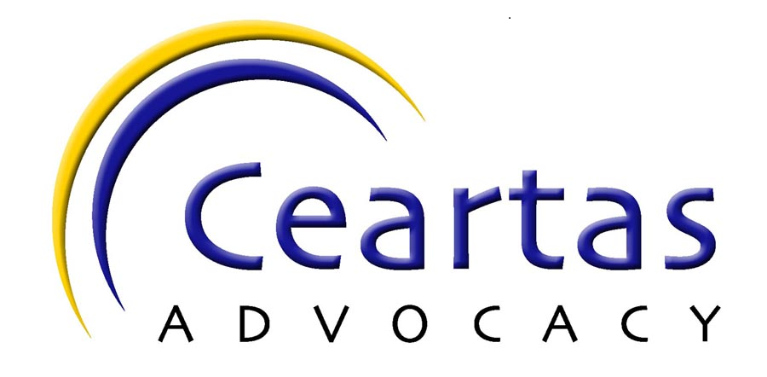

Dear Applicant,

Many thanks for your interest in this position at Ceartas. I enclose an application pack which should include:

- Job description
- Person specification
- Application Form
- Equal Opportunities Monitoring Form

Completed application forms should be returned by 12 noon Monday 12TH Sept 2022 to

Ceartas
Suites 5-7 McGregor House
10 Donaldson Crescent
Kirkintilloch
Glasgow G66 1XF

Or

info@ceartas.org.uk

Unfortunately only candidates short listed for an interview will be contacted.

Many thanks for your interest

Sharon Bairden
Chief Officer

