

Role Profile – Finance Administrator

Reports To:
Finance Manager

Role Purpose:
The Finance Administrator is responsible for maintaining day-to-day financial processing, accounting and administrative services in order to meet the requirements of the finance function within Head Office at Sight Scotland.
You will also be working closely with the Finance Manager and others to ensure the smooth implementation of a new financial accounting system.
All roles within Sight Scotland and Sight Scotland Veterans are expected to work to our values and Our Ways of Working framework:
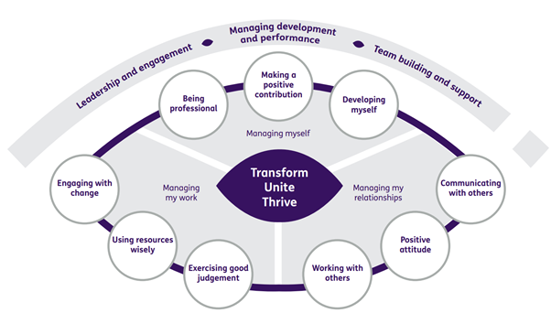

Our Ways of Working – Managing my Work
The Finance Administrator is responsible for the cash book / treasury functions within Sight Scotland and Sight Scotland Veterans and assists the Payroll Administrator with the smooth running of the payroll and pension functions.

Key tasks
- Monitoring of bank accounts and ensuring cash book is kept up to date
- Daily bank reconciliations
- Ensuring that there are sufficient funds available to meet ongoing commitments
- Administration of petty cash float and processing regular petty cash claims from Sight Scotland’s services
- Processing payments as required
- Receiving payments and ensuring correct banking of receipts on a daily basis
- Making payments through Sight Scotland’s Corporate Internet banking system
- Inputting information through the cash book / accounting system
- Processing monthly credit card statements
- Arranging foreign currency transactions
- Assisting the Payroll Administrator in the processing of information for the monthly salary and pensions payments
- Administration of mail and franking of outgoing mail
- Assisting with the implementation of Sight Scotland’s new Finance system

Any other duties as required by the Finance Manager.

Our Ways of Working – Managing Myself and Managing my Relationships

To do this role, you will:

- Have had good experience of working in a finance team
- Be numerate and accurate
- Be self-reliant and able to work independently with effective time management skills
- Have effective communication skills
- Be able to demonstrate strong planning and organisational skills, attention to detail
- Be able to respond positively to a variety of situations and people to meet changing priorities

It would be desirable for this role if you have:

- Experience of working in the non-profit sector

On a day-to-day basis you will work with different people and teams, these could be:
- Colleagues
- Other Sight Scotland services
- Senior Staff
- External stakeholders

Requirements of this role are:
- You are a member of the PVG scheme (paid for by Sight Scotland)
- You will have a 6-month probation period
- That you participate in all staff training and development
- Ability to build positive professional relationships at all levels
- You will wear the appropriate PPE in accordance with current guidance for the role
- You will follow Sight Scotland’s guidance, policies and procedures relating to your own health and safety and that of colleagues and service users at all times
- You will uphold the principles of Sight Scotland’s Dignity at Work and Equal Opportunities policies at all times, working in a way which supports an inclusive work environment that is respectful of differences.

What we can offer you:
- Generous annual leave entitlement
- Generous pension scheme
- Access to learning and development opportunities
- Employee Perks through the Employee Assistance Programme
- And many more, please visit our website for more information
This job profile is not exhaustive. The duties of the post holder may be reviewed from time to time and the employee may be called upon to work in other locations within Sight Scotland.

