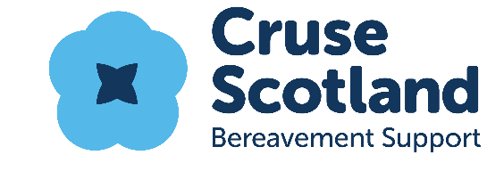
Job Description

Job Title: | Step by Step Friendship Groups Co-ordinator
Location: | Various locations across Kingdom of Fife
Reporting to: | East Area Manager
Hours: | 21 hours per week
Salary: | £14,640 (pro rata £24,400) plus 6% contribution to pension

Purpose and Aim of the Role:
To co-ordinate the Step by Step friendship groupwork programme, by ensuring effective delivery and facilitation of 6 fortnightly support groups across Fife (located in Glenrothes, Kirkcaldy, Dunfermline, Methil and St Andrews/Cupar) as outlined in Cruse Scotland strategy and Implementation plan. The project allows participants the opportunity to form social and friendship networks which will in turn help with their wellbeing and combat factors such as loneliness and isolation.

Profile:
The Step by Step Co-ordinator will have excellent communication skills, and engage effectively with a wide range of enquiries from bereaved people. The post holder will work with Cruse Scotland volunteers, staff and partner agencies.

Key Functions and Responsibilities:

Day to day management of the Step by Step project, working closely with the East Area Manager

Management of 6 friendship groups within the geographical localities of Fife, this includes:
  - One walking group – various locations in Fife
  - One group which is led and facilitated by a colleague
  - One new group yet to be established in Cupar/St Andrews
- Working directly with bereaved people and clients, including those that are interested in becoming a group member, as well as existing group members
- A good basic level of fitness is required for leading walking groups
- The candidate should also be able to risk assess new walking routes ahead of planned activities.
- Responsibility for ensuring delivery of agreed actions that arise out of each group meeting and activity
- Ensuring adequate information is kept and answering questions and requests in relation to the Step by Step group.
- Introduce and maintain suitable evaluation measures for social group support
- Participation in the recruitment, training and development of volunteers involved in the Step by Step project.

Establish and maintain effective relationships with local and partner agencies to promote Step by Step across Fife
- Develop supportive pathways for members to exit groups to mitigate risk of dependency
- Ensuring the timeous collection and input of volunteer and client data and ensuring that client documentation is issued in line with policy timescales
- Carry out any other duty as reasonably required by the Area Manager, commensurate with the post. This may include duties for which the post holder has the necessary experience and/or training.
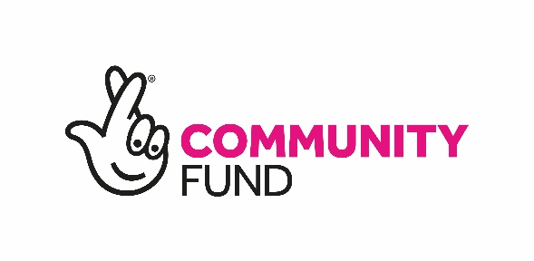

This post is funded by the National Lottery Community Fund to 31st May 2023 and to be extended pending future funding being secured
Person Specification and Profile

Skills and Qualities | Essential | Desirable
Skilled use of Microsoft Office and Outlook
Excellent organisational skills
Competent report writing skills
Excellent communication skills with the ability to adapt those to suit particular situations
Excellent interpersonal skills showing warmth and understanding
Ability to problem solve
Ability to effectively manage time and priorities workload
Ability to meet deadlines
Excellent listening skills
Good level of fitness
Experience
Experience of working with vulnerable people
Experience of setting up and facilitating support groups
Experience of working with volunteers
Experience of community development
Group walk leader experience
Experience of risk assessing
Qualifications
Community Development Qualification
Educated to Degree or Diploma level or equivalent
Willingness to complete “Paths for All” walk leader training or have gained this qualification
Personal Qualities
Of a calm disposition
Approachable
Team player
Able to use own initiative
Self-motivated
Ambassadorial
Punctual
Trustworthy
Efficient
Confidential

