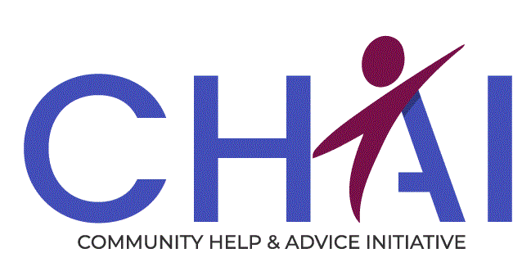

Job Description ADVICE WORKER – Recovery Hubs

Hours: 35.75 hours per week (full time)
Salary Range: £23,785 - £25,476 per annum

Background information
The Advice Worker in this role will provide income maximisation through benefit and debt advice and casework to people working with the substance Recovery Hubs in Edinburgh. The Recovery Hubs are a one-stop shop service offering a full range of drug and alcohol treatments and supports provided by the NHS, social work staff and the voluntary sector.
The model of provision will typically involve a half-day of direct or telephone client contact, followed up with a further half-day casework.
The post requires someone with an understanding of substance misuse issues, excellent people skills, experience of providing income maximisation through benefits and debt advice. The ability to research solutions and a desire to assist people to resolve issues are required as well as excellent administrative skills and case management. CHAI has excellent training to keep you up to date with advice work, but we do require some knowledge and experience of benefit and debt advice work.
This post is funded until 31st March 2024 but may be subject to continued funding.

PURPOSE OF THE JOB
- To provide advice, information and representation to individuals who are actively engaged with the Recovery Hubs and are referred by a partner agency.
- To manage and maintain ongoing advice work.
- To assist in the promotion and development of advice services within the Recovery Hubs.
- Help to create better financial stability, which can reduce stress, and then people are more able to focus on better health and well-being outcomes, and engagement with recovery services.

RESPONSIBLE TO
- The Advice Worker will be primarily responsible to the Service Manager (Income Maximisation & Employability).

MAIN DUTIES
- To provide advice and information and – when required – tribunal representation to people working with the Recovery Hubs.
- To develop and maintain positive relationships between CHAI and the partner organisations within the Recovery Hubs such as Health Care professionals, social workers, and support workers.
- To provide or contribute to training or briefing sessions to help other professionals understand the welfare system and how they can support individuals with this.
- To facilitate referrals to other appropriate community services for project clients, as required.
- To keep up-to-date and accurate records using the project case management system to record and report on work undertaken.
- To maintain knowledge of changes and developments within welfare benefits and debt legislation and issues.
- To co-operate with other members of staff (both internal and external) in the smooth running of the service.
- To prepare regular reports to the Service Manager and project partners, as required.
- To carry out other reasonable duties deemed necessary

Essential | Desirable
Experience | Experience
- Experience of providing generic advice to members of the public | - Minimum 12 months experience of working in a setting where advice and information is provided to service users  - Experience of working with drug and alcohol services
Qualification/Training | Qualification/Training
- Relevant qualification at SVQ level 3 – or more – in a relevant discipline e.g., Law, social science etc | - Vulnerable Adult Awareness
Knowledge and Skills | Knowledge and Skills
- Confident understanding of the welfare system and income maximisation principals  - Excellent communication and networking skills.  - Ability to work as part of a team but can work on own initiative  - Competent ICT Skills  - Ability to set and meet targets  - Ability to follow procedures and processes | - Advocacy skills  - Experience of representing people in formal settings  - Knowledge of issues relating to addiction  - Experience of being a welfare rights or money adviser  - Experience of using a case management system e.g., Advice Pro
Disposition | Disposition
- Understand of the needs of people on low income and with additional needs  - Commitment to client centred approach  - Desire to help people out of hardship  - Pro-active approach to identifying client needs and accommodating them.  - Holds positive attitudes towards clients | - Flexible approach to the working environment  - Understanding the barriers for people with substance misuse issues
Other
- Will be required to obtain a Protection of Vulnerable Groups Scheme Record Disclosure

