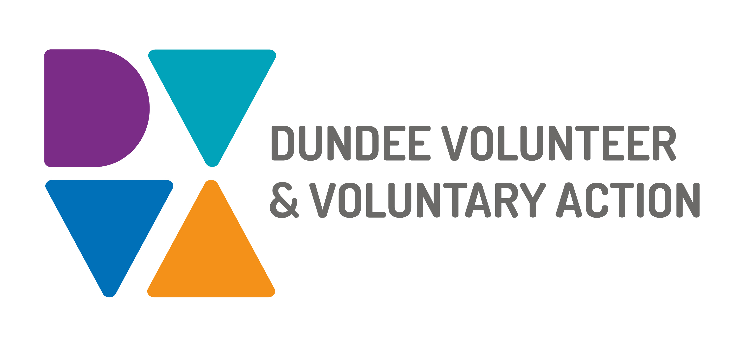
Job Description and
Person Specification

POST TITLE: Mental Health Networking Co-ordinator

DURATION: Permanent, subject to an initial 6 months probationary period

HOURS OF WORK: 20 hours per week, to be worked in accordance with DVVA Conditions of Service

SALARY: Grade 4: £25,979 - £28,866 (pro-rata)

PURPOSE OF POST: To facilitate and support third sector involvement in planning, delivering, and evaluating mental health and wellbeing services and supports for people living in Dundee. To ensure third sector voices are heard in strategic planning and commissioning arenas relevant to the mental health and wellbeing needs of citizens of Dundee. To support partnership working and collaboration, using co-production techniques to maximize resources available to communities, so that people achieve best possible mental health and wellbeing outcomes.

MAIN DUTIES:

Third sector engagement

- Establish, develop, and sustain productive working relationships with third sector and other partners across health and social care in Dundee.

- Support third sector partners to identify and articulate their needs, issues, priorities, strengths, and impacts.

Third Sector Mental Health and Wellbeing Forum

- Support, facilitate, and develop the Third Sector Mental Health and Wellbeing Forum in keeping with Terms of Reference agreed with members.

- Work alongside others to strengthen the third sector within the Health and Social Care Partnership, growing capacity and attracting investment.

- Collaborate with others to develop and maintain an accessible directory of community based Mental Health and Wellbeing support for local people.

Strategic partnerships

- Promote, advocate for, and facilitate active third sector involvement in strategic and operational partnerships responding to local mental health, wellbeing, and suicide prevention needs.

- Ensure third sector representation at strategic levels, so that the views and interests of the third sector shape priorities, direction, work plans and activities which strengthen mental health, wellbeing, and suicide prevention across the city.

Contribute to developing and delivering the Mental Health and Substance Use Team Plan

- Provide line-management support to staff assigned.

- Monitor, report, and evaluate the work undertaken, capturing its impact on the third sector, communities, and individuals.

- Use IT systems provided for recording and communication purposes.

- Maintain accurate records of attendances, outputs and outcomes to evidence work undertaken.

- Actively and constructively participate in team meetings and activities.

- Contribute to shared team initiatives as assigned.

- Work with team colleagues to ensure the plan and its delivery reflects the needs of individuals, organisations, and communities.

- Strive to maintain good practice in co-production.

OTHER DUTIES
The job description is a broad picture of the post at the date of preparation. It is not an exhaustive list of all possible duties as it is recognised that jobs change over time. Should the duties change radically then the post and grading will be reviewed.

CONDITIONS OF SERVICE
- These are set out in the organisation’s staff handbook.
- All staff meeting the qualifying criteria may join a defined contribution pension scheme provided by TPT Retirement Solutions.
- The organisation has an equal opportunities policy and seeks to be an equal opportunities employer.

ANNUAL LEAVE: 21 days per annum on appointment increasing each year by 1 day to a maximum of 25 days, plus 6 public holidays, plus 5 days Christmas closedown. Pro-rata for part-time staff.

LOCATION: Our main office is based in Dundee city centre and we also have community hubs in Lochee and Whitfield. There may be the opportunity for hybrid working depending on role and duties.

TRAINING: Staff may make application to pursue appropriate training.

JOB DESCRIPTIONS are reviewed from time to time.

Person Specification

Mental Health Networking Co-ordinator

 | Essential | Desirable

Professional/Educational Qualifications
Qualified to degree level or equivalent or successful track record of working with communities. | Yes
Qualified in Community Learning and Development |  | Yes
Knowledge and Experience
Establishing and maintaining effective working relationships in a diverse field. | Yes
Role of the third sector in health and social care | Yes
Project management and delivery | Yes
Partnership working | Yes
Managing people |  | Yes

Skills and abilities
Excellent communication skills, both oral and written | Yes
Excellent organisational skills with the ability to handle multiple tasks simultaneously | Yes
Strong interpersonal and teamwork skills | Yes
Strong leadership skills | Yes
Innovation and creative problem solving | Yes
IT skills, including in the use of Microsoft Office | Yes

Personal Qualities
Self-motivated and enthusiastic | Yes
Flexible approach and reliable in meeting deadlines | Yes
Strong sense of ethics | Yes

Additional Job-Related requirements
Basic disclosure check | Yes
Flexible working which may include evening and occasional weekend work | Yes
Ability to move around town easily and efficiently | Yes

