Person Specification: Support worker

 | Essential | Desirable
Knowledge
Knowledge of the causes and effects of domestic  abuse and an understanding of a feminist approach to domestic abuse | E
Knowledge & understanding of the issues and  support needs of children & young people who are experiencing domestic abuse and their mothers / carers | E
Knowledge of adult & child protection procedures |  | D
Knowledge of child development |  | D
Knowledge of the issues, policies and legislation within Scotland affecting women who experience domestic abuse |  | D
Knowledge of Housing Support and Welfare system |  | D
Knowledge of Children’s Hearing systems |  | D
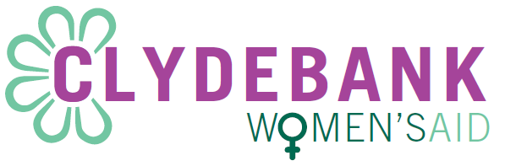

Experience
Experience of providing support to and working with women experiencing domestic abuse |  | D
Experience of working with programmes and materials that support WCYPEDA |  | D
Experience of developing and facilitating one to ones  and group work with women, children & young people |  | D
Experience of interagency work when providing support to WCYPEDA |  | D
Experience of child protection work |  | D

Abilities – skills and aptitudes
Able to work in ways that engender a trusting relationship with women, children and young people | E
Able to work with women, children and young people to identify their needs and support in fulfilling these | E
Able to engage with and develop relationships with women, children & young people within professional boundaries | E
Able to communicate effectively both orally and in writing | E
Able to work with confidential material appropriately | E
Able to produce written reports as required | E
Able to work with women, children and young people to identify their needs and support in fulfilling these | E
Able to work on own initiative and as part of a feminist collective | E
Able to maintain accurate and up to date records of work | E
Able to build and maintain good relationships with external agencies, practitioners, partners and other collective managers | E
Ability to maintain up to date information on legal, housing and welfare relevant to domestic abuse | E
To work collectively in producing statistical information and other reports on work done with women to meet the requirements of funders and the collective | E
Adequate use of Microsoft packages | E

Requirements
Commitment to promoting women, children and young people’s rights | E
Commitment to feminism and working within a feminist management structure | E
Commitment to working in an inclusive and anti-oppressive manner | E
Commitment to maintaining and updating a range of support materials for WCYPEDA | E
Willingness to undertake appropriate and relevant training | E
Commitment to working as part of a feminist collective in fulfilling collective responsibilities | E
Ability to work flexibly taking into consideration the ages of children and young people. | E
Driving license with the use of own car |  | D

