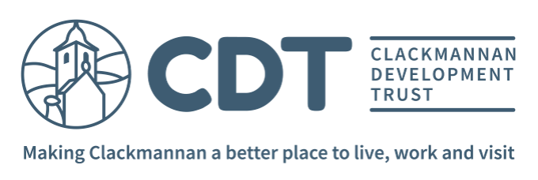

Media and Communication Officer

Job Description

Job Title Media and Communication Officer

Salary 20 – 24K (pro rata) dependent on experience

Reports to Community Development Manager

Hours 16hrs per week over 2 – 3 days (days to be agreed which may include occasional evening and weekend working)

Location Clackmannan Development Trust, 1 Main Street, Clackmannan (flexible working available with a mix of working from home and office based)

Brief Purpose of the Post

Clackmannan Development Trust is a local charity working to make Clackmannan a better place to live, work and visit. The Media and Communication Officer’s role will be to develop and apply a range of traditional and digital communication tools in order to support and promote the Trust and its activities.

Main Duties and Responsibilities

Plan, lead, develop and review the Trust’s Engagement and Communication plan.

Produce the Trust’s communications including community website, bi-annual newsletter, e-bulletins and Annual Report.

Write press releases when required.

Develop and expand on social media and traditional media opportunities.

Engage with and increase the membership of the Trust.

Work in an inclusive and engaging way with local people to involve and support them in the Trust’s activities.

Support working groups such as Events and Caring and Connected Clackmannan by helping with promotion and building awareness through communications.

Use your initiative alongside the team to support new ideas to develop into projects.

Produce a monthly progress report to line manager and Board, in addition to contributing to quarterly reports for funders measuring the overall impact of the programme.

Knowledge, Skills Experience and Qualifications

Essential

- Educated to HNC level or equivalent experience in IT/Comms/Marketing or Community Development.
- Proficient in using Mail Chimp and Social Media Platforms
- Excellent interpersonal and communication skills including the ability to effectively liaise with Board members and other stakeholders.
- Experience of working with volunteers and/or third sector organisations.
- Experience of working independently and of balancing time between multiple projects and responsibilities.
- Have a positive attitude and the ability to motivate others.
- Able to work flexible hours (including some evening and weekend working)

Desirable

- Knowledge and experience of community development
- Knowledge and experience of partnership working
- Knowledge and experience of Wordpress
- Experience of planning/organising events
- Experience of working in the Third Sector

