
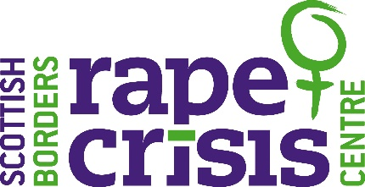
Scottish Borders Rape Crisis (SBRCC) is a company limited by guarantee, registered with OSCR and registered in Scotland as company number SC?????? and charity number ????.
Trustee
Recruitment Pack
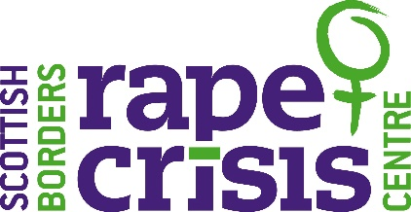

September 2022

Dear Applicant,

Vacancy: Trustee

Thank you very much for your interest in volunteering with Scottish Borders Rape Crisis Centre (SBRCC).

Please find enclosed:

- Would you like to make a difference?
- Background & Services
- Our Vision, Mission & Values
- Strategic Priorities
- Role description
- Person specification
- Application form

Further information about our organisation’s work is available on our website, www.scottishbordersrapecrisis.org.uk

Closing date: Monday 31st October 2022 at 6pm . However, we are always keen to hear from women who are interested in this role and the work of SBRCC.

Please note that we do not accept CVs. The full application form should be completed and emailed to recruitment@sbrcc.org.uk

We look forward to receiving your application. In the meantime, if you have any queries, please do not hesitate to contact me by email at dorothy@sbrcc.org.uk

Best wishes,


Dorothy West
SBRCC Chair

Would you like to make a difference?

Our vision at SBRCC is an end to violence, in all its forms, against women and girls. Access to early high-quality support when survivors need it can be life-changing. We believe that women’s rights should be protected and their voices heard.
This is reflected in everything we do at SBRCC. By working together with, and listening to, adult and young survivors, communities and by influencing public policy and opinion, we are helping to transform the lives of survivors of sexual violence recovering from the sexual trauma they have suffered.
Our Board is committed to our vision and values and members bring a wide range of skills, knowledge, expertise, objectivity, insight and strategic thought to the table. They involve themselves in our work and steer our organisation forward. We are looking for Trustees who can help us expand the range of skills around the table. We are particularly looking for expertise in the areas of marketing, communications, social media, finance/accounting, HR or legal knowledge, community and corporate fundraising, community engagement and experience of working in the voluntary sector.
We are also keen to hear from applicants with strong business links. We welcome applicants from women across Scotland. At the moment meetings are via Zoom, prior to the pandemic meetings were held in Galashiels however, ongoing virtual attendance is possible.
The positions are voluntary; however reasonable travel expenses are met. The Board currently meets four times a year, optional development meetings are also scheduled four times a year.

Only women need apply under Schedule 9, Part 1 of the Equality Act 2010

Background

SBRCC was established in 2010 and we are an all-women led organisation, believing that this allows us to offer the most appropriate and secure support to women and young people affected by rape or any other form of sexual violence. We acknowledge that males experience rape and sexual violence however, we also know that women and girls are disproportionately affected by gender based violence. That sexual violence and domestic abuse is overwhelming committed against women and girls by males, and it is to women and girls that primarily our efforts are directed. Our specialist young person’s support service - Unity. Launched in October 2019, supporting all young people of any gender/gender identity and we have received many referrals since its launch. The vast majority of referrals have been received for young women and girls, we also receive referrals for young men, boys and other young people who identify as transgender or non-binary.

We are members of Rape Crisis Scotland and work to National Service Standards.

We work to empower survivors, supporting them to find and make their own choices. We offer them information and support but we believe that they are the experts in their own lives. This means that we will not tell or advise them what to do.

We respect the courage and strength it takes survivors to speak out about their experience of sexual violence, regardless of whether it has been a recent assault or whether it happened a long time ago.

Our Services

The principal objective of the SBRCC is to provide high-quality, free and confidential support services to survivors of sexual violence. Our services are LGBT inclusive.


Emotional and practical, support, information and advocacy for self-identifying female survivors aged 18+, who have experienced any form of sexual violence at any time in their lives.


Emotional and practical, support, information and advocacy for all young people of any gender/gender identity aged between 12 and 18, who have experienced any form of sexual violence at any time in their lives.

Adult male survivors can contact SBRCC and will be offered initial telephone support, signposting and support to gain access to other support services.

What do we offer?
- One to one support, offered at the centre or in safe outreach venues across the Borders, telephone, text, email and Zoom or MS Teams support can also be offered.
- Comprehensive Resource Model (CRM) - Trauma treatment for a small number of survivors who have symptoms of Post Traumatic Stress Disorder (PTSD) or Complex Post Traumatic Stress Disorder (CPTSD) who have been through one to one support.
- Group Work (Butterfly Project) this is 4-week self-esteem and confidence building course. We also provide short courses on topics such as managing anxiety, becoming more assertive, self-care and wellbeing, relationships and intimacy and our quarterly Self-Care Crew group.
- We also have a service user involvement group - kaleidoscope. Members have been instrumental in recent development such as the branding of our adult support service.
- Complementary therapies and meditation classes for survivors engaged in support or on the waiting list.
- Support & Advocacy for survivors engaged or considering engaging with the criminal justice process.
- Sexual Violence Prevention work aimed at young people between the ages of 11-25.
- No Excuses! Consent & Healthy Relationship Workshops provides training to youth workers to deliver workshops to the young people they work with.

Covid -19 Response

For most of 2020/21 we have provided our services remotely and digitally due to the pandemic. We quickly set up systems and process to transition to this way of working and to ensure the continuation of support to the survivors who access our services.
This was a challenging time for the survivors we support and for our team but we are immensely proud of how well we have adapted and have continued to provide our services throughout. Survivors have told us that although digital support will never replace in person support, it has been valuable and for some it has been their lifeline.

We have offered centre based in person support from October 2020 and resumed outreach support in September 2021. This was initially offered to those who had tried digital support and this was not effective for them or there were risks in providing support digitally, this may have been a risk to their safety or a risk to their emotional wellbeing. We are now working in a hybrid way with staff working at least one day a week in the centre.

Communities & Partnerships

- Training for other external agencies and in-house training.
- Community engagement activities and fundraising
- Campaigning & Events
- Active participant in partnership working

We are the only dedicated, specialist service in the Scottish Borders providing support to survivors who have experienced any form of sexual violence. Our services are continuously monitored and evaluated to ensure they meet the needs of survivors. We aim to promote awareness and understanding of the causes and prevention of sexual violence and the mitigation of its effects.

Survivor Feedback

Sunrise

I felt understood and supported when talking to my support worker.

Since having support, I am kinder to myself now and look after myself better. I’m also in a better state of mind towards what happened.

I liked that there was no pressure to talk about certain things and I could talk freely about things that were bothering me.

Since having support, I have realised that your behaviours aren’t always your fault but the effects of what the violence has done to you.

The team at SBRCC are pretty amazing!

I wasn’t sure what to expect but they have really helped me so far and been a big support for me.

Since having support, I feel more relaxed and I have had less panic attacks.

Being able to talk about everything I was feeling and it being accepted and believed. I never felt dismissed.

Unity

I enjoyed being able to talk about whatever I felt I needed to without feeling judged.

My support worker is so understanding and actually cares about what it is I have to say.

The sessions are better than I thought they would be – they’re not scary at all.

Since receiving support, I have been able to cope with my anger. I am now able to listen to people before me getting angry.

Kaleidoscope – (Service User Involvement Group)

When I first came to SBRCC/Sunrise, I was an anxiety ridden scruffy mess. I used to despise being female. Now, I'm further along my journey, am feeling more feminine, even glamourous now and again, and less anxious. Empowered. I still have further to go, but the path ahead is so much brighter! Thank you so much.

I love being involved, feel like I am giving something back, doing something for you as you have done something for me.

Being part of the group is empowering, energising. I like connecting with others. I have attended so many groups in the past which have made me feel worse but this is the one group that I love, its therapeutic.

Vision, Mission & Values

Our Vision
‘Our vision is an end to violence, in all its forms, against women and girls’.

Our Mission
Scottish Borders Rape Crisis Centre (SBRCC) aims to relieve the distress of self-identifying females over the age of 18, and survivors of all gender/gender identity aged between 12 and 18, in the Scottish Borders area, who have experienced sexual violence and to support their friends, family and non-offending partners through the provision of emotional and practical support, information and advocacy. We also aim to promote the understanding of the causes and prevention of sexual violence and the mitigation of its effects.

Values

Our Strategic Priorities 2021-2024

Over the last three years we have learned a lot from survivors, staff, volunteers and partners and this has informed our priorities for the next three years:

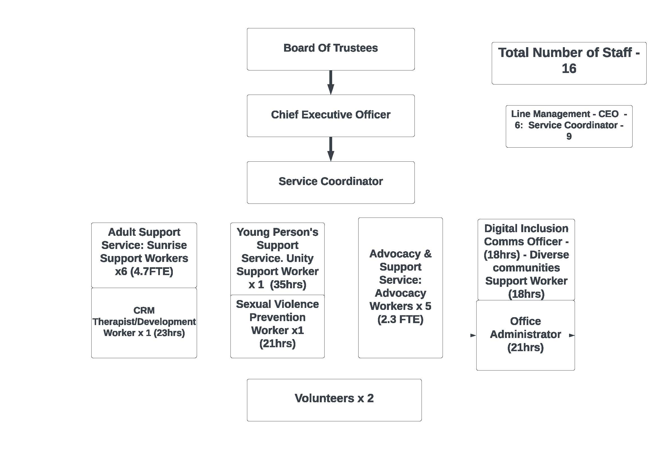
Role Description – Trustee
Summary
Scottish Borders Rape Crisis Centre (SBRCC) is a Scottish Charitable Incorporated Organisation (SCIO). The overriding duty of a trustee of SBRCC is to advance the purpose of the organisation. The effective delivery of the roles and responsibilities set out below with ensure that this duty is met.

Legal responsibilities:
As part of the Board of trustees you will:
- Ensure the proper administration of the SBRCC. That is SBRCC’s assets and resources are used only for its purposes and that SBRCC is run in accordance with its constitution, charity law and other applicable laws and regulations.
- Ensure that mechanisms are in place to safeguard the assets of SBRCC, including; money; physical assets; intellectual property, staff and reputation.
- Act reasonably and prudently in all matters relating to SBRCC.
- Accept ultimate responsibility for everything that SBRCC does.
- Avoid any conflict between your own personal interest and those of SBRCC.

Individually and as a member of the Board of Trustees
You will:
- Subscribe to the following principle: “Violence against women and girls, in any form, has no place in our vision for a safe, strong, successful Scotland. It damages health and wellbeing, limits freedom and potential, and is a violation of the most fundamental human rights.” (Equally Safe: Scotland’s strategy for eradicating violence against women and girls).
- Protect and promote the purpose, beliefs, values and achievements of SBRCC.
- Gain understanding of where SBRCC’s money comes from, its broad financial position, and the risks to which it may be subject.
- Ensure that effective monitoring and reporting systems are in place to provide the information required to enable trustees to discharge their responsibilities, particularly in respect of:
  - finance, property, and other material resources;
  - human resources; and
  - service development and delivery
- Participate in the development of SBRCC strategic Service Plan.
- Participate actively and effectively in the work and agenda of the Board of trustees.
- Effectively discharge any delegated task to achieve agreed outcomes and timescales.

To meet these responsibilities, you will at minimum:

- Attend and contribute to 4 Board meetings each year, except when prevented by unexpected illness or planned holidays, and other meetings as required.
- Read and respond to Board documents.
- Commit unreservedly to confidentiality.
- Undertake self-development in areas where you consider yourself to be less well informed.
- Develop and maintain good working relationships with other trustees, SBRCC employees and volunteers.
- Understand existing or potential conflicts of interest and how to deal with them.
- Consider undertaking and/or participating in discrete pieces of relevant work including working groups.
- Consider, over time, taking on an office-bearer role (currently the Chair), or membership of the Management Committee.
Term
Following a successful recruitment exercise trustees will be appointed by the Board of SBRCC for the period up to the next AGM. At the next AGM newly appointed trustees will be eligible for appointment by a ballot of the membership for a period of 3 years.

Trustee Code of Conduct and Engagement Agreement
The expectations of all trustees are set out in above named documents which trustees are required to sign at the time of appointment or reappointment. The expectations, roles and responsibilities are clearly set out in the documents which we shall ask you to sign and thereafter act in accordance with.

Person Specification – Trustee

Personal Qualities and Skills

- Share and endorse the vision and mission of SBRCC.
- Able to work effectively as part of a team. Able to relate to a wide range of people, without pre-conceptions.
- Able to commit to self-learning to develop the knowledge and understanding of the role of a trustee as well as the mission, values and organisation of SBRCC.
- Commitment to learning and working with others to develop and share understanding of the impact of sexual violence on all who experience it.
- Support the principle that local services led by women can help to reduce these effects by supporting survivors of sexual violence through a range of services.
- Recognition that men may also be survivors of sexual violence and should be offered sign-posting to appropriate support.
- Awareness of the diversity of the individuals and communities living within the Scottish Borders and the implications for the role, management and services of SBRCC.
- Recognise the importance of education and targeted promotion in preventing and reducing the incidence of sexual violence.
- Be able and willing to devote time to prepare for and attend meetings and to follow up matters arising from them.

Experience
The focus of this specification is on the qualities that people can bring to this role which does not require a specific level or type of employment background, or indeed any employment history.

However, because we would like to strengthen the range of skills and experience represented on the Board of Trustees, applications from women offering experience of the following would be welcome:

- Management of human resources, finance management, publicity and public relations.
- Fundraising
- Legal background
- Living with disabilities
- BAME and/or cultural minority heritage.

Only women need apply under Schedule 9, Part 1 of the Equality Act 2010

Application Form – Trustee

Section 1. Personal Information

Name (in full)

Address
(including postcode)

Mobile number

Daytime telephone number (if appropriate)

Email address

Section 2. Skills / Knowledge / Experience Overview – please tick those which apply to you. There is not an expectation that you will have all of these skills.

Feminist/Gendered Analysis of violence |  | Third sector knowledge
Board / Committee participation |  | Marketing
Accountancy / Financial |  | Media / PR
Fundraising |  | Organisational Development
Governance |  | Change Management
Human Resources |  | Policy Development
Information Technology |  | Risk Management
Campaigning |  | Health & Safety
Legal |  | Strategic Planning
Management Systems |  | Social Media
Website Development & Management |  | Training
Business Development |  | Audit / Quality
Partnership & Networking |  | Service User Participation
OTHER(S) – please list below

Section 3. Please tell us what interests you about the role of Trustee at SBRCC

Section 4. Experience, skills and knowledge - Please describe how your experience, skills and knowledge are relevant and would enable you to fulfil this role.

Section 5. Employment History – please list any relevant previous employment starting with the most recent.

From | To | Employer | Title and main duties | Reason for leaving

Professional Qualifications

Name of awarding body | Date awarded | Qualifications obtained, Membership of Professional Institution etc.

Training – Please provide details of any courses or training undertaken which is relevant to this post.

Course/Training | Provider(s)

Section 7. Referees – Please give details of two referees. One of your referees should be your current employer if you are employed, or your last employer if you are unemployed.

References will only be sought for successful candidates.

Reference 1
Name

Job Title

Address

Relationship to you

Telephone number

Email

Reference 2
Name

Job Title

Address

Relationship to you

Telephone number

Email

Declaration

Rehabilitation of Offenders – Do you have any criminal convictions other than those spent under the Rehabilitation of Offenders Act? | Yes/No

Disqualification

Section 69 of the Charities and Trustees Investment (Scotland) Act 2005 disqualifies the following from acting as charity trustees:

- Someone with an unspent conviction for dishonesty under the Act
- An undischarged bankrupt
- Someone who has been removed under either Scottish or English Law by the courts or by the charity commission from being a charity trustee
- A person disqualified from being a company director
- Someone who has granted a Protected trust Deed (PTD)

I declare that I am not disqualified from being a Charities Trustee or Company Director and that the information given on this application form is correct and complete.

Signed:

Print Name:

Date:

Please note all personal information will be kept and used in line with our Data Protection / GDPR policy. For more details please contact SBRCC directly.

Disability - Do you consider yourself to have a disability which we require to take account of to assist you in attending an interview or carrying out this role? | Yes/No

Please email your completed application form to recruitment@sbrcc.org.uk

Or post your completed application to:

Susie Stein
Chief Executive Officer

Scottish Borders Rape Crisis Centre
1A Wilderhaugh
Galashiels
TD1 1PW

