Candidate Information

Fundraising & Business Development Manager, Strategic Partnerships & Business Development

Salary: | Grade I: £37,004-£44,041
Hours: | 37.5 hours per week  This job is proposed to be full-time but we are happy to discuss working hours and patterns to suit individual circumstances.
Contract: | Permanent
Disclosure: | PVG Scheme membership is not required
Bases: | Edinburgh / Hybrid. Sustrans Hub in Edinburgh or Glasgow with the flexibility to work from home, or home-based within reasonable travelling distance from Edinburgh or Glasgow.
Travel: | There will be occasional visits to partner / client offices in sites across Scotland and UK as required, including Bristol to meet with the Fundraising and Supporter Engagement team. The post holder may also be expected to occasionally work on a flexible basis including some overnight stays and will be asked to travel as sustainably as possible.
 | A key part of being the Charity that makes it easier to walk and cycle is that most colleagues walk, wheel, cycle or use public transport for the majority of their work journeys. We support this with access to a Sustrans pool bicycle and National Standards Cycling Training.

Job / Project Specific Information
The purpose of this post is to deliver the fundraising and income generation strategy in Scotland. The post holder will work closely with colleagues to understand why funding is needed and grow and diversify our income through restricted & unrestricted sources. The post holder will ensure we have financial resources for sustainability and growth areas.
The post holder will work closely with the Head of Strategic Partnerships & Business Development and as part of the lead generation team that sits within that function in Scotland. To maximise opportunities across the UK and for fundraising support and guidance, the post holder will also work closely with the Sustrans UK Fundraising & Supporter Engagement function.
You will develop and lead one direct report: the Business Development & Fundraising Coordinator responsible for supporting funding diversification and income generation.
Specific Role
The post holder will work directly with the Head of Strategic Partnerships & Business Development, as part of the Lead Generation team who will identify projects/programmes for funding, a viable pipeline and implement plans to bring the pipeline to fruition through bids to statutory funders as well as trusts and foundations. The post holder will work collaboratively with our Project Pipeline Manager and Business Development & Fundraising Coordinator to identify and activate cross-programme opportunities (internal and external).
The post holder will be responsible for developing and implementing the Fundraising and Supporter Engagement Strategy in Scotland and delivering income generation pre-dominantly through approaches to trusts and foundations and extending UK wide campaigns to audiences in Scotland. The post holder will be expected to deliver unrestricted income, transformational gifts from trusts, foundations and other partners, capitalising on Sustrans assets such as the NCN or Paths for Everyone stream. Not all our income will be raised by the Fundraising & Business Development Manager. Some is derived from grant funding in which the Strategic Business Manager will lead.
Where this role sits in the Sustrans Scotland structure:

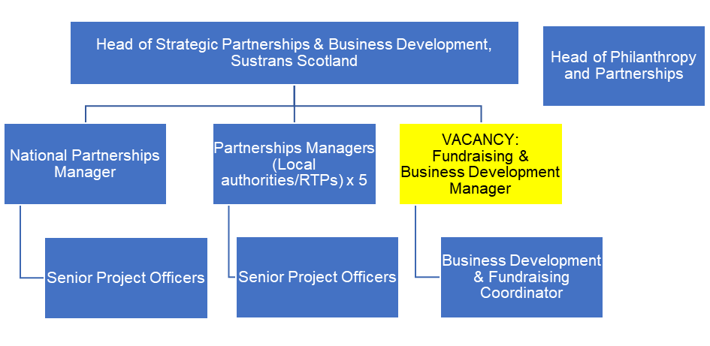
Job Description - About the Role

Overview
The purpose of this post is to lead on delivery of the fundraising and supporter engagement strategy in Scotland and develop the business in Scotland. The post holder will work to grow and diversify our income through restricted & unrestricted sources, primarily through trusts and foundations and extending UK wide campaigns to Scottish audiences. The post holder will ensure we have financial resources for sustainability and growth areas.
Where this role sits in the structure: | Reporting to the Head of Strategic Partnerships & Business Development, at Sustrans Scotland, the post holder will sit within the Strategic Partnerships & Business Development function. Internally, the post holder will work closely with the Strategic Partnerships & Business Development lead generatin team, the partnerships management team and the UK Fundraising & Supporter Engagement function. You will be Working collaboratively with other Heads of functions, Portfolio Director, and the Director for Scotland.  Externally the post holder will work with Strategic partners, public sector commissioners, charitable trusts and foundations, individual donors, corporates and other income sources deemed relevant.  You will have line management responsibility for the Business Development & Fundraising Coordinator post.

Key Responsibilities

Delivery of the below projects or services:
- Identify new business opportunities: generate business development ideas and innovations as relate to our services and qualify leads, prospects and funding.
- Deliver the fundraising and supporter engagement strategy in Scotland with a particular focus on diversifying the portfolio to maximise income from trusts/foundations and expanding UK wide fundraising campaigns to Scottish audiences.
- Lead, manage and develop the Fundraising and Business Development Coordinator to maximise opportunities and income.
- Maximise unrestricted and restricted income that facilitates the business development pipeline through compelling funding asks, great relationships (new and existing) and excellent stewardship.
- Maximise opportunities to drive impact at scale by supporting the development of and using Sustrans’ case for support.
- Ensure Sustrans Scotland has the financial resources to maintain and grow its services. You will lead on securing funding from public sector commissioners, charitable trusts and foundations, and other income sources deemed relevant.
- Work with key colleagues to develop propositions and budgets for funding proposals.
- Attend networking events and meetings with potential donors, grant makers and commissioners.
- Develop and manage budgets associated with income generation and fundraising.
- To ensure reporting to the Senior Leadership team in line with agreed deadlines, and agree financial working and reporting arrangements.
- To work with RMU to ensure that monitoring and evaluation of the programme is implemented to ensure that impact is measured and reported.
- Support the development and delivery of a single customer view across Sustrans

We don’t expect anyone to be an expert in all these areas and as long as you meet the person specification we can train you in any gaps.

Person Specification
The following criteria sets out the method by which the skills, knowledge and experience will be assessed against. Our website has a useful guide about how to make a great job application.

 | Application Form | Interview
Specific experience required
Relevant previous experience/ proven track record in fundraising and income generation
Experience of managing and developing staff
Proven track record of fundraising monitoring
Experience of leading relationships with funding bodies and trusts
Experience of managing restricted and unrestricted income
A proven track record in networking and partnership / client development to deliver impact
Experience of working directly with a business development function
Experience of successful working across organisations to ensure a corporate approach
Skills and Abilities
Exceptional influencing and negotiation skills : Ability to persuade and influence potential donors / funders
Good organisational skills (including time and budget management skills, Donor CRM and a methodical approach)
Strong communication skills (including presentation, written and verbal/interpersonal)
Ability to function on own initiative with limited supervision, prioritising own workload
Ability to multi-scan and link strategic thinking to day to day issues.
Ability to innovate: creative and agile
Specific knowledge required
Knowledge of the fundraising landscape in Scotland
Knowledge of relevant legislation, commissions and best practice relating to fundraising and income generation
IT literate (knowledge of word-processing, databases, spreadsheets packages, internet and website usage)

This document does not form part of the contract of employment but does outline our expectations.
If we need to amend this document in the future we will consult with the post holder before doing so.

Everyone at Sustrans

Our values guide us in everything we do:
- Including everyone
- Having the courage to question
- Acting local, thinking big
- Getting things done, together
- Always learning.

- Sustrans has clear health and safety policies and it is essential that all our colleagues follow these. Very often our teams come into contact with young people through schools work or community engagement so it is everyone’s responsibility at Sustrans to comply with our Safeguarding policies. Sustrans health and safety information will be shared with the newly recruited candidate during the induction process.

- One of our key strategic goals is to be a charity “for everyone”, building a more diverse and inclusive Sustrans. We recognise there is much more we can do to bring together diverse life experiences and voices to enable us to more fully understand, access and represent the communities we work in. Everyone at Sustrans should support this goal and follow our Equality, Diversity and Inclusion policies and procedures.

- Sustrans asks that all our employees develop their skills, knowledge and experience through training and personal development activities. Sustrans will support you with clear objectives and a supportive management culture - our teams tell us that one of the great things about working for Sustrans is the learning and knowledge sharing opportunities.

- It is very important that our colleagues are happy and able to work with IT systems - we use Microsoft programmes and other databases every day (we will train you on our bespoke systems).

- It is also important that everyone at Sustrans supports and follows with the charity’s guidance on branding/key messages and contributes towards raising Sustrans’ profile.

- Everyone at Sustrans is required to work their contracted hours and record their time – if extra hours are worked then we can take time off in lieu.

- We ask that everyone in Sustrans helps us to develop new opportunities for funded work and builds excellent relationships with our delivery partners and stakeholders.

- Two of our values are we get things done, together and we’re always learning. Senior leadership often requires their teams to get involved in activities that are outside of their job descriptions as we feel this is one of the ways you can learn on the job, develop new skills, make new contacts and progress your career with Sustrans.

