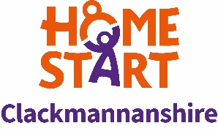

**EQUAL OPPORTUNITIES MONITORING FORM**

To ensure Home-Start Clackmannanshire’s implementation and development of its *Equality Fairness and Diversity Policy,* applicants are asked to complete the details below. This information, which will be used solely for monitoring purposes, will be treated as confidential. It will be separated on receipt of the application forms and before they are considered by the short-listing panel.

The basic information on these forms will be transferred to a summary sheet for the purpose of retaining overall statistical information. These completed individual forms will then be destroyed. The responses to these questions will not affect the success or otherwise of a job application in any way.

|  |  |  |  |  |
| --- | --- | --- | --- | --- |
| Application for the post of Groups Co-ordinator | | | | |
| Where did you see the post advertised? |  | | | |
| Date of Birth: | Male: | | Female: | |
| Religion |  | | | |
| How would you describe your ethnic origin? (please tick) | Asian Indian  Pakistani  Bangladeshi  Other Asian background  Black Caribbean  African  Other Black  Chinese or other ethnic group  Chinese  Any other ethnic group  Mixed Any mixed background  White British  Irish  Other White background | | |  |
| Are you registered as disabled at a job centre and a holder of a green card? (please tick) | Yes | No | | |
| Do you consider yourself to have a disability even though your disability isn’t registered? | Yes | No | | |