

Role Profile – Hub Co-ordinator

Reports to: Deputy Centre Manager

Role Purpose:

Our Activity Hubs provide innovative and person-centred services and support to veterans struggling with sight loss. The services aim to reduce isolation while improving independence and confidence to live well with a visual impairment now and in the future. The services offer veterans access to information, support, meaningful activity and social engagement in a welcoming environment.

You will provide leadership and operational co-ordination to the teams working within and from Sight Scotland Activity Hubs.

All roles within Sight Scotland and Sight Scotland Veterans are expected to work to our values and Our Ways of Working framework:

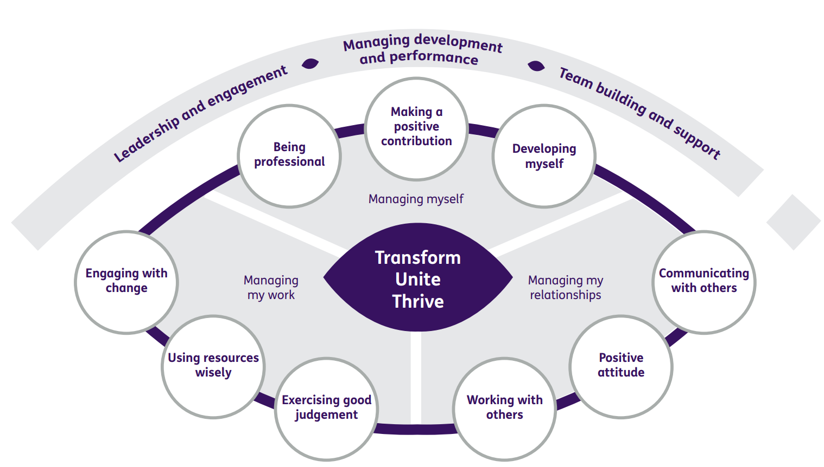

Our Ways of Working - Managing my Work
Main Responsibilities and accountabilities are that you will, alongside and in the absence of the Deputy Centre Manager

- Provide leadership and coordination to the teams working from Sight Scotland Veterans Activity Hubs
- Support person centred, asset based and outcome focused approaches to practice which are responsive to individual needs
- Support the continuous review of service provision and team performance to ensure best practice and quality services
- Support and encourage a culture of co-production within our hubs which ensures the veterans community have a large role in shaping service delivery
- Support in the creation and maintenance of sustainable partnerships that positively support service impact and allow for variety of service interventions
- Support the development of a volunteering community which will complement our staff teams and further enhance service delivery
- Ensure high quality supervision is regularly undertaken, and support and guidance are provided which strengthens skills, practice and knowledge and encourages a culture of staff development which maximises potential
- Act as a positive practice role model for all staff and volunteers across Sight Scotland Veterans through coaching, mentoring and modelling of practice
- Work with the leadership team to promote consistent approaches across both hubs
- Promote strong, sustainable links between the hubs and the local communities
- Be involved in the creation of relevant protocols and risk assessments and monitor adherence to these as well as relevant policies/procedures and guidelines within the services
- Work alongside the Deputy Centre Manager to ensure that the service is well managed and fully compliant with the SSSC, Health and Social Care Standards and Care Inspectorate
- Support the Deputy Centre Manager to ensure line management processes are maintained including recruitment, learning and development and absence monitoring
- Encourage and maintain clear channels of communication between veterans, staff teams and the Sight Scotland Veterans management team
- Maintain and develop positive working relationships with colleagues across Sight Scotland Veterans and our sister charity Sight Scotland
- Provide driving/escorting duty if/when required.

Our Ways of Working – Managing Myself and Managing my Relationships

To do this role, you will:

- Have SVQ 3 level or equivalent qualification in Health and Social Care/Social Sciences or have relevant experience of leading and managing services in a related field
- Have demonstrable experience of working with people with visual impairment or those with other disabilities, and/or their families
- Have demonstrable experience of mentoring, supervising and supporting staff and/or volunteers
- Have experience of outcome-focused assessment and of the principles of person-centred support
- Have experience of working within a co-productive environment with service users
- Have experience of working within a multi-disciplinary team/environment
- Be able to demonstrate knowledge of statutory and 3rd sector provision in respect of people with visual impairment
- Have experience of networking, partnership and multi-disciplinary working with a variety of other stakeholders
- Demonstrate excellent inter-personal and communication skills, including report writing and presentation skills
- Have the ability to inspire enthusiasm and motivation in others
- Be IT proficient and able to support staff and volunteers in this area.

