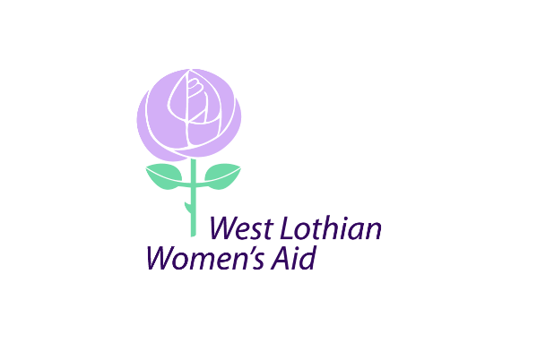
West Lothian Women’s Aid
92 Ivanhoe Rise, Dedridge
Livingston
EH54 6HZ
01506 461938
info@wlwa.org.uk

10/10/2022

Dear Applicant

Re: Staff Vacancy – part time outreach worker (20 hours per week)

Please find enclosed the application pack for this post.

This comprises of the following.

- Application form
- Job description and person specification
- Application guidance

Please complete your application and return marked for my attention either to the address above or to ilena@wlwa.org.uk by Friday 28th October 2022 at 9am. We are unable to consider CVs as part of the application process so any CV’s submitted will be disregarded.

Please note that we are unable to respond to every applicant, but should you not have heard back from the organisation by the end of November 2022 you can assume that on this occasion you have not been successful in being shortlisted for interview.

Yours faithfully

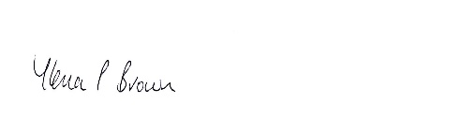

Ilena Brown
Manager

