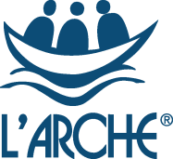

Deputy Support and Care Leader
L’Arche Edinburgh

Do you have a passion for ensuring people with learning disabilities live fulfilled lives? Do you want to help lead a community that values people for who they are and what they can do?

L’Arche Edinburgh is a community of more than 80 people with and without learning disabilities. It is a place of belonging where people with learning disabilities can live independent, yet connected lives. We’re looking for someone to join us as a Deputy Support and Care Leader.

Along with the Support and Care Leader and another Deputy Support and Care leader you will help to lead a team of approximately 12 to 15 people. The leadership team aims to provide and develop high quality person-centred care supporting the practical, social and spiritual needs of those who call L’Arche home. We are always looking to increase choice for the people we support as part of shared living in each of our Houses and in individual supported tenancies and explore ways that we can grow as a Community.

L’Arche Edinburgh is an ecumenical Christian community which welcomes people of all faiths and none. We are part of a global network of communities where people with and without learning disabilities live and share in life together, working for a world where we all belong.

Knowledge and experience in care or supported housing is a key requirement for this role, but we are also looking for someone with an enthusiasm for our values and the ability to inspire others. You might be looking to step up from a support worker or to use your current management experience in a different way. If you are interested in being part of a mutually supportive and lively community, then we want to hear from you!

Finding out more about L’Arche
The Community Leader or Support and Care Coordinator (Registered Manager) would be very happy to talk informally with you to answer any questions and give you a feel for what being a Deputy Support and Care Leader in L’Arche is like via 0131 553 3478 .
You can find out more about L’Arche Edinburgh at www.larche-edinburgh.org.uk
and L’Arche in the UK at www.larche.org.uk

What qualities those who live in our Houses or in their own individual tenancies are looking for in the people who form their leadership team:
- A person who genuinely cares about the core members (people with learning disabilities who live within the community), and isn’t just taking it as ‘a job’; someone whose heart is really in it.
- A person who is committed to communicating with family members on a regular basis, seeing that their loved one looks well and is taken care of.
- A person who is great at communicating – written and verbal – who knows what’s really going on.
Community life
At the heart of L’Arche is the support we provide to people with learning disabilities. As well as providing high quality housing and supported living, we also work with individuals to access employment and voluntary opportunities. In addition, many of our Communities provide day support services. Furthermore, we assist people to access relevant healthcare and, where appropriate, receive therapeutic services. We work hard to ensure that the needs of individuals with learning disabilities are met holistically, and that people are supported to live fully integrated and empowered lives within the wider communities in which they live.
We have a long history of working with social services and social work departments, health authorities, primary care trusts, registration and regulatory authorities, housing associations and others, to provide high quality support that is recognised as being truly responsive to people with learning disabilities.
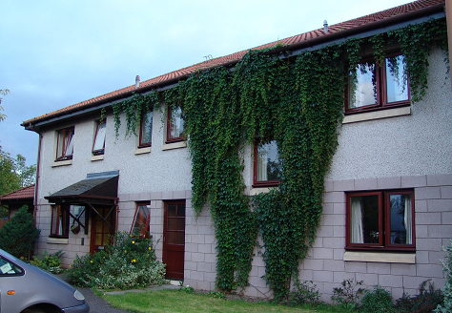
Creelha
L’Arche Edinburgh: Background information
L’Arche Edinburgh is one of ten communities that form L’Arche in the UK and belongs to an International Federation of 153 communities in 38 countries.

L’Arche Edinburgh opened its first house in 1991. It has grown since then and has a network of houses and flats. The community is made up of adults with learning disabilities, more than forty employed assistants, Committee members and many other friends and volunteers.

Our employed assistants are drawn from two sources. Most are local people employed on standard contracts, whom we term “live-out assistants”. But what makes us different is that up to a third of our assistants live in our houses alongside the people with disabilities to whom they provide support. They receive board, lodging and expenses. This experience of living in community alongside people who are different from themselves is a source of huge richness. Many of these live-in assistants are from outside the UK, and Brexit and Covid brings us new challenges in this area.

Our services are registered with the Care Inspectorate under their dual category of Care at home and Housing Support.

Shared Households:
- The Skein: home to four people with learning disabilities today and supported by a team of 14 assistants, up to four of whom live in the house. This was our first house, opened in 1991. Assistants work in The Skein and support people who live nearby in their own flat.
- David House: a house for four people with more complex support and healthcare needs. 12 assistants support David House, some of whom live in the house
- Creelha: home to four people with disabilities, supported by 10 assistants, some of whom live in the house. Assistants work in Creelha and support people who live nearby in their own flat.

Flats for individuals:
- We support four people who live independently in nearby flats, and who choose to live as neighbours

Work and day opportunities:
We do not run centre-based day activities, but instead have been ahead of the time in developing individualised day opportunities in the local community.

Community and spiritual life
L’Arche Edinburgh normally has a rich and vibrant community life involving Community Gatherings, parties, outings, celebrations and meals to bring together large and small groups. The major feasts such as Christmas and Easter are celebrated together, and there are other opportunities for prayer, reflection, and quiet time for those who wish to participate. It is hoped that many community activities will become possible again in the near future.

L’Arche Edinburgh Support Services
JOB DESCRIPTION

Job Title: Deputy Support and Care Leader
Reporting to: Support and Care Leader
Hours: 40 hours per week, including evenings and weekends
Sleepovers: Sleepovers are occasionally required and are paid at £85.77 per night
Salary: £23,254 - £24,211 (pay review pending Dec 2022)
Annual Leave: 30 days inclusive of public holidays (rising to 35 in second year)
Probationary Period: 6 months

_________________________________________________________________________
Purpose of the role:
- To provide person-centred care and support to people with learning disabilities, and to enable them to lead the lifestyle of their choice.
- To help the Support and Care Leader to lead, manage and support the assistant team to provide quality support and care
- To work closely with the Support and Care Leader in fulfilling the requirements to meet service provision standards whilst upholding L’Arche values and the ethos of community living

MAIN RESPONSIBILITIES:
PROVIDE SUPPORT AND CARE TO ADULTS WITH LEARNING DISABILITIES
To assist the Support and Care Leader to:
- Build positive working relationships with individuals using the service

- Provide direct support to people to help them achieve outcomes important to them

- Provide personal care to people that meets specific needs and requirements including being responsible for the safe handling and administration of medication

- Support people to maintain their home which may include support with personal finances, domestic tasks, maintaining tenancy/occupancy

- Ensure that core members are empowered to make choices and take control over their lives, balancing the individual’s right to make choices and take reasonable risks, and their need to maintain a safe and healthy lifestyle

- Ensure core members’ needs and wishes as described in their Support Plans are achieved through providing high quality person-centred support at all times, and that these plans are updated regularly

- Recognise that all behaviour is a form of communication that has a message and a value, and work closely with people in order to understand what is being communicated and respond appropriately

- Model positive ways of supporting people to team members and members of the public whom the person comes into contact with , and promote a culture of respect and dignity at all times

- Ensure all relevant parties responsible for the planning and delivery of support are regularly updated on changes and progress

- Recognise the value that families have in the lives of the people we support and work in partnership with Welfare/Financial Guardians, family members and other important people in the person’s life, and ensure they are kept aware of relevant issues

- Ensure communication of information is clear, timely and done with respect for confidentiality

In addition you would be expected to:

- Work as a team member and actively contribute to effective and positive team working

- Occasionally accompany individuals on a short break or holiday

MANAGEMENT & ADMINISTRATION
To help the Support and Care Leader to:
- Manage all aspects of the service

- Provide regular support and supervision to team members

- Participate in Assistant appraisals and other performance management processes, leading as delegated

- Plan and deliver the Weekly Team meeting, including follow up and appropriate delegation of duties, leading when required e.g. to provide cover for the Support and Care Leader

- Effectively plan and manage the rota including sickness, holidays and training, arranging cover to ensure appropriate support is delivered to individuals in line with their support agreement.

- Prepare for and take full part in core members’ reviews and meetings related to their support
- Recruit and support all new assistants induction to aid integration into the team and their knowledge of all polices and support plans

- Identify potential difficulties/complex situations arising from assistant management, report those to the Support and Care Leader (or in their absence and where urgent to the Support and Care Coordinator) and, if appropriate, work with the Support and Care Coordinator and other Deputy Support and Care Coordinator on solutions

- Ensure that individuals receive relevant support to manage their personal finances including welfare benefits if appropriate

- Ensure good quality record keeping is maintained

QUALITY AND DEVELOPMENT
To help the Support and Care Leader:
- In the delivery of quality assurance and service improvement processes

- To deliver all care and support in line with the Health and Social Care Standards

- To ensure all L’Arche policies and procedures, and individual plans and guidelines are implemented

- To ensure the SSSC codes of practice are adhered to by all team members

- To contribute to the wider development of L’Arche as required

TO ENSURE GOOD QUALITY HOME LIFE IN LINE WITH L’ARCHE VALUES and NATIONAL CARE STANDARDS
To help the Support and Care Leader to:
- Promote a feeling of belonging for all who live and work in the house, paying attention to any dynamics and facilitating quality relationships between individuals within an atmosphere of welcome and respect

- Ensure celebrations of birthdays, anniversaries and the house spiritual life are well facilitated in line with L’Arche ethos of community living and spirituality

- Ensure the fabric, fixtures and fittings in the house environment are in good order, and that the house is kept to a high standard of cleanliness

- Deliver the annual maintenance action plan as delegated

PROMOTE AND MODEL EFFECTIVE COMMUNICATION
To help the Support and Care Leader to:
- Promote effective communication within the team at meetings and ensure messages and systems for communication such as log books are working well

- Promote and ensure good communication with families and professionals

- Disseminate information within the House and team

- Be creative about the participation and involvement of people with learning disabilities as much as possible in the running of their home whether as part of a shared house or independent flat

- Collate information to input into reports on the house for the local committee as required

TO IMPLEMENT SERVICE REGULATION AND COMPLIANCE REQUIREMENTS

To help the Support and Care Leader to:
- Prepare for and participate in Care Inspectorate inspections

- Contribute to HMO compliance requirements

- Ensure that all relevant Health and Safety regulations are observed when on shift, promote a strong health and safety culture within the service and report any concerns to the Support and Care Leader

TO DEVELOP YOUR PRACTICE AND PLAY AN ACTIVE ROLE IN LEADERSHIP TEAM

- By providing cover for the Support and Care Leader when required e.g. holidays, by attending meetings with other members of the wider management team including the Leaders meeting, and contribute to discussion and decisions

- By using own support and supervision positively and being reflective about own performance seeking guidance when unsure

- By taking opportunities for further learning, training and development where required and demonstrating personal responsibility for own learning

- Being open to and supportive of L’Arche traditions and practices including accompaniment (non-line management mentor)

The information given in this job description is given to ensure the post holder has the best opportunity of understanding what is required to be effective in the post. It is not intended to be prescriptive in every detail and it is expected the post holder will be as positive and flexible as possible while using this as a framework. There may be from time to time, other duties deemed appropriate and/or necessary by the Support and Care Leader, Support and Care Coordinator or Community Leader.

Deputy Support and Care Leader – Person Specification

The people with learning disabilities within our service are looking for a Deputy Support and Care Leader who has the following skills and qualities:
- “They’ve got to get on well with people”
- “They’ve got to be able to sort things out if they go wrong”
- “Be able to answer the telephone, talk to people and make appointments for me”
- “I want them to take their time to get to know me”
- “Make sure people are here when I need them”

Provision of support and care for people with learning disabilities means also supporting some people who have physical disabilities. This could include wheelchair users or people with higher mobility needs and involve lifting and physically supporting people. Therefore, the work may be physically demanding at times.

Leadership and Management – candidates should demonstrate experience and competence in
- Understanding and insight into working with staff groups and leading and motivating teams
- Communicate effectively verbally and in writing
- Good organisational and administrative skills
- Ability to delegate effectively

Supporting People – candidates should have
- Experience of support work within a social care setting with adults with learning disabilities
- Experience of support work with adults with learning disabilities who live independently
- Experience of working collaboratively with people with learning disabilities to plan their care and support
- Understanding of the emotional and behavioural support needs of adults with learning disabilities
- Understanding of the principles and practice of supported living
- Understanding of what it means to think and work in a person centred way

Personal Qualities – candidates should demonstrate
- personal authority and potential to lead others
- personal motivation by the mission, values and objectives of L’Arche and an openness to the ‘vocational’ aspects of belonging to L’Arche and to becoming a member of the community
- emotional maturity and resilience to deal with leadership responsibilities, referring more complex situations to the Support and Care Leader
- ability to work with autonomy, initiative and responsibility

Qualifications
- SVQ 3 Health and Social Care and the additional supervisory qualification required by SSSC OR have the ability and commitment to achieve SSSC required qualifications within the required time period (see Terms and Conditions).
- Evidence of openness to continuous professional development
- IT skills
- Full driving license and ability to drive Motability vehicles (desirable)

TERMS AND CONDITIONS:

Full terms and conditions are contained in the L’Arche contract and Employee Handbook
- Total working hours are 40 per week (typically 5 shifts of 8 hours each). The hours require shift working involving some evening and weekend work. There will be a typical and predictable pattern of the same two consecutive days off each week, which may vary on occasion if needs arise. Split shifts may be required.
- The salary is on a 3 point scale starting at £23,254 placement subject to experience and a pay increase is pending subject to a review.
- A satisfactory performance appraisal after 12 months in the post is dependent upon meeting the required standards and, if not already held, significant progress towards the completion of the SVQ3 Health and Social Care.
- Sleepovers are required occasionally for the Deputy Support and Care Leader role. Sleepovers are currently paid at £85.77 per night.
- The post is subject to a probationary period of 6 months which may be extended if necessary.
- For new employees, during the probationary period sick pay is paid at the statutory rate only. On successful completion of the probationary period and during the subsequent period up to two years of service an employee, sick pay is paid at the full rate for 20 working days in any 12 month period (initially and thereafter increases with service).
- Time off in lieu will be given when circumstances require the post holder to work extra hours.

This role qualifies for a Skilled Worker Visa under the Health and Care Visa arrangements as it is a role in an eligible occupation code (6146) and providing adult social care services. L’Arche may be able to sponsor full-time applicants for up to 5 years and who can demonstrate that they meet the requirements for this post.
Closing date for CV or completed application form is 30th October 2022.

L’Arche Identity and Mission Statement

Identity:
- We are people with and without learning disabilities, sharing life in communities belonging to an International Federation.
- Mutual relationships and trust in God are at the heart of our journey together.
- We celebrate the unique value of every person and recognise our need of one another.

Mission:
- Make known the gifts of people with learning disabilities, revealed through mutually transforming relationships
- Foster an environment in community that responds to the changing needs of our members whilst being faithful to the core values of our founding story
- Engage in our diverse cultures, working together towards a more human society
We value:
- Treating people with dignity and respect: We value every person and celebrate who they are. We do not just tolerate diversity, but actively embrace it in our communities. A key way we demonstrate dignity and respect is by being fully present to each other when we are together and listening deeply to one another.
- Friendliness and welcome: We are deeply committed to building friendships together, which calls us to live life with a joyful and grateful spirit. A key way we demonstrate friendliness and welcome is by offering meaningful invitation and welcome to newcomers and also to each other on a daily basis.
- Empathy: We are committed to understanding and sharing the feelings of one another. We prioritise the qualities of compassion, caring, and kindness to nurture empathy. A key way we demonstrate empathy is through the quality of the shared life we build together.
- Integrity: We strive to have integrity in everything we do and in every relationship we build, seeking to be authentic and honest, trustworthy and open because to build meaningful relationships we need to reveal who we are. A key way we demonstrate integrity is through our willingness to be both vulnerable and courageous.
- Commitment to community building: We choose to share life together rather than merely work together. Sharing life means we create mutual relationships with one another and also share responsibility for the life and wellbeing of the community as a whole, practicing forgiveness and celebration and creating a place of belonging that is open to all who share our mission and values. A key way we demonstrate our commitment to community building is through our nurturing of our shared spirituality expressed through the community traditions and practices that shape our daily life together.
- Openness to reflection, learning and growth: We are personally committed to growth and development in the dimensions of L’Arche identity and mission and also support the growth of the whole community by nurturing the gifts of each person, creating a learning culture together and being attentive to our personal and communal spiritual life. A key way we demonstrate our commitment to learning is the frequency and quality of our personal and group reflective practices and processes.
- Commitment to the vision and mission of L’Arche: We actively engage in all dimensions of L’Arche mission and practice both personally and communally. A key way we demonstrate our commitment is our visibility as people with and without learning disabilities together engaged in our local neighbourhoods and the wider world in order to shape a more human society.

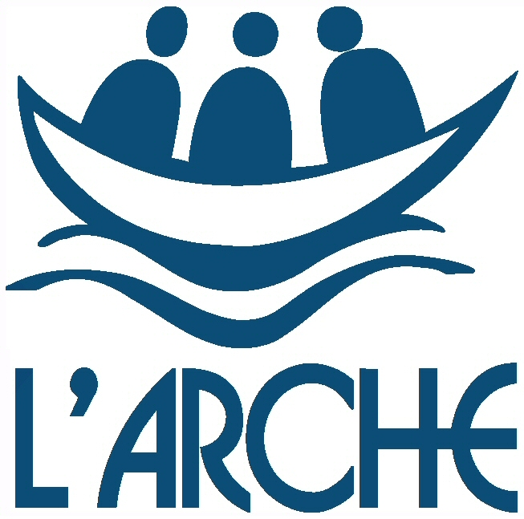



Creelha

