Role Profile – Centre Officer

Reports to: Deputy Centre Manager

Role Purpose:

Our Activity Centre’s provide innovative and person-centred services and support to veterans struggling with sight loss. The services aim to reduce isolation and anxiety while improving independence and confidence to live well with a visual impairment now and in the future. The services offer veterans, their families and carers access to information, support, meaningful activity and social engagement in a welcoming environment.

You will provide tailored support to veterans and their families at all stages of their sight loss journey. You will work alongside the veterans to ensure that the support provided is person-centred, tailored to their needs and is the right support for them. You will support the leadership team to coordinate and manage the activities provided within and from the Activity Centre which will support the overall wellbeing of the veterans and their families. You will work closely with colleagues across the organisation and external stakeholders to ensure that veterans can access the relevant support.

All roles within Sight Scotland and Sight Scotland Veterans are expected to work to our values and Our Ways of Working framework:

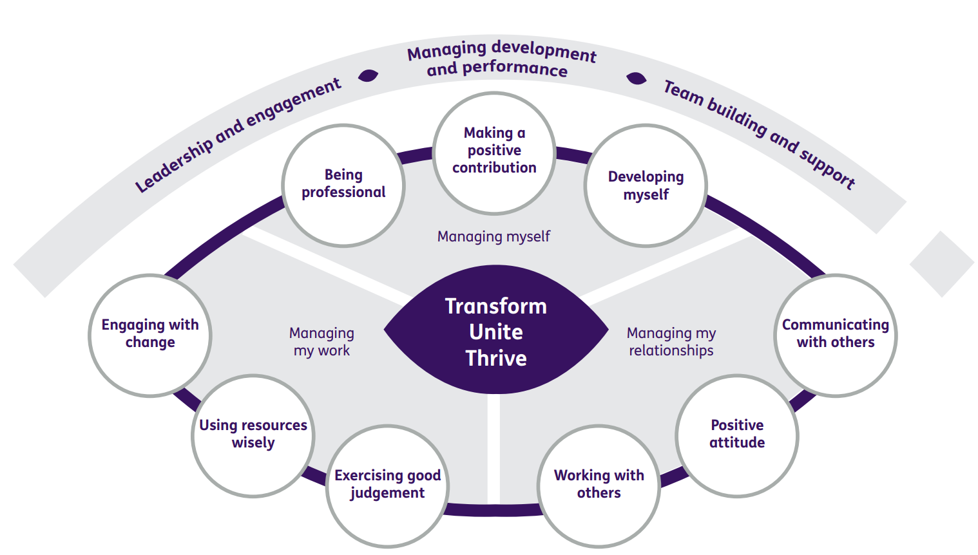

Our Ways of Working - Managing my Work
Main Responsibilities and accountabilities are that you will:
- Support veterans and their families/carers to maximise the benefit they gain from attending the Centre.
- Develop and facilitate innovative and creative activities/events which are geared towards supporting veterans throughout their sight loss journey and beneficial in supporting the overall wellbeing of veterans.
- Carry out relevant risk assessments to ensure comprehensive risk management of activities and outings.
- Work alongside veterans to create a person-centred plan of support with clear aims and coordinate their attendance via assessment and supported visits to the Centre.
- Support person-centred, asset-based and outcome-focused approaches to practice which are responsive to individual needs.
- Support a culture of co-production within the Activity Centre which ensures the veterans community have a large role in shaping service delivery.
- Support partnerships that positively support service impact.
- Support the volunteering community which complements our staff teams.
- Act as a positive role model for all staff and volunteers across Sight Scotland Veterans through coaching, mentoring and modelling of practice.
- Work with the leadership team to promote consistent approaches across both hubs.
- Encourage and maintain clear channels of communication between veterans, staff teams and the Sight Scotland Veterans management team.
- Maintain and develop positive working relationships with colleagues across Sight Scotland Veterans and our sister charity Sight Scotland.
- Encourage service users and their families to provide feedback and to share their stories about the impact of the service to help promote the service.
- Provide driving/escorting duty if/when required.
- Participate in and contribute to supervisions and staff meetings.
- Maintain all necessary records/databases.

Our Ways of Working – Managing Myself and Managing my Relationships
To do this role, you will:
- Have an SVQ level 3/HNC in Health and Social Care/Health/Sport (or willingness to work toward) or another relevant qualification.
- Have demonstrable experience of working with people with a vision impairment, those with other disabilities, and/or their families.
- Have demonstrable experience of outcome-focussed assessment and the principles of person-centred support and co-production.
- Have up-to-date knowledge of the context in which rehabilitation, enablement, care and support are provided in the community for older people or people with disabilities.
- Have an understanding of the support needs of people with a vision impairment.
- Be able to demonstrate excellent communication skills.
- Have the ability to build positive relationships with service users, families, carers and other stakeholders.
- Be committed to enabling visually impaired people to learn/maintain skills and access opportunities which support their independence and wellbeing and promotes social inclusion within local communities.
- Be responsive to others in order to identify the needs of those who use the service.
- Have excellent time-management skills to plan, prioritise and manage your workload.
- Have the ability to work calmly under pressure.
- Have the ability to adapt to change and respond positively to non-routine situations.

To do this role it is desirable if you:
- Have additional relevant qualifications.
- Have experience of working with service veterans.
- Have experience of working with people with vision impairments.
- Have experience in a rehabilitation setting.
- Have evidence of continuous development and a willingness to undertake further training & development.
- Have knowledge of statutory and 3rd sector provision in respect of people with a vision impairment.
- Have knowledge of statutory and 3rd sector provision in respect of service veterans.

On a day-to-day basis you will work with different people and teams, these could be:
- Colleagues
- Other Sight Scotland services
- Senior Colleagues
- Volunteers
- Members
- Members families/carers
- External Agencies and relevant partners

Requirements of this role are:
- You are a member of the PVG scheme (paid for by Sight Scotland Veterans).
- You will have a 6-month probation period.
- That you participate in all staff training and development and maintain your own professional development.
- You understand and are committed to Sight Scotland Veterans aims, principles and equal opportunities policies.
- You will wear the appropriate PPE in accordance with current guidance for the role.
- Good IT skills with a good knowledge of Microsoft Office packages.
- Understanding of and ability to maintain confidentiality.
- You will have a flexible approach to working hours is expected to reflect business needs.
- Have the willingness to undertake considerable travel in a wide area in order to visit members in their own homes (in some cases this may necessitate overnight stays away from home).
- You will have access to a vehicle for use on the job and a valid driving licence.
- You have a suitable home-working environment.

What we can offer you:
- Generous annual leave entitlement which increases after 4 years’ service.
- Generous pension scheme.
- Discounts for Carers.
- Access to learning and development opportunities.
- Employee Perks through the Employee Assistance Programme.
- Cycle to Work scheme.
- And many more, please visit our website for more information.
This job profile is not exhaustive. The duties of the post holder may be reviewed from time to time and the employee may be called upon to work in other locations within Sight Scotland Veterans.

