

**Candidate Pack**

**for**

**General Manager**

with the opportunity of appointment to **Chief Executive**  following an 18 month development programme

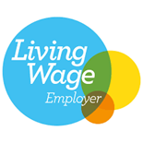 

In partnership with



**About Us:**

Milltown Community is a small, independent and forward looking charity which has adapted, changed and is now thriving in its vision to enable neurodiverse adults and those with learning challenges to be the best they can be, to achieve and to be enabled rather than disabled. Our current residential community of 7 amazing tenants living in two houses, is supplemented each day by up to 20 workers and learners who are developing land based and artisan craft skills at our rural location in Arbuthnott in the south of Aberdeenshire. We are a registered ASDAN qualifications centre offering a combination of short courses and Employability programmes all from our productive small holding and workshops on site.

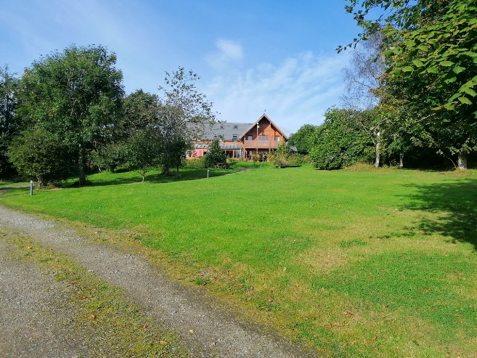

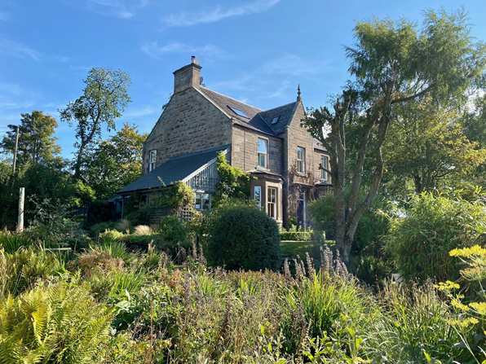

Our residential houses

We are about to embark on a strategic planning process which will encompass our existing Vision, Values and Mission but needs to be a collaborative process facilitated by the person who be at the heart of the charity for the next 5 years. This is why we are offering the opportunity to progress from General Manager to Chief Executive within 18 months and to benefit from a ‘Future Leaders’ leadership & management programme specifically tailored to charity leadership.

In partnership with Third Sector Solutions Scotland we will be offering the successful candidate the unique proposition of combining operational management responsibility with a learning and development programme which will be led by a team of the most experienced third sector professionals and senior managers in Scotland. You will be coached and mentored throughout the programme, enabling you to benefit from their many years of experience in professional management standards, charity leadership, human resources, financial management, business development, strategic planning, income generation and outcomes based commissioning all within the context of regulated health & social care provision in Scotland.

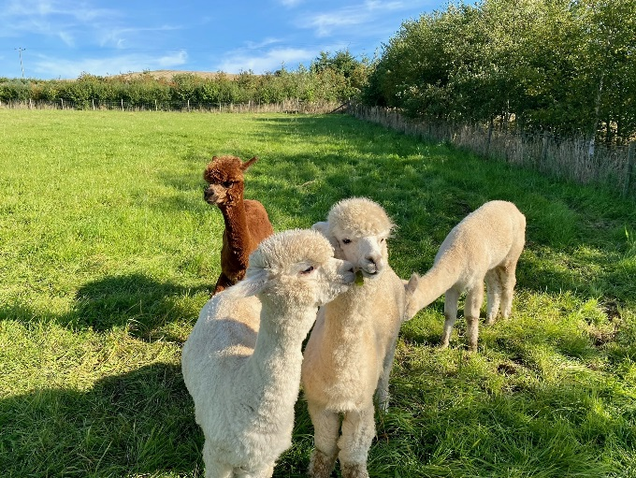 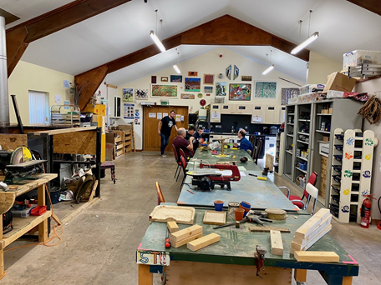

The boys The production workshop

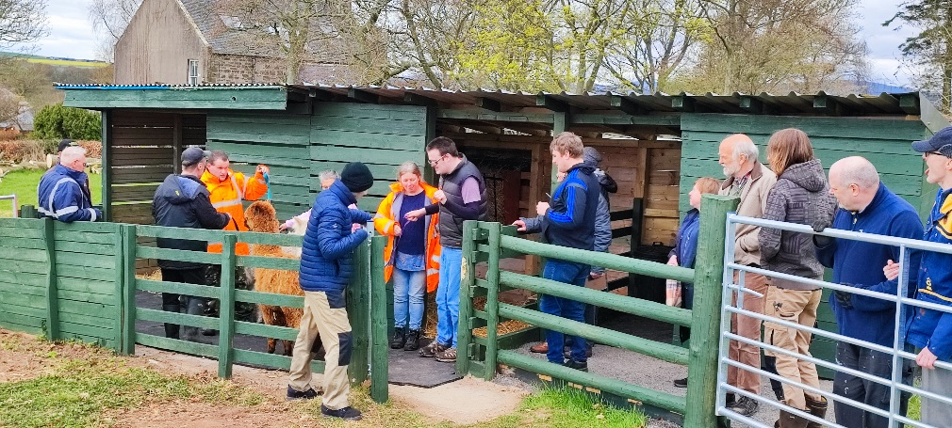

The Alpaca sheds

Milltown Community is a very special place, unique in its setting and one that inspires as the people we support inspire us and live their lives with optimism and joy. The rural surroundings present an incredible place to work and the potential to develop what we can offer is not hard to see.

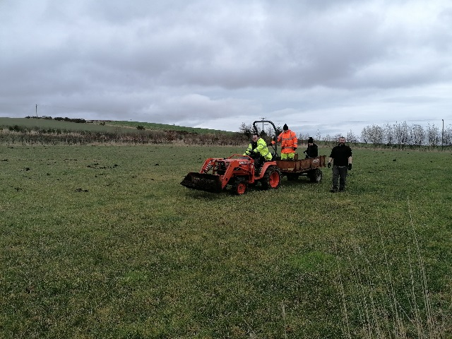 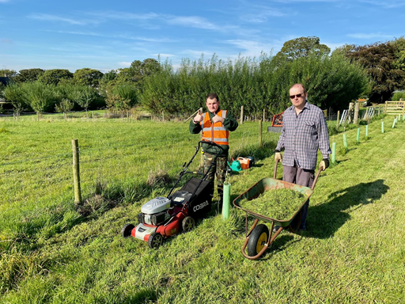

Learning to drive a compact tractor Creating wildlife corridors

The recruitment process for this role will be in three stages:

1. An initial zoom or Microsoft Teams call with Third Sector Solutions Scotland to learn more about the role and the learning & development programme. This will also be an opportunity for you to express your early stage thoughts and to ask questions.
2. Visit to Milltown Community with a ‘Walk & Talk’ interview and opportunity to meet some of our tenants, day learners and staff team. You will need to set aside at least 2 hours for this stage.
3. A more formal face to face interview with the Milltown Community Board of Trustees and advisers which may include a short task to be prepared in advance.

It is our aim to have a General Manager in position by December 2022

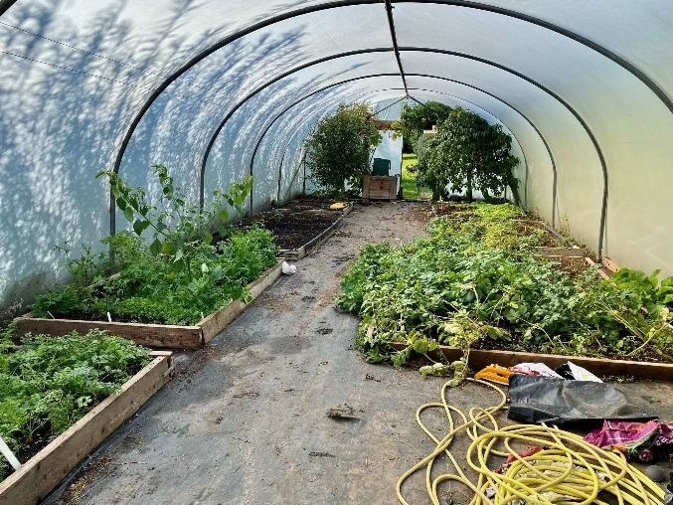 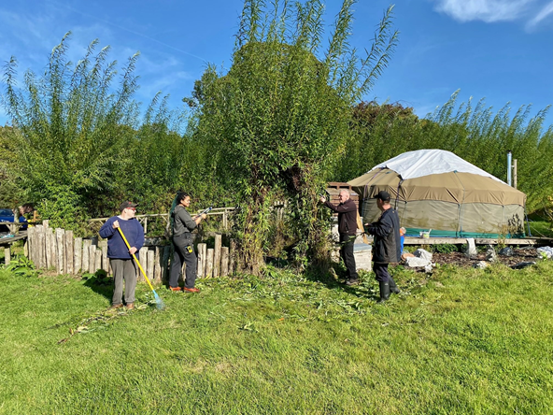

Productive growing Willow harvesting

**Our Values, Vision and Mission Statements:**

VALUES: We recognize that everyone has value, with their own gifts, aspirations and abilities.

We accept that in understanding difference that we learn our need for each other.

We believe that everyone is unique and we endeavour to enable each individual to reach their fullest potential and to live their best possible life.

We want to ensure that each person feels appreciated and supported on their life and work journey, that we help each other practice empathy and kindness and create a culture of mutual care & compassion.

We nurture our surroundings, creating a haven for wildlife, a place of peace and harmony, productive growing and the best environment to look after our animals.

VISION: Milltown Community is a small integrated community living and working in rural Aberdeenshire providing supported living, supported learning, skills development and supported employment opportunities for neurodiverse adults. We are adapting, thriving and striving to be the best we can be, inspiring others to engage and support our work and being an example of excellent practice in every aspect of our service provision.

MISSION: It is our mission to support neurodiverse adults live their lives as independently as possible, to create and nurture an environment and way of living and working which values everyone and encourages individual growth, learning and personal development. We believe in the value of each individual, in their potential, their ability to achieve, to inspire others and live life to the full.

In supporting neurodiverse adults live as independently as possible, we accept that Milltown Community needs amazing, selfless people who share aspects of their lives with those we support. Our people understand the vocational nature of their work, the importance of always ensuring the highest standards and the need for patience and kindness in achieving the best outcomes for our tenants, workers and trainees.

**What this role will require:**

As our potential General Manager and aspiring Chief Executive you will need some important attributes, capabilities and characteristics.

1. Our values really do guide our actions and you will need to live and embody these each day of your work with us.
2. You will need to provide a very hands operational leadership to a committed team and to do so with a balance of confidence and willingness to listen, to collaborate and to never lose the sense of direction & purpose.
3. At times, leading a charity such as ours can seem a lonely place, but you will work with a new and enthusiastic Board of Trustees and will have access to mentors both during and after your learning and development programme as an aspiring CEO.
4. We are unique in that we provide Support at Home but also Supported Learning, Skills Development and Employability Service, so you will need to understand both well with a passion to develop them as part of our portfolio of charitable work.
5. You will need to be creative, particularly in regards to leading our fundraising and other income generation work, to work with others to organise events that will both raise awareness and money.

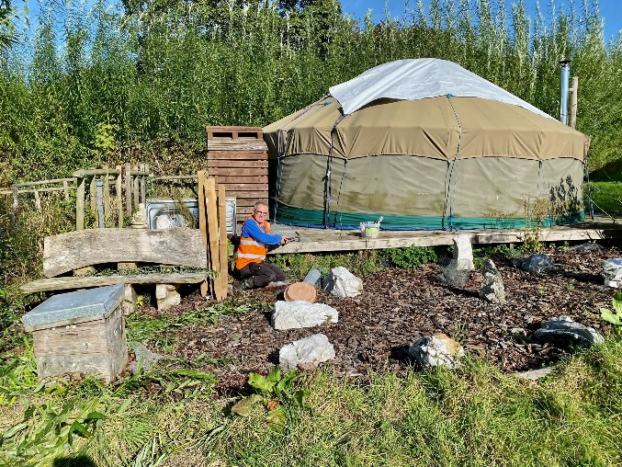 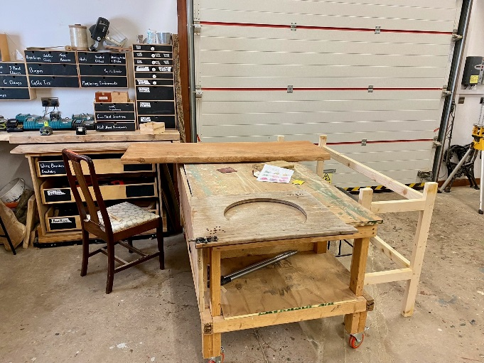

Yurt repairs in the kitchen garden Furniture restoration

**Job Description and Principal Responsibilities**

* To provide purposeful leadership, inspiration and direction in developing, refining and executing Milltown Community’s strategic plans consistent with the overall goals approved by the Board. Ensure all employees understand the strategy and the contribution of their own role to its fulfilment.
* In conjunction with the Team & Programmes Leaders and with the support of the Board, pursue and achieve the short, medium and long term performance objectives of the Charity and to do so with conviction, sound judgement, fiscal rigour, empathy and good governance.
* To promote an open, caring, uplifting and dedicated culture in which high standards are the norm. Nurture the potential of all staff, manage with consistency and clarity, recruit and motivate high calibre individuals, build cohesive teams, champion high management and professional practice standards, communicate well and make Milltown Community a highly desirable place to work.
* Build and sustain close collaborations and partnerships with other organisations, both those with whom relationships are already well established and also where new opportunities are still to be identified.
* Engage externally with a wide range of stakeholder including SSSC, Care Inspectorate, HSCP’s: contract commissioners, profit for purpose, not for profit and communities, including parents, carers and families. Articulate the purpose of the Charity with presence, passion, persuasion, coherence, and champion our values, vision and mission in raising awareness.
* In conjunction with the Board of Trustees and the management team, develop relationships to strengthen the long term sustainability of Milltown Community.
* Exemplify the spirit of Milltown Community: be forward looking, inspiring, personable, astute, open, persuasive, empathetic, balanced and uncompromising when required.
* In the short, medium and longer term, pioneer innovative ways, using people and technology, to deliver the maximum life benefits to the greatest number of those living with learning difficulties.
* You will be expected to immediately become the ‘Registered Manager’ for Milltown Community and will therefore need a level of qualifications required by the Scottish Social Services Council.

**Key Qualities required for this position include the following:**

**Strategic:** Working closely with key staff, and supported by Trustees and Advisers, should have the experience, creativity and boldness to refine and deliver a strategic vision which continues to break new ground, yet remains grounded. The balance between vision and pragmatism is fundamental.

**Enterprising:** Milltown Community aspires to be the best it can be. At the heart of this ambition is combining excellence in professional health and social care practice with the Charity’s growth ambitions.

**Inspiring:** Inside the organisation and externally, you will engage with, lead, persuade and inspire existing relationships and new contacts, including Trustees, the management team, staff, funders, partners, collaborators, other organisations and institutions, businesses, communities and individuals.

**Influential:** You will have the presence and personality to win the respect of and influence a wide range of audiences. Excellent communication skills, deep collaborative commitment and the power of persuasion, are paramount.

**Creative:** Milltown Community has a pioneering and ambitious spirit – a powerful mix of creativity and pragmatism. This mix is critical to support innovative ways of working which deliver high quality, compliant, cost effective and outcomes led health & social care services

**Astute:** The role requires intellectual sharpness, diplomacy, sound judgement, an eye for detail and the vision to see the opportunities that might escape less perceptive individuals.

**Adaptable:** We are working towards a 5 year strategic plan and we need you to own this process and while there are no specific models, maps or charts that define Milltown Community’s journey, willingness to observe, learn, adapt and refine along the way will be the hallmarks of our future CEO’s success.

**Balanced:** Milltown Community is a Charity which must be run with rigour and fiscal acumen, carefully balanced by the sensitive management needed in an organisation where we provide support services to vulnerable adults and where people are valued for who they are.

**Resilient:** The role demands courage, conviction, enterprise and stamina. Tough decisions will sometimes be required so this role is certainly not for the faint hearted.

**Empathetic:** Milltown Community is dedicated to improving the lives of neurodiverse adults and those who have been living with learning challenges. You must embody the vision values and mission of the Charity and be its most passionate, personable and compassionate ambassador.

**THANK YOU SO MUCH FOR READING THIS CANDIDATE PACK AND WE LOOK FORWARD TO YOUR APPLICATION.**

Applications should be made via email enclosing your current CV, relevant specifically to this role and a covering/supporting letter to: [ianrideout@thirdsectorsolutions.org.uk](mailto:ianrideout@thirdsectorsolutions.org.uk)

**The closing date for applications is midnight on 21st October 2022**

