Role Profile – Administrator
Head Office/ Scottish Braille Press

Reports To: Facilities Manager

Role Purpose:
You will be responsible for ensuring the smooth running of our joint Head Office and Scottish Braille Press reception at Robertson Avenue, and providing an excellent level of customer service to colleagues, visitors and external contractors who visit or work within the building as well as those contacting Sight Scotland by post, email or telephone. As well as coordinating front desk activities you will also be responsible for general office administration and facilities management tasks. You will also act as lead Fire Marshall and a nominated First Aider for the building.

All roles within Sight Scotland and Sight Scotland Veterans are expected to work to our values and Our Ways of Working framework:
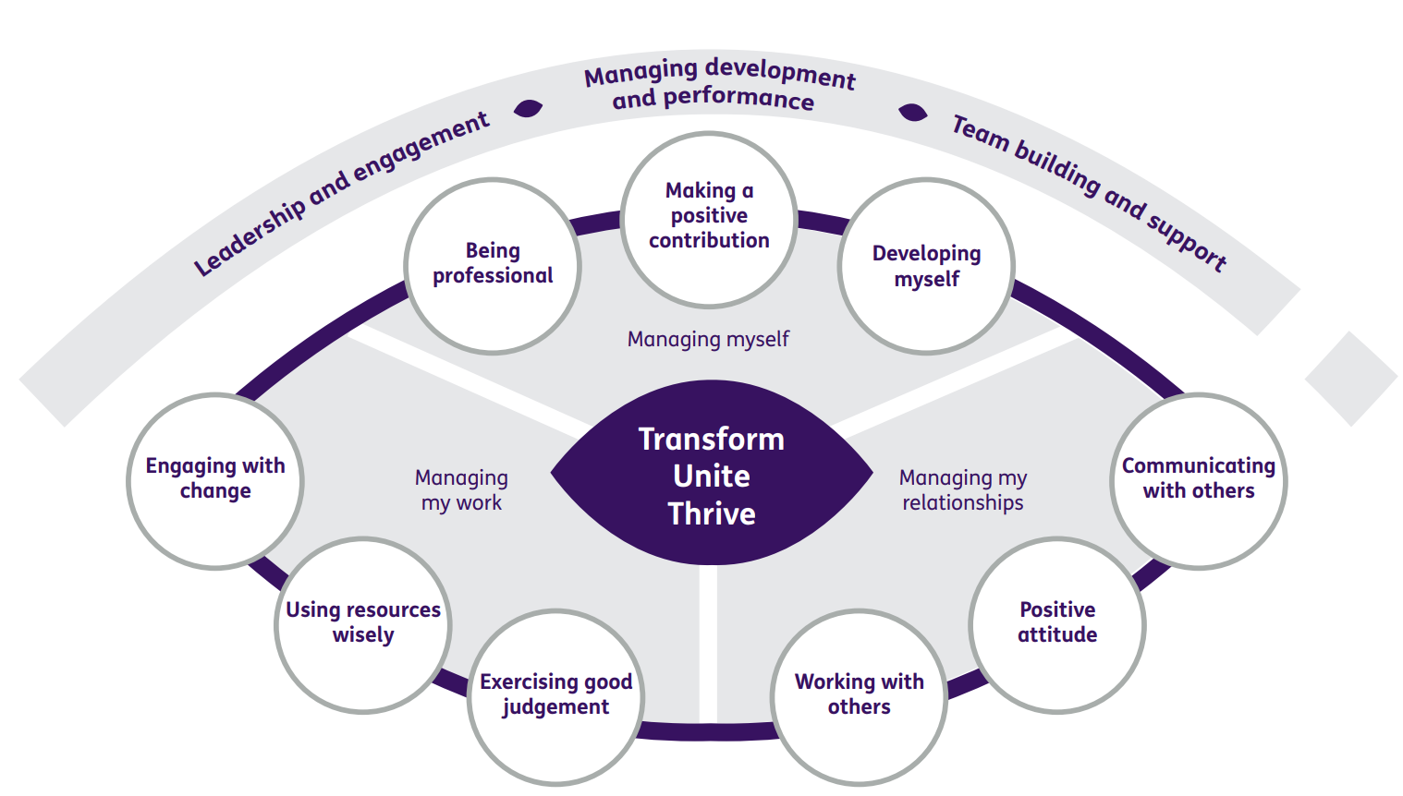

Our Ways of Working – Managing my Work
The main responsibilities and accountabilities of this role are:
- Ensuring reception cover for the Sight Scotland / Sight Scotland Veterans Head Office and Scottish Braille Press joint reception.
- Ensuring all guests are received in a positive friendly manner and our culture and values are presented every day.
- Dealing with colleagues, clients and contractors, monitoring their access arrangements and conducting safety briefs.
- Answering telephone, email, post and website enquiries professionally and accurately, working with colleagues across the organisation to source the answer to the enquiry / ensure follow up by the service. Tracking topics and numbers of enquiries for reporting purposes.
- To make sure the front of house and meeting rooms are efficiently managed to the standard expected by Sight Scotland / Sight Scotland Veterans.
- To be the Lead Fire Marshall for the building.
- To be a nominated trained first aider for the building. Training will be provided.
- As well as coordinating front of house tasks, undertake a range of administrative tasks to support services, colleagues in the building and facilities management, including:

- Processing incoming / outgoing mail for Head Office teams.
- Recording fundraising income (cash / cheques) received by post and ensuring it is securely transferred to the fundraising team, including the scanning of any relevant documents as required.
- Dealing with deliveries to the building.
- General filing, scanning, photocopying and administration support for staff as required.
- Record keeping for facilities management as required.
- Signing in/out of access keys and equipment to staff/external contractors.
- Monitoring fire alarm system and conducting system tests.
- Ensuring fire logbook is up to date.
- Issue staff access fobs.
- Preparing meeting rooms, arrange tea, coffees and buffet lunches when required. Clear rooms after use ready for next booking.
- Manage meeting room bookings.
- Manage pool car bookings.
- Responsibility for stationery supplies and ordering for Head Office.
- Ordering general supplies for the building as required.
- Sourcing other resources as required by colleagues / services.
- Any other duties as may reasonably be required.

Our Ways of Working – Managing Myself and Managing my Relationships
To do this role, you will:
- Have previous experience of working in a busy reception.
- Have previous experience of office and/or facilities administration.
- Have excellent customer service skills.
- Have good time management skills.
- Be able to multitask.
- Be able to evidence excellent MS Office skills.
- Have strong organisational skills.
- Be able to communicate effectively (verbal and written) including having an excellent telephone manner.
- Have experience of working effectively as part of a team.

It would be desirable for this role if you have:
- Recognised qualification in keyboard associated skills and office management techniques.
- Previous experience as a nominated First Aider and / or Fire Marshall.

On a day-to-day basis you will work with different people and teams, these could be:
- Colleagues
- Other Sight Scotland services
- Senior Staff
- External visitors and contractors
- Members of the public

Requirements of this role are:
- You are a member of the PVG scheme (paid for by Sight Scotland).
- You will have a 6-month probation period.
- You participate in all staff training and development and maintain your own professional development.
- You will wear the appropriate PPE in accordance with current guidance for the role.
- You will follow Sight Scotland’s guidance, policies and procedures relating to your own health and safety and that of colleagues and service users at all times.
- You will uphold the principles of Sight Scotland’s Dignity at Work and Equal Opportunities policies at all times, working in a way which supports an inclusive work environment that is respectful of differences.

What we can offer you:
- Generous annual leave entitlement which increases after 4 years’ service
- Generous pension scheme
- Discounts for Carers
- Access to learning and development opportunities
- Employee Perks through the Employee Assistance Programme
- Cycle to Work scheme
- And many more, please visit our website for more information

This job profile is not exhaustive. The duties of the post holder may be reviewed from time to time and the employee may be called upon to work in other locations within Sight Scotland.

