


Centre Intern
Thomas Pocklington Trust (TPT) and RNIB are collaborating with charities in the sight loss sector to create new opportunities for blind and partially sighted people to find employment through the Get Set Progress Internship programme. Sight Scotland Veterans is delighted to be offering an internship as part of the Get set Progress scheme.

Sight Scotland Veterans provides support to all veterans in Scotland who are experiencing changes to their sight, regardless of the cause, or what point you are at. We give support that ranges from practical advice and identifying solutions that help you stay as independent as possible, to vital emotional support and opportunities to meet others facing sight loss.

Our Values

Sight Scotland Veterans values, Transform, Unite and Thrive, reflect what we do, how we do it and why we do it.
These statements explain what each value means to us, in what we do as an organisation, and how we act as colleagues.
- Transform: We transform outcomes for people with sight loss. We embrace change and constantly look for ways to improve.
- Unite: We connect with partners and communities to support more people. We work across the organisation to maximise our impact.
- Thrive: We care about those we work with and want them to flourish. We do vital work, we want to thrive too!

What are the benefits of a Get Set Progress internship for me?

As part of your 9-month internship you will gain the following:
- obtain valuable work experience within the charity sector
- Training opportunities
- A mentor offering support, advice and guidance throughout
- help deliver positive changes for people with sight loss

As part of the GSP Internship programme, you will also be enrolled onto the TPT Employment Programme, where you will gain employment support, guidance and advice from their Employment Team, skills obtainable are:

- CV writing
- Job searching
- Cover letter and speculative letter writing
- Application form writing
- Interview techniques

Centre Intern (9 months fixed term)

Reports to: Deputy Centre Manager
You will also be assigned a mentor to support you during the internship.

Role Purpose:

Our Activity Centres provide innovative and person-centred services and support to veterans struggling with sight loss. The services aim to reduce isolation and anxiety while improving independence and confidence to live well with a visual impairment now and in the future. The services offer veterans and their families and carers access to information, support, meaningful activity and social engagement in a welcoming environment.

You will provide tailored support to veterans and their families at all stages of their sight loss journey. You will work alongside the veterans to ensure that the support provided is person-centred, tailored to their needs and is the right support for them. You will support the centre team by coordinating and facilitating activities provided within and from the Activity Centre which will support the overall wellbeing of the veterans and their families.

All roles within Sight Scotland and Sight Scotland Veterans are expected to work to our values and Our Ways of Working framework:

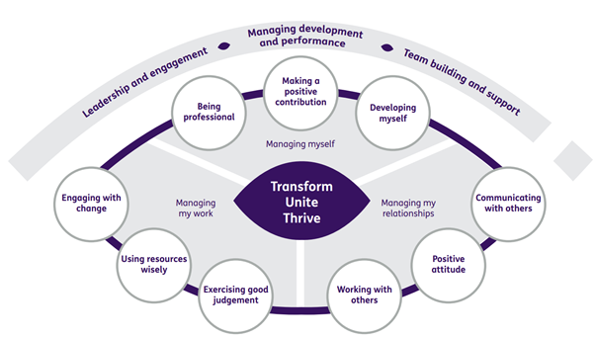

Our Ways of Working - Managing my Work
Main Responsibilities and accountabilities are that you will:
- Support veterans and their families/carers to maximise the benefit they gain from attending the Centre.
- Develop and facilitate innovative and creative activities/events which are geared towards supporting veterans throughout their sight loss journey and beneficial in supporting the overall wellbeing of veterans
- Be involved, alongside other Centre Officers in relevant risk assessments of activities and outings
- Support other Centre Officers in the creation of person-centred plans of support with clear aims

Our Ways of Working – Managing Myself and Managing my Relationships

To do this role, you will:

- Lived experience of sight loss
- Have a clear value base and able to demonstrate your willingness to provide support which will benefit veterans living with sight loss and their families
- Have an understanding of the support needs of people with a vision impairment
- Be able to demonstrate excellent communication skills
- Have the ability to build positive relationships with service users, families, carers and other stakeholders
- Be committed to enabling visually impaired people to learn/maintain skills and access opportunities which support their independence and wellbeing and promotes social inclusion within local communities.
- Be responsive to others in order to identify the needs of those who use the service
- Have excellent time management skills to plan, prioritise and manage your workload
- Have the ability to work calmly under pressure
- Have the ability to adapt to change and respond positively to non-routine situations

On a day-to-day basis you will work with different people and teams, these could be:
- Colleagues
- Other Sight Scotland services
- Senior Colleagues
- Volunteers
- Members
- Members families/carers
- External Agencies and relevant partners

Requirements of this role are:
- You are a member of the PVG scheme (paid for by Sight Scotland Veterans)
- That you participate in all staff training and development
- You understand, and be committed to Sight Scotland Veterans aims, principles and equal opportunities policies
- You will wear the appropriate PPE in accordance with current guidance for the role.
- Good IT skills with a good knowledge of Microsoft office packages
- Understanding of and ability to maintain confidentiality
- A flexible approach to working hours is expected to reflect business needs
- You engage in regular one-to-one meetings with your line manager, mentor and the TPT Employment team

What we can offer you:

- Discounts for Carers
- Access to learning and development opportunities
- Employee Perks through the Employee Assistance Programme
- Cycle to Work scheme
- And many more, please visit our website for more information

This job profile is not exhaustive. The duties of the post holder may be reviewed from time to time and the employee may be called upon to work in other locations within Sight Scotland Veterans.

