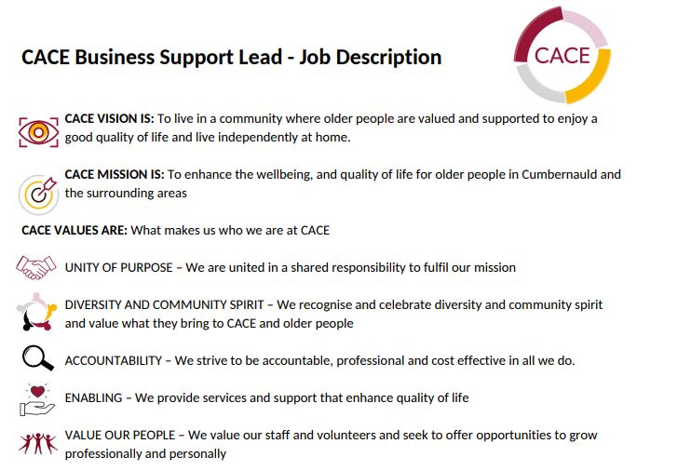

PURPOSE OF THE ROLE:

The CACE 'Business Support Lead' will be responsible for provision of seamless support for a wide range of business tasks including HR, financial and general administration, facilities management and undertaking the role of health and safety officer. You will also be expected to use your admin skills to work alongside others to ensure that as a team, all projects and services are delivered in an effective and efficient way, which is person focused.

Coordination and support include customer service, helping staff and volunteers to meet deadlines, manage processes, arrange diaries, delivering reports and budgets, and ensuring effective use of internal and external communications at CACE.

The Support Lead will be responsible for liaising with CACE management to manage all admin systems and processes used. Support to the team in areas of collecting in evaluation and data will be required. This will involve working alongside colleagues for monitoring and evaluation purposes.

The role will be responsible for ensuring our telephone systems and our I.T systems are in good working order. This communication system is vital in ensuring CACE can engage and communicate with a range of stakeholders. As the first point of contact at our office, the role provides customer service in person and via phone and email, there are additional responsibilities around liaising with our key facilities contacts and staff.

KEY ROLES AND RESPONSIBILITIES - CACE BUSINESS SUPPORT OFFICER

1. Reception and Administrative

- Responsible for all reception duties, including fielding enquiries and referrals for our services, responding to email and telephone enquiries efficiently, maintaining notes and actions on Beacon, which is our client record management system,
- Support the maintenance and updating of all organisational policies and procedures
- Responsible for all administrative support including maintaining records, accurate and timely correspondence, support for report writing, overseeing record-keeping and support for internal meetings including minute taking.
- To act as the first point of contact for communications to and from CACE email inbox, and provide support for communications content via our website, social media platforms and direct mailings.
- To ensure filing systems are up to date, both on and offline, and archived storage is managed appropriately.
- Monitoring and ordering stationery and any other office and service supplies.
- To work with management team to ensure that all materials such as information pack, newsletters and any other documentation are put together and disseminated in a timely fashion.

2. General facilities and infrastructure management

- Act as key liaison with external partners re internet functionality, telephony and facilities (e.g. landlords, utility providers, insurers).
- Ordering and monitoring of all I.T and communications equipment as agreed by the management team.
- Support the training of all staff in I.T and communication systems. Undertake the role of Data Controller and manage the organisation’s GDPR compliance?

3. HR Support and Administration

- Provide advice to staff as appropriate, following guidance from the management team and HR professionals.
- Maintain accurate personnel files, including monitoring and recording individual timesheets, requests for annual leave and sickness records.
- Ensure all new starter paperwork is in place and compliant with legal requirements (e.g. right to work documentation, Disclosure Scotland checks etc).
- Establish and maintain systems to monitor and renew all personnel documentation as required by legislation.
- Assist with preparation of HR letters and other documents
- Maintain training records and ensure all staff and volunteers have the correct training required to perform their roles and that all training is up to date.
- Work with management and Payroll to assist with calculations and support.
- To adhere to the principles of always maintaining confidentiality.

4. People Management/Supervision of other staff

- Provide supervisory support to our cleaner.
- Support and supervise any admin volunteers.

5. Financial responsibilities

- Maintaining accurate digital and physical financial records.
- Day-to-day bookkeeping using Xero, including processing customer and supplier invoices, creditor and debtor management and payment processing.
- Managing company credit cards.
- Bank and credit card reconciliations.
- Processing expenses for staff and volunteers.
- Management and reconciliation of petty cash.
- Provision of monthly and quarterly financial reports as required by the Senior Management Team and the Board.
- Support CEO and Deputy CEO to maintain accurate forecasts as required.
- Maintain up-to-date salary records to enable accurate forecasting and reporting.
- Provide any financial information required to assist with the preparation of bids and reports.
- Supporting external accountants with record provision to enable preparation of annual accounts.
- Work with the senior management team to develop and implement improved financial processes and controls

6. Health and Safety

- Undertake the role of health and safety officer, including any necessary training and ongoing CPD.
- Work with colleagues to ensure that health and safety legislation and risk assessments are understood and implemented, and that staff, volunteer and service user safety is secured.
- Ensure colleagues are adequately trained in relevant health and safety matters,
- To liaise with external parties when required to ensure HSE guidelines are being adhered to.

7. Other Duties

- Adult support and protection (ASP) duties are everyone’s responsibility. In this role there will be an expectation of following internal guidelines and processes for reporting all concerns.
- Support the management team to ensure all staff and volunteers have necessary ASP training.
- Any other duties that may be required from time to time; CACE is a small charity and as such requires its staff to be flexible in response to business needs. Staff may not unreasonably refuse a request to undertake any task which is appropriate to their level for which they have the necessary skills and / or experience. Any resulting change to their objectives and priorities will be discussed and confirmed with their line manager.

PERSON SPECIFICATION - BUSINESS SUPPORT LEAD

Qualifications/Education

- Educated to National % (or equivalent by experience/formal education) - Essential

Skills

- Highly IT literate: Required: Advanced user of Excel, Word, Outlook and Powerpoint (add any other software/packages you rely on). - Essential
- Experienced in writing professional social media posts ad editing online content. – Desirable
- working knowledge of CRM software working knowledge of Xero. - Desirable
- Bookkeeping and charity accounts - Essential
- Budgeting, forecasting and cash flow preparation - Essential
- Knowledge of Adult Support & Protection legislation and procedures - Desirable
- Knowledge of health and safety at work practices -Desirable
- Familiarity with basic HR processes - Essential
- Excellent interpersonal and communication skills - Essential
- Exceptional attention to detail - Essential
- Ability to work as part of a team and on own initiative - Essential
- Good written and oral communications skills - Essential
- Managing time and responding to and prioritising a range of competing demands Able to plan own workload - Essential
- Ability to deal with queries in a diplomatic, professional and confidential manner Good telephone manner - Essential

Experience

- Experience/good knowledge and understanding of volunteering - Desirable
- Participation in a multi–disciplinary team environment - Desirable
- Experience of working in demanding administrative roles - Essential
- Experience of delivering high quality services to service delivery teams Experience of delivering high quality customer services to the public Experience of using data and record keeping systems - Essential
- Experience of providing HR support - Essential
- Experience of managing health and safety in the workplace - Desirable
- Experience of maintaining charity finances - Essential
- Experience of managing/supervising staff - Desirable
- Experience of the social care and charity sectors - Desirable

Competencies

- Supporting good quality admin processes
- Motivating and supporting others to achieve CACE vision, mission, and strategy Innovative and creative thinking
- Be Solution focussed
- Be engaging, consults with teams and others
- Managing and developing yourself and support the development of others
- Work collaboratively as a team player to, role modelling good behaviours to achieve the organisations vision
- Ability to contribute to team meetings, development days and any team training.
- Support the Recruiting and selecting individuals
- Knowledge of the local area and communities
- Ability to monitor local financial procedures
- Ability to support the monitoring of business continuity plans
- Good communication and influencing skills
- Working knowledge of health and safety practices
- Understanding of the Risk Assessment process
- Continually look to improve services for people in need of support
- Follow good financial and resource stewardship
- Uphold the values and act with integrity, in accordance with CACE ensuring anti-discriminatory practise and promote diversity

Working hours and location

The role will be based at our main office, though travel to our services in the surrounding areas may also be required from time to time. This role is 35 hours per week, worked between the hours of 9am and 5pm, Monday to Friday (including a 1 hour unpaid break for lunch). You may be asked to work outside of these hours on occasion. CACE welcomes flexible working requests.

Diversity

We recognise the value of diversity, promote equality and challenge discrimination. We welcome and encourage job applications from people of all backgrounds.

