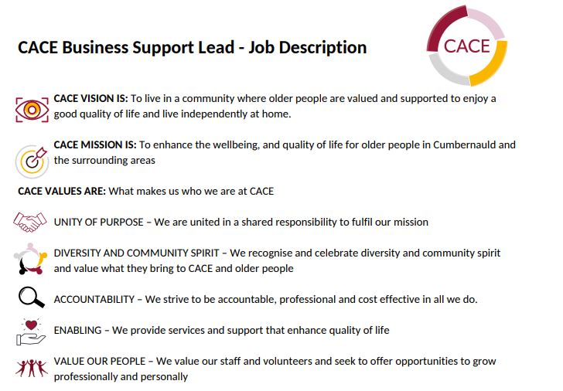

JOB TITLE: Volunteer coordinator
REPORTS TO: CEO
RESPONSIBLE FOR: volunteers and activities relating to volunteering

JOB OVERVIEW:

- To assist with the organisation of and provide delivery of CACE’s services for older people via the involvement of volunteers.
- To recruit and support appropriate volunteers via training and supervision
- To ensure accurate record keeping and evaluation of activities relating to volunteers

PERSONAL COMPETENCIES

- You'll bring passion for our values of putting service users first
- You will be a skilled communicator, able to make people feel welcome, comfortable, and encouraged to engage with a variety of services
- You're a highly motivated self-starter as well as a collaborative team member
- You will be an effective problem- solver
- You’ll be able to deliver activity at an operational level but also think strategically
- You will be experienced in keeping accurate records and evaluating the impact of volunteers
Key Accountabilities and Activities
Service Excellence

- Deliver a well-run volunteer programme that make a proven positive impact on participants
- Promote the aims and objectives of CACE
- Undertake training and participation in relevant networks to continually develop learning and good practice in relation to services
- Undertake such duties as may be required by the CEO that are consistent with the overall aims of the post.

Delivery of Services

- Provide effective delivery of the volunteer programme to ensure it works towards our organisational vision – including recruitment, training, placement, and support of volunteers.
- Ensure robust record keeping in relation to volunteers and volunteer activity
- Engage with, develop and manage relationships with key stakeholders including volunteers, service users and other staff
- Utilise problem solving skills to ensure volunteer related issues are dealt with effectively
- Collect data which enables accurate assessment and evaluation of the effectiveness and impact of our volunteer programme.
- To ensure compliance of volunteering with relevant legislation and guidelines and to follow risk management procedures relevant to activities.
- Hands-on involvement in group strategic projects, ensuring volunteer programme insight and knowledge is incorporated appropriately
- Work with other staff to engage service users and volunteers with activities.
- Contribute to the researching of potential new services involving volunteers

Information Management

- Ensure that record keeping is up to date and compliant with GDPR processes
- Collect accurate information to inform evaluation of services and lead evaluations relating to volunteer activity

Relationship Management

- Develop effective relationships with key stakeholders (internal and external) to ensure a high level of service is maintained and contribute to the overall promotion of CACE and its services.

