Student Advisor

Student Engagement

Grade 5
At Heriot-Watt University Student Union we have one simple purpose, putting students first, always. We are led by elected student officers, who are guided and supported by staff to make sure students are represented across all areas of university life. We also offer students opportunities to expand their skills and stand out to future employers, while building meaningful and lifelong connections and friendships.
The Student Engagement Department is here to make sure the student experience is the best it can be for the 10,800 students across our three Scottish campuses by delivering advice, opportunities and representation. This role will focus on delivering independent advice and guidance to students on all aspects of life at university, as well as exploring new and innovative ways to support students and streamline processes. You'll be joined in the team by the Student Voice Coordinator who focuses on improving and promoting representation through our democratic and academic structures, and the Activities Coordinator who provides opportunities through societies and volunteering.
The whole team empower Full-time Officers, volunteers, and students to build relationships, take action and make an impact by encouraging them to find creative solutions and drive change on the areas that matter to students.

Purpose of the role
At Heriot-Watt, we strive to make sure students get the help they need, no matter their circumstances. The Student Advisors will provide advice and guidance to students who visit the Union’s Advice Hub, both in person and online. Advisors also attend disciplinary meetings with students to ensure they are represented, as well as implement new ways to engage and inform students to positively shape their student experience.
In this role, you will work with our elected officers to increase their understanding of issues students are facing. You will work closely with the Vice President Wellbeing, Student President, and the Wellbeing Members of Parliament to improve student wellbeing, and put students first, always.

Organisational position
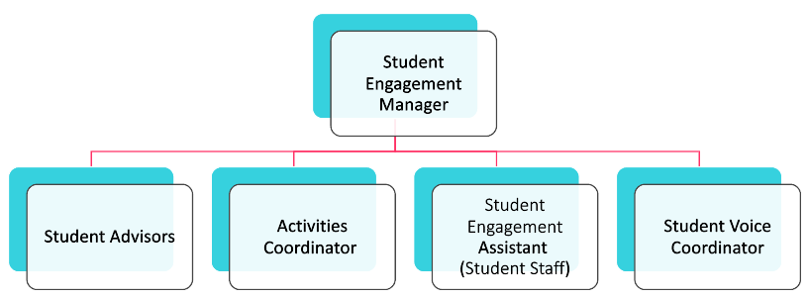

Principal Duties
Life at university isn’t always straightforward for our students. Our Student Advisors ensure students have help when they need it, as well as identifying proactive ways to improve the student experience and tackle the root causes of issues. There are several ways you will improve the student experience:

Provide advice & support to students
The Student Advisors are responsible for supporting any students who come to the Advice Hub with relevant information and an excellent service. These are some of the ways you might do that:
- Give advice and guidance to students who contact the Advice Hub to resolve problems and find a way forward in their studies.
- Develop and maintain understanding of Heriot-Watt University policies and procedures, as well as issues facing students in the Higher Education sector, to provide students with up to date, relevant advice.
- Manage caseload and prioritise casework according to deadlines and the needs of students.
- Liaise with University services to jointly provide the best experience for students in need of support.
- Cover a busy enquiries desk (sometimes over a lunch period).
- Provide students with free contraceptives and sanitary products.

Create new ways to engage students
Student needs are constantly changing and adapting. The Advice Hub needs to respond to student expectations, which includes increasing the information available to them digitally. Part of your role will be to:
- Develop and maintain guides for students on a range of issues, e.g. completing appeals or mitigating circumstances forms, how to find accommodation etc.
- Assist with maintaining Advice Hub webpages to ensure that information is accurate, accessible and up to date.
- Consider how processes can be streamlined within the Advice Hub and try new methods to engage and improve life for students.
- Coordinate activities throughout the academic year to increase student engagement in the Advice Hub.
- Continually strive for improvements to the student engagement and representation aspects of the Union.

Representing Student Views
Throughout the year, Student Advisors will gather data and information that improves our understanding of the issues students face. Student Advisors need to:
- Accurately capture and monitor Advice Hub statistics to be aware of any trends that occur.
- Communicate trends internally with the Full-time Officers and staff, to work with the University to resolve common issues.
- Contribute to policy development in the Union and University that impact upon students.

General Duties
For most of your role, you’ll be working on the areas above, but the working environment in the Union requires team members to be flexible, adaptable, versatile, and to work as a team. As such, you’ll need to:
- Be willing to travel to our Scottish Borders Campus in Galashiels at least once a month.
- Take on other tasks or activities that are relevant for the role from time to time, e.g. contributing to Welcome Week Activity.
- Follow all HWUnion policies, procedures, and governing documents.
- Undertake personal and professional development as required to maintain appropriate knowledge and skills.

Competencies
All staff at Heriot-Watt Student Union are expected to demonstrate our core competencies:

Accountability
Takes personal responsibility for the part they play in our students’ union, its mission and values, the student body and wider society

Student Focus
Keeps the needs of students at the heart of activities

Personal Effectiveness
Consistently role models high standards and good practice

Inclusivity
Applies an understanding of equality and diversity to strengthen positive engagement in all our student union activities and services

Results Focused
Maintains commitment to targets and results, striving consistently to achieve them

Communications
Helps to provide clear, consistent and appropriate messages at all levels of our students’ union and beyond

Political Awareness
Applies an appreciation of the political environment in which our students’ union operates

Person Specification
If you have most of the criteria, we encourage you to apply, and welcome transferable skills from other industries or backgrounds. It’s unlikely that we will find a candidate with all the skills below, but preference will be given to candidates who demonstrate experience across a number of these areas in their application and interview.
 | Essential | Desirable

Personal qualities
Able to maintain a high standard of personal integrity, confidentiality and diplomacy | x
Affinity to our values of fun, student focused, brave, welcoming and empowering | x
Empathy and ability to comfort and provide support for students in difficult and distressing situations | x
Innovative approach to problem solving and implementing creative solutions | x

Qualifications
An SCQF Level 9 qualification (e.g. Bachelors/Ordinary degree, graduate diploma/graduate certificate/professional development awards, etc) or at least 2 years relevant experience in a similar service user engagement role | x
Qualified to deliver relevant training e.g. Scottish Mental Health First Aid |  | x

Skills/competencies
Excellent communication and interpersonal skills, reflected appropriately across different media to different audiences | x
Able to communicate complex information in an accessible way | x
Experience using IT applications including Microsoft Office and Databases, plus the ability to adapt quickly to new systems | x
Able to prioritise casework effectively and manage deadlines | x

Knowledge & Experience
Demonstrable understanding of mental health issues and the challenges typically affecting students in higher education | x
Ability to create clear content on a range of issues | x
Experience working with members/customers in a front facing role, handling sensitive information and signposting |  | x
Experience of giving advice and guidance to young people |  | x

Interests
Improving life for students, and making a genuine difference | x
Delivering high quality serviced and a focus on client needs | x
Working with a diverse range of students | x

