25th October 2022

Dear Applicant

Communications Assistant

Thank you for your interest in the above vacancy with Govan Community Project.
Enclosed with this letter is a copy of the job description, and a copy of our application form. The application form can be completed electronically, however we are also happy to receive paper applications. Should you require any reasonable adjustments to support you with the completion of your application, please contact Traci Kirkland on 07443964017.
The closing date for applications is 12.00 noon on Monday 7th November 2022. No late applications can be considered. We aim to hold interviews in the week commencing 14th November 2022.
To enable us to monitor diversity within our recruitment processes, we would be grateful if you could complete our anonymous diversity survey which can be accessed here: http://bit.ly/GCPHReqmonitoring, however this is not mandatory and opting out of this will have no impact on your application.
Completed applications being submitted by email should be sent to recruitment@govancommunityproject.org.uk. Paper applications should be sent to:
Traci Kirkland, Head of Charity
Govan Community Project
Pearce Institute, 840-860 Govan Road
Glasgow G51 3UU

We look forward to receiving your application.
Kind Regards
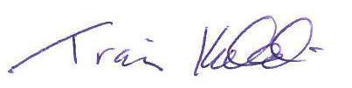
Traci Kirkland
Head of Charity

