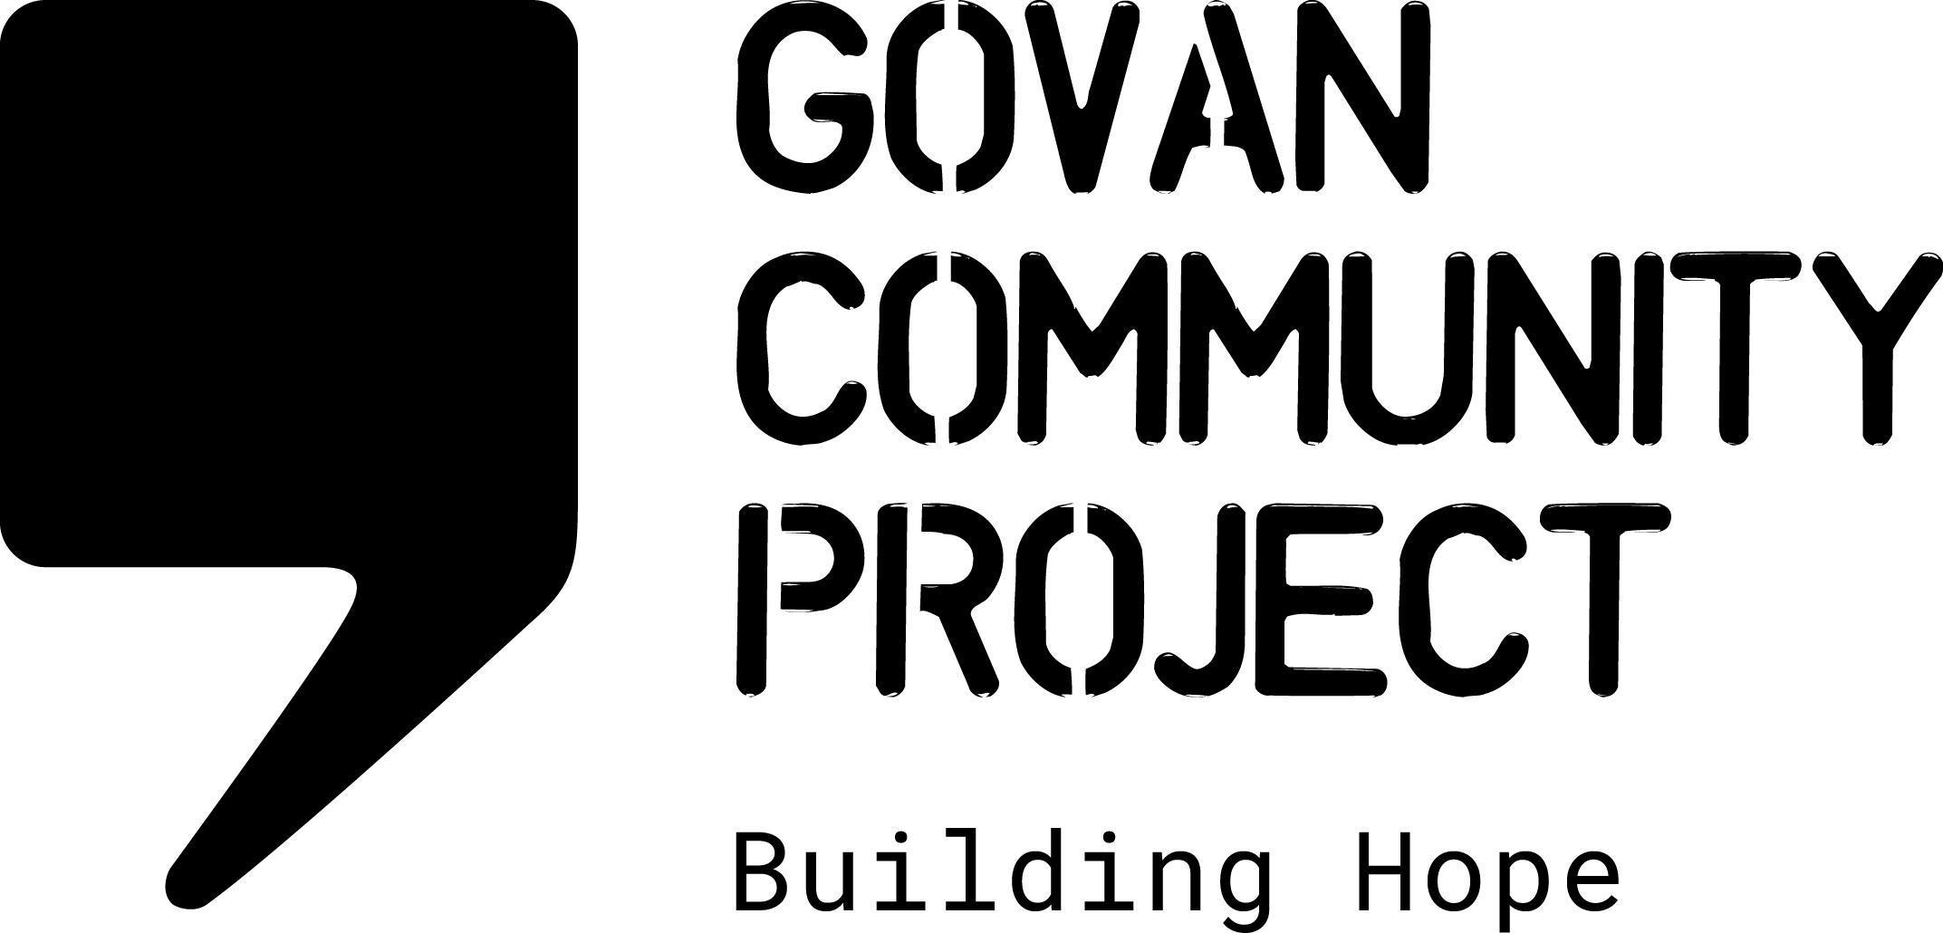
JOB DESCRIPTION

Job Title: | Communications Assistant
Location: | Pearce Institute, Govan & Homebased
Hours Per Week: | 14 hours per week Currently funded till March 2024
Salary Scale: | £19,000 per annum (pro rata’d)
Reporting To: | Head of Charity

OVERALL PURPOSE OF THE JOB

To support the GCP team to provide a co-ordinated approach to social media communications, ensuring that information is shared on all platforms used. The comms assistant role is crucial to ensuring a regular social media presence, sharing information in a timely manner, promoting our activities & opportunities, updating on policy & campaigning developments relevant to the asylum/refugee community,and sharing information from partner agencies.

MAIN DUTIES AND RESPONSIBILITIES

Social Media Content

- Managing all social media channels- planning and creating engaging content for social media platforms and scheduling sharing of information which promotes the work of GCP
- Support the involvement of GCP community members in developing content for social media
- Support the staff team with communicating information about projects and activities
- Responding to direct requests/contacts made via social media and forwarding enquiries to the appropriate staff member
- Maintain GCP website and update as required
- Coordinate the roll out of any GCP social media campaigns
- Upload relevant information to GCP website
- Work with partners to support collaborative social media campaigns

Marketing Strategy & Development

- Create a quarterly GCP Newsletter and grow the Newsletter mailing list
- Work alongside the Head of Charity to develop a Marketing and Communications strategy for the organisation
- Work with the staff team to develop a style guide for GCP social media content
- Work alongside any web development support to enhance the website functionality (if available)
- Utilise digital resources, digital analytics and training opportunities to maximise traffic to social media and website

Reporting, Monitoring and Evaluation

- To gather data on traffic and engagement
- To provide quarterly and ad-hoc reports to Head of Charity
- Undertake research/consultation with community members on accessibility of social media

Other Duties

- Working as part of the staff team to maintain the Values and Ethos of Govan Community Project
- Adhere to all organisational policies and procedures
- Work with the staff team to contribute towards providing a safe, welcoming, clean and tidy environment for staff and visitors
- Attend meetings and contribute to strategic development
- Perform any other tasks or duties deemed necessary

Personal specification:

Essential
- Evidenced experience of using social media and creating engaging content, either in a paid or voluntary capacity.
- Excellent written communication skills with the ability to create content for different audiences
- An ability to review, select and report on current affairs in relation to the asylum system and immigration
- A basic level of design skills for developing content for social media, preferably with experience of design platforms such as Photoshop or Canva
- A commitment to the aims of the organisation
- A flexible working approach and excellent time management skills
- Ability to work independently and as part of a team.

Desirable
- An understanding of the challenges faced by members of the asylum community
- Experience using mailchimp and website content management systems for creating/updating content
- Lived experience of the asylum process.
- Ability to provide written content in a relevant second language eg Farsi, Arabic, Kurdish Sorani

