Candidate Information

Project Manager – Behaviour Change, England South

Salary: | Grade G: £28,499 per annum pro rata
Hours: | Full time hours are 26.25 hours per week  We are very happy to discuss working hours to suit individual circumstances.
Contract: | Permanent
DBS: | Enhanced DBS is required
Base: | Hybrid – within reasonable distance of Sustrans offices in Reading or Bristol with flexibility to work from home. Based within South-East / South-Central geographical area.
Travel: | We may occasionally need you travel further during the course of your work including occasional overnights stays.
 | A key part of being the Charity that makes it easier to walk and cycle is that most colleagues cycle, walk, wheel or use public transport for the majority of work their work journeys. We support this with access to a Sustrans pool bicycle and National Standards Cycling Training.

About the Role

As Project Manager you will be responsible for project management of active travel behaviour change projects in multiple locations across the South, with a focus in the Central South region. Alongside project management you will also have line management responsibility for a group of project officers working to make a difference to individual travel behaviours and local communities.

The successful candidate will be joining a team of committed and experienced Project Managers, sharing best practice and working to be impactful and innovative, seeking out new opportunities for Sustrans as they arise. You will also collaborate with the wider regional and national teams to develop Sustrans’ position as experts in delivery of place-based, people-centered active travel projects.

You will build close working relationships with key stakeholders in the local authorities where your projects are based, helping to raise ambition for liveable cities and towns for everyone and securing the legacy of our work.

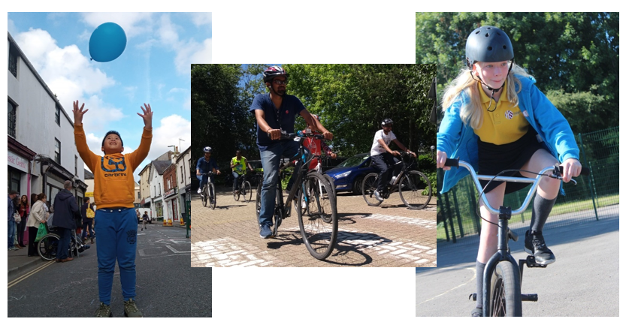
Where this role sits in the structure:

Job Description - About the Role

Overview

To assist the Programme Manager and Head of Delivery, England South, in managing the effective delivery of behaviour change, community engagement and built environment projects. The post holder will be responsible for directly managing a small team of behaviour change officers in the South, Central region alongside project management. The Project Manager will also be responsible for assisting with new business opportunities and services.

Where this role sits in the structure | Reporting into the Head of Delivery – England South  Working closely with the Delivery Team including other Project Managers, Volunteer Coordinators, Project Officers, Research and Monitoring Unit, Partnerships Manager and Communications Team.  Close collaboration with other regional team members in Design & Engineering, Partnerships and Network Development.  This role currently has line management responsibility for six Project Officers.

Key Responsibilities

Delivery of projects or services:
- To oversee and coordinate the delivery of a programme of work tailored around overcoming identified barriers to active and sustainable modes, which will include projects involving practical engagement activities e.g. led rides/ walks, cycle training for adults and children, active travel awareness events, relevant road safety events, personalised/ household travel information/ advice, on street engagement events, collaborative-design workshops.
- To ensure projects maximise the potential benefits from integrating behaviour change, community-led urban design and the improvement of cycling and walking infrastructure.
- To be responsible for working with project officers to plan and coordinate the practical delivery of projects, assisting at key events, workshops etc. and taking a role in practical project delivery to utilise expertise.
- To enable the success of projects through effective management of the team, including assigning Project Officers to specific short-term tasks.
- To work with Sustrans volunteer programme staff to ensure the promotion and coordination of opportunities for local volunteers/ champions to support projects.
- To manage project budgets, as delegated by the Programme Manager, England South, via FocalPoint – Sustrans’ project finance system
- To ensure monitoring and reporting tasks are carried out, with particular respect to partner and funder requirements.
- To collaborate with colleagues and external partners, supporting them with advice and evidence from our projects, encouraging policies that enable more people to travel sustainably.
- To ensure that all projects are being managed in accordance with Sustrans’ Project Management Framework (PMF) and Customer Relationships Management (CRM) and FocalPoint systems.

Business development:
- To support the England South Programme Manager, Head of Delivery and Director to develop relationships through involvement in key local networks.
- To participates in bid writing for projects at the direction of the Head of Delivery and Programme Manager, England South.
- To contribute toward the development of new ideas and innovative strategies for product development, marketing, branding, or business opportunities.

Communication and marketing:
- To report on the progress of relevant projects in the region to stakeholders, funders and within Sustrans, as appropriate.
- To contribute towards raising the profile of Sustrans, by representing the charity at meetings, activities and events, as required.
- To collate project-related information for marketing and broader communications purposes.

People management:
- To line manage Project Officers, motivating and developing a team.
- To manage, develop and coach the Project Officers by setting clear objectives and monitoring performance to maximise their potential.
- To work with HR to ensure that training and development of staff is planned effectively and in line with business need.
- To be responsible for supporting recruitment and for the induction of new officers.

We don’t expect anyone to be an expert in all these areas and as long as you meet the person specification we can train you in any gaps.

Person Specification
The following criteria sets out the method by which the skills, knowledge and experience will be assessed against. Our website has a useful guide about how to make a great job application.

 | Application Form | Interview
Specific experience required
Substantial experience of project management and delivery of projects with a range of partners
Experience of leading, managing, motivating and developing a team
Experience of developing transport behavioural change, community-based or environmental programmes
Experience of budget management
Experience of working on projects within an established project management framework
Experience of developing communications and marketing plans
Experience of producing reports and monitoring project delivery
Skills and Abilities
Ability to supervise a team, some of whom will be working remotely
Ability to communicate and collaborate with a wide range of stakeholders/ partners
Excellent verbal and written communication skills
Ability to work with limited supervision and plan, prioritise and work to tight deadlines
Ability to motivate and enthuse others
Excellent presentation skills
Specific knowledge required
Good understanding and knowledge of sustainable transport policy locally and nationally
An understanding of the challenges facing staff working with hard to reach groups and/or disadvantaged communities

This document does not form part of the contract of employment but does outline our expectations.
If we need to amend this document in the future we will consult with the post holder before doing so.

Everyone at Sustrans

Our values guide us in everything we do:
- Including everyone
- Having the courage to question
- Acting local, thinking big
- Getting things done, together
- Always learning.

- Sustrans has clear health and safety policies and it is essential that all our colleagues follow these. Very often our teams come into contact with young people through schools work or community engagement so it is everyone’s responsibility at Sustrans to comply with our Safeguarding policies.

- One of our key strategic goals is to be a charity “for everyone”, building a more diverse and inclusive Sustrans. We recognise there is much more we can do to bring together diverse life experiences and voices to enable us to more fully understand, access and represent the communities we work in. Everyone at Sustrans should support this goal and follow our Equality, Diversity and Inclusion policies and procedures.

- Sustrans asks that all our employees develop their skills, knowledge and experience through training and personal development activities. Sustrans will support you with clear objectives and a supportive management culture - our teams tell us that one of the great things about working for Sustrans is the learning and knowledge sharing opportunities.

- It is very important that our colleagues are happy and able to work with IT systems - we use Microsoft programmes and other databases every day (we will train you on our bespoke systems).

- It is also important that everyone at Sustrans supports and follows with the charity’s guidance on branding/key messages and contributes towards raising Sustrans’ profile.

- Everyone at Sustrans is required to work their contracted hours and record their time – if extra hours are worked then we can take time off in lieu.

- We ask that everyone in Sustrans helps us to develop new opportunities for funded work and builds excellent relationships with our delivery partners and stakeholders.

- Two of our values are we get things done, together and we’re always learning. Managers often require their teams to get involved in activities that are outside of their job descriptions as we feel this is one of the ways you can learn on the job, develop new skills, make new contacts and progress your career with Sustrans.

