Job Description & Person Spec
Post: | Youth Development Worker: Agent for Change
Responsible to: | Senior Worker/Centre Manager
Contract | Fixed Term March 2024
Hours: | 21hrs per week

Purpose of Position:
The Development Worker will lead on and be responsible for building the capacity of creating a social action project which seeks to develop and embed children and young people’s rights within their communities. Working alongside a core group of children and young people, you will be responsible for the effective development and delivery of all aspects of the Agents for Change project.

With a commitment to diversity, equity and inclusion, the Development Worker will also lead a small team that will undertake educational interventions with a view to maximizing inclusive and participatory experiences. The role will include leading on training, group work and action research sessions through a
co-design approach which centres on increasing skills and amplifying voices and ensures that communities become home for their rights.

Major Tasks:
- To lead on inclusive recruitment and training of children and young people to co-design the project.
- To lead and support a wider team in the delivery of the Agents for Change Project.
- To ensure participants can maximize their involvement in all aspects of the project including planning, development, decision making process and evaluations.
- To lead on, contribute and ensure staff involvement in monitoring and evaluation of the project.
- To manage all appropriate resources which include human and budgets.
- Support and guide staff to plan and deliver learning activities within the project.
- To plan and deliver a progressive educational curriculum.
- To prepare, co-ordinate and present end of term evaluations and project reports, as set out within agreed frameworks and funding outcomes.
- To co-operate and liaise effectively with team members and senior leadership.
- Take a creative and enthusiastic approach to making our youth and children’s work a leader in its field.
- Take an effective role in current or developing partnership working.

Job Activities:
- Support and lead other team members in the delivery of all learning opportunities and programme activities.
- Address any matters that may arise during the delivery of a session in partnership with children, young people and where appropriate senior leadership.
- Listen to and engage with children and young people in a positive, supportive, and challenging way.
- Provide a safe, secure, and stimulating environment for children and young people.
- Offer a reflective space when planning/recording sessions.
- Lead on all elements of session planning, delivery and evaluation in relation to the project.
- Liaise with manager in relation to staff absences/cover.
- Co-ordinate and develop the project programme alongside children and young people.
- Ensure that all venues are fit for purpose and meet the Agents for Change requirements.
- Ensure that all supporting resources for programme delivery are available and appropriate to staff/participants requirements.
- Ensure that all non-staffing resources are allocated appropriately and accounted for.
- Ensure that the views of participants are reflected in and taken account of when planning, developing, delivering learning programmes and activities.
- Be a valued team member and positive leader.
- Ensure team members contribute to the monitoring and evaluation process, reflecting service requirements.

Support Development and Training
- Ensure all staff members understand and can implement practice that reflects the most relevant policies alongside the UNCRC.
- Assist staff members in contributing to the delivery of the service where appropriate.
- Provide support and guidance to Agents for Change team.
- Identify training needs of team members and communicate requirements to the relevant senior leadership member.
- Where appropriate, support staff members in the delivery of accredited opportunities for children and young people.
- Complete core training, and training offered as part of CPD, within agreed timescale.

Administrative Responsibilities
- Provide reports/updates as and when required.
- Ensure that all statistics/relevant information are inputted to systems.
- Liaise with senior leadership regarding funding applications and budget requirements.
- Undertake all appropriate duties as requested by the senior leadership team.
- Maintain clear and concise information.

Supervision and Management of People
(Numbers and type of staff)
- Normally up to a maximum of 2 in total including:
- Youth and Children’s Workers (sessional)
- Volunteers

Creativity and Innovation
Be creative and innovative, think of ways that will stimulate and activate children and young people’s interests. The post holder will require a degree of independence and be able to provide a flexible approach to the development of team members, programmes of activities, evaluations, and make contributions to reports with the senior leadership team. The post holder will be imaginative, basing interventions on ages and stages and at all points will seek to amplify children and young people’s voices.

Contacts and Relationships
Contacts may include:
- Children, young people and at times their families.
- Parents and carers, where appropriate, providing feedback on a multitude of matters.
- Agents for Change team and the wider youth and children’s team.
- Key Stakeholders including wider community organisations, businesses, public sector services and funders (Children In Need, #IWill and the Hunter Foundation).
- Senior Leadership team or nominated CEC staff member.
- CEC departments including FM & BS

Decisions (Discretion)
Decisions made will include those relating to:
- Resource/budget.
- Programme development and content.
- Publicity and Promotion, including social media content.
- Monitoring and evaluation.
- Health and safety - e.g. setting up the venues safely and on-going assessments.
- Provision administration - this covers such things as registers and end of session recordings.
- Staffing required and allocation of tasks.
- Implementation of organisation policies and best practice.
- Matters to refer to senior leadership team including welfare concerns.

What Will Success Look Like:
- Children & young people feel valued and listened to.
- Children and young people have increased their skills and feel confident in carrying forward action research in relation to the UNCRC.
- Offered and supported a wide range of experiences for young people and children and had fun in the process.
- A team who alongside children and young people, have carried out action research and an ‘investigation’ into the UNCRC within a community context.
- You will have led a team who has co-designed and launched a Charter on the UNCRC for Children’s Rights in the community.
- Children & Young people of all ability have engaged positively in all programmed activities
- Children & Young people have their learning recognised/accredited.
- You have led a team who feel supported, valued, and informed
- A team who effectively deployed its resources to support programme delivery
- A team that created, a vibrant, and appropriately programmed curriculum delivery that took place in a safe environment at times and spaces which were developmentally appropriate
- Supported team members who identified a range of continuing professional development opportunities
- Contribution to a team that performed to an exceptional standard, providing a supportive, safe, inclusive, and ambitious environment
- Delivered on funded targets reinforcing our proven track record of delivering successful targeted outcomes
- Continued to develop monitoring and evaluative frameworks, enabling staff and volunteers to use identified tools to enhance the quality of the educational interventions and support given to assist children and young people’s progression.
- Strong local partnerships being developed, which has resulted in direct benefit to young people, children and their families.
- You have ensured the positive contributions that children/young people services make is evident within and beyond our community
- You have worked alongside others to consolidate and develop our strategic aims

Personal Attributes:
The Youth Development worker will be an individual who can show:
- Positivity and drive
- Excellent communication skills
- Excellent organisational skills
- Excellent interpersonal and team working skills
- Self-motivated
- Effective time management skills
- Understanding, of and commitment to, social justice, equal opportunities and the UNCRC
- Flexibility to meet the needs of children and young people and a willingness to work on their terms

Complexity:
The post-holder is required to have a working knowledge of youth work principles and practice and the UNCRC.

The post-holder should have an awareness of the importance of youth participation and co-design and should ensure that the principles of inclusion and equal opportunity underpin their practice.

The post-holder will be expected to develop and maintain positive working relationships with a wide remit of groups, organisations and individuals at all times.

The post holder understands due to the nature of working with young people and children that there may be occasions for unsociable hours work.

Special Conditions:
As this post requires the candidate to have contact with young people and children, the appointment will be made after a successful PVG check.

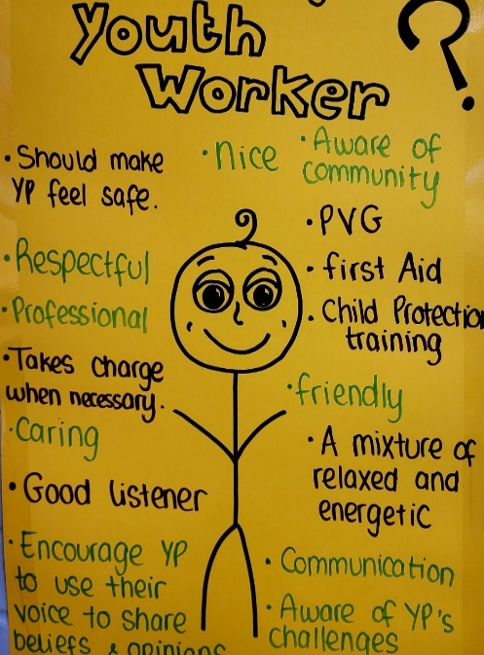
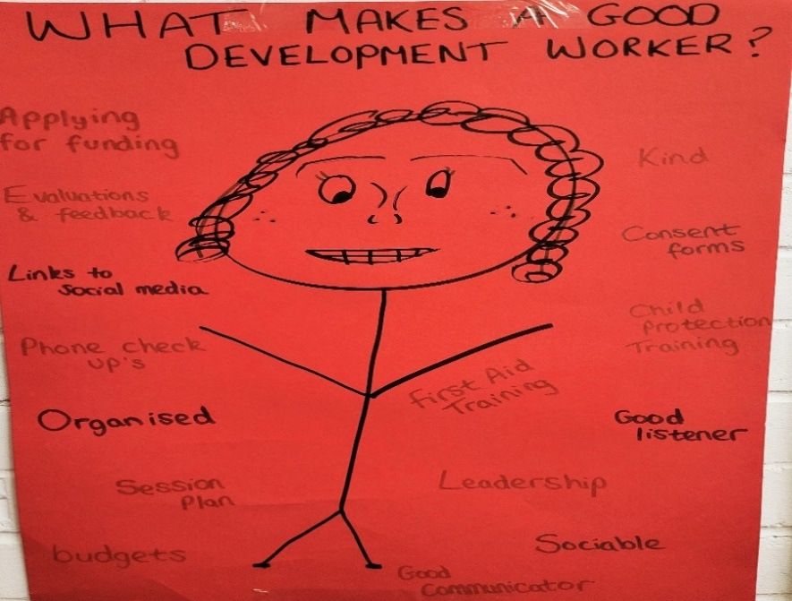

Person Specification | Essential or Desirable
Education
Educated to degree level or equivalent qualification in Community Education,  Education, Social Sciences, Youth Work or equivalent experience. | Desirable
Experience
At least 3 years of substantial and demonstrable experience of working directly with a diverse range of young people and children within a multitude of settings. | Essential
Experience of leading staff and volunteers. | Desirable
The ability to effectively work alongside staff, young people and children who  present with sparkle. | Essential
Experience of promoting equality of opportunity and combatting discrimination. | Essential
Knowledge of current good practice in working alongside young people & children in particular action research and the UNCRC | Essential
Substantial and demonstrable experience of delivering age and stage programmes. | Essential
Good working knowledge of existing organisations working with and providing services for young people both in East Edinburgh and citywide. | Essential
Experience of working with a range of IT and social media platforms. | Essential
Experience of working alongside others to deliver positive outcomes and results. | Essential
An understanding of working with external funders whilst securing funds. | Desirable
Skills
Excellent communication skills, both verbal and written, relationship building, negotiation and interpersonal skills. | Essential
Effective people management and coaching skills. | Essential
Ability to relate and communicate to young people & children from all backgrounds. | Essential
Ability to both lead a team and work as a team member. | Essential
Self-motivated and able to work to multiple deadlines. | Essential
Strong organisational skills, with structured approach, ability to be flexible and responsive with a focus on participant needs. | Essential
Ability to be non-judgemental and open-minded. | Essential
Ability to care about and be sensitive to individuals and the community. | Essential
Ability to be flexible to meet the needs of individuals, groups and the organisation. | Essential
Ability to adhere to and maintain effective relationships whilst interacting with  people within appropriate professional boundaries. | Essential

