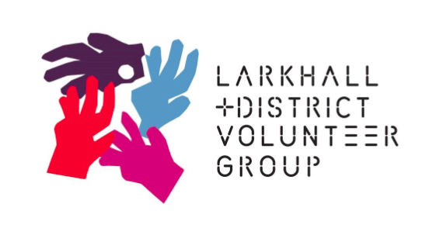

**Role Description - Board Trustee**

**Role Purpose**

* To be an active and contributing member of the Trustee board
* You will help to ensure organisational compliance in all areas of legislation, policy and procedure, using personal skills and experience to help the board in reaching structured and sound decisions.
* You will assist the Chairperson with the recruitment and selection of employees.

**Role Description - Vice Chair**

**Specific Duties and Responsibilities**

* To act for the Chair in their absence
* Undertake assignments at the request of the Chair

**Role Description - Treasurer**

**Specific Duties and Responsibilities**

* Oversee and present budgets, accounts and financial statements
* Be assured that the financial resources of the organisation meet its present and future needs
* Ensure that the charity has an appropriate reserves policy
* Prepare and present financial reports to the Board, raising issues and answering questions at regular meetings and the AGM
* Liaise with the Charity Manager about financial matters
* Ensure that the charity has an appropriate investment policy (if required)
* Ensure the organisation’s compliance with legislation
* Ensure that the accounts are prepared and disclosed in the form required by funders and the relevant statutory bodies – OSCR and Companies House
* Ensure that the accounts are scrutinised by the independent examiner and any recommendations are implemented

Some of the tasks above may be delegated to a member of staff however the Treasurer must ensure they are carried out.

Trustees for LDVG have responsibility for governance of the Charity and overseeing the management and administration of the organisation. Trustees have, and must accept, ultimate responsibility for directing the affairs of LDVG, ensuring that it is solvent and well run, delivering quality services for people in Larkhall and District for which it was set up. Trustees are accountable for their decisions and actions to the public, funders and service users.

**Time Commitment**

The Board meets approximately 12 times per year normally from 4pm to 6pm on 3rd Tuesday of the month. The Charity now has an interactive comms system which will allow for the occasional opportunity to join online.

There will, from time to time, be the opportunity for Trustees to join subgroups such as Fundraising, HR, Finance & Evaluation and Research which may meet out with the main Board meeting.

Communication between meetings usually takes place by e-mail, letter or occasional phone call.

Further information available by contacting chairperson: :chair@ldvg.org.uk