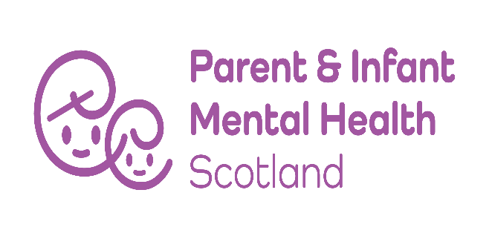

Parent and Infant Mental Health Scotland

Job Description

Job Title:

Development Manager

Job Purpose:

The post holder will have specific responsibility for the operational management of the organisation and the development along with the Board of Trustees of a new Parent and Infant Mental Health Scotland strategy for PIMHS. This will be in partnership with a multitude of high profile stakeholders across Scotland; including statutory services, third sector organisations, professional organisations, parents and families affected by mental ill health during the perinatal period.

You will also continue to develop joint working with Maternal Mental Health Alliance (a UK wide coalition of organisations working in the perinatal mental Health field).

Accountable to:

The post holder will be accountable to the Chair of Parent and Infant Mental Health Scotland on behalf of the Board of Trustees.

Responsible for: All permanent and temporary staff

Terms and Conditions:

- Annual salary is £40,000 p.a.
- PIMHS runs an employee pension scheme through NEST and makes a 4% of salary employer contribution. Employees need to make a minimum 4% contribution.
- 25 days holiday and 12 public holidays
- The post holder will be home based, but there will be some travel to meetings in Scotland and other parts of the UK.
- The post holder will be subject to a Disclosure Scotland check.

Main Responsibilities:

- To provide leadership to Parent and Infant Mental Health Scotland (PIMHS) and to be responsible for the management and administration of the organisation.

- In partnership with the Board of Trustees to look at ways of securing further funding for the organisation.

- To lead the PIMHS engagement with Scottish Government, statutory services, third sector organisations, experts by lived experience and parents and families affected by mental ill health in the perinatal period.

- To implement the PIMHS strategy, by using PIMHS collective voice to engage, inform and influence national decision makers.

- To raise awareness and drive action to increase interest and investment in perinatal and infant mental health.

- To provide strategic leadership to co-ordinate and influence efforts to improve access to quality perinatal and infant mental health and early years services.

- To harness our membership to inform strategic decision making.

- Liaise with the Chair as appropriate to undertake regular reviews of performance against the agreed strategy.

- Ensure the Board of Trustees have at their disposal sufficient, high quality regular management and monitoring information and professional advice to fulfil their governance responsibilities.

- To attend Board of Trustees meetings.

Skills and Experience:

- Strong project management skills and ability to provide qualitative evidence that you are meeting the stated objectives of the post.

- Ability to manage and provide ongoing supervision and support to other members of staff.

- Strong interpersonal skills. You should have the experience and ability to engage with a range of stakeholders including policy makers, budget holders, practitioners, volunteers, and families with experience of mental ill health which may have been exacerbated during pregnancy and the early years.

- A general understanding of perinatal and infant mental health issues, and the social and emotional wellbeing of babies and parents more broadly.

- Excellent presentation, influencing and negotiation skills and ability to liaise with a wide range of stakeholders.

- Experience of managing conflicting demands, meeting deadlines and adjusting priorities.

- Excellent communication skills, both written and verbal.

- Ability to work with patience, tact, empathy and diplomacy.

- Excellent IT skills (Word/Excel/PowerPoint. Teams etc, Internet and e-mails).

- Willingness to travel across Scotland and occasionally beyond with occasional out of office hours and overnight stays where necessary.

- Willingness to work as part of a remote team and from home.

October 2022

