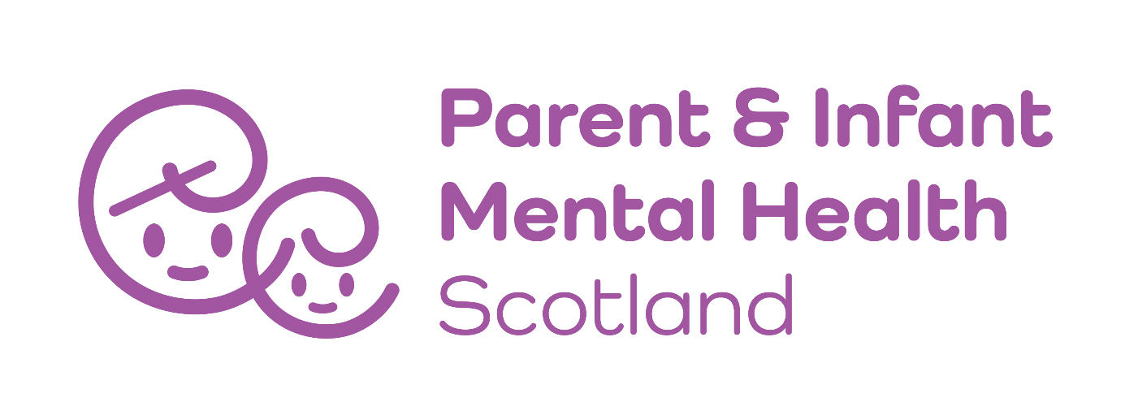

Parent and Infant Mental Health Scotland (PIMHS) Overview of Strategic Plan 2020 – 23

Our vision is that every parent, carer and baby can easily access great mental health care during pregnancy and the first three years of life.
Our mission is to drive change using our strong collective voice to engage, support and challenge national and local decision makers to value and invest in the social and emotional wellbeing of babies and families in the early years.
Background
This strategic plan sets out Parent and Infant Mental Health Scotland’s (PIMHS) vision and objectives for the 3 years, 2020-2023. Historically, much of our work has been ad hoc rather than strategic, based on limited resources available to a group of volunteers. This document represents a step change in approach, setting out our plans for the future in alignment with the changing policy, health and social care landscape and what we will need to realise our ambitions.
The need for a coordinated and increased response to perinatal and infant mental health care has never been greater, and especially so now as the effects of Covid and the increasingly challenging economic context bite down. There is a critical, nation-wide gap in connecting experience on the ground and decision makers at a policy and resource level. New and expanding opportunities are opening up and we intend to be well positioned to maximise those and increase our impact both at a strategic and grassroots level.
National funding body, The Robertson Trust has taken a special interest in the field of perinatal mental health in relation to its funding theme ‘Improving the Wellbeing of Women and Girls.’ Having identified the opportunity for PIMHS to evolve and ‘step up’, the Trust has been instrumental in providing support to build our capacity to develop this plan and deliver against it.
Following 18 months of strategic planning, we have secured further funding from the William Grant Foundation, and the Cattannach Trust to help drive the shift away from a traditional, clinical understanding of mental illness towards a greater understanding of the social and emotional wellbeing of parents and babies, with an emphasis on relationships.
Methodology
This plan has been developed in consultation and collaboration between board members, the wider membership, women and families with lived experience, strategic stakeholders and professionals working in the field of perinatal and infant mental health. During the summer of 2020, we carried out a consultation with members and stakeholders to determine need, our direction of travel and priorities for action. Methods of consultation included:
- A public online survey (72 responses)
- Focus groups with women with lived experience (Change Agent women)
- A round table discussion with key stakeholders in the perinatal field (21 participants)
Recommendations from independently commissioned research and our own learning have also been taken into consideration. Current policy and strategy has also been carefully reviewed to ensure we are filling a critical gap and working in a connected and integrated way.
Background
PIMHS has its roots in Maternal Mental Health Scotland (MMHS). MMHS was set up in 2009 by a group of health and third sector professionals who were either working directly with pregnant women, up to 12 months after the birth of their baby or had a particular interest in perinatal mental health. Over the years, MMHS championed the need for service improvements for women and their families across Scottish NHS Boards with varying degrees of success. In 2014 the organisation registered as a Scottish Charitable Incorporated Organisation. The organisation is member led and almost entirely volunteer run.
In 2022, the organisation changed its name to Parent and Infant Mental Health Scotland. The change of name was to allow us to better advocate on behalf of women, partners, babies and families to create local services that can provide a spectrum of care running from family support through to specialist care.
Over our 13 years of delivery, we have stimulated discussion about perinatal, and latterly, infant mental health, commissioned research to improve understanding and developed initiatives and resources which are responsive and effective. We work across Scotland in close association with other organisations and statutory services to bring about positive change to women, parents and families’ experience of perinatal and infant mental health support in both prevention and crisis.
Achievements
Despite underfunding and minimal resources, PIMHS has managed to win significant support and make a notable impact. The following are examples of some successes:
- Influenced the Scottish Government to recognise the importance of maternal mental health and allocate more resources to it (the Perinatal and Infant Mental Health Fund and funding for the Managed Clinical Network as examples)
- Commissioned research including with NSPCC ‘Getting It Right For Every Mother and Baby’
- Instigated and developed a Managed Clinical Network for perinatal mental health bringing together a range of experts across Scotland
- Established and supported ‘Change Agents’ as an independent, peer led group of women with lived experience to use their voices to challenge stigma and demand better support
- Advocated for the posts of both a Perinatal and Infant Mental Health Participation Officer to the Programme Board, and now employ those roles.
- Organised annual conferences (with 200+ attendees) when there was no national forum for issues related to perinatal and infant mental health in Scotland. The event brings together professionals and people with personal experience
- Collaborated with a range of partners to deliver specific initiatives, for example with Maternal Mental Health Alliance (MMHA) to deliver the Everyone’s Business project in Scotland.
- Developed an international partnership with a group in Malawi through THET
- Developed the Perinatal Mental Health Masters Modules and share learning and best practice across a range of fora
- Evolved MMHS into Parent and Infant Mental Health Scotland, a robust and well governed charity with wide representation.
Our Evolution
Whilst we are proud of our achievements to date, we recognise that there is more we want to do and more that demands to be done. Over the past 18 months, we have engaged in a period of capacity building, consultation and planning. We are in the process of transitioning from a volunteer led organisation contributing what we can around our busy day jobs, into an organisation able to act as the national, collective voice for perinatal and infant mental health in Scotland, driving change and improvement with the resources to back us up.
Through extensive consultation with national stakeholders we have identified a need to become more diverse and inclusive to better support mothers, fathers and babies, particularly those groups and community networks who have been overlooked and underserved historically. We are delighted to have secured funding from The Robertson Trust, Cattannach Trust and The William Grant Foundation, to expand our reach and remit to better reflect our growing ambition for parents and babies in the perinatal period. The name change to Parent and Infant Mental Health Scotland (PIMHS) was the first step in our evaluation and we are now recruiting a Development Manager and Communications Lead to harness our memberships and drive forward the new strategy.
Strategic context
Interest in perinatal and infant mental health as a public health issue has been growing since 2012. The Scottish Intercollegiate Guideline Network (SIGN) explored clinical guidelines needed to facilitate a world-class maternal mental health service and concluded that effective detection and treatment depended on individuals and organisations working together, including GPs, community mental health services, health visitors, social services, and third sector organisations.
As a result, the Perinatal Mental Health Managed Clinical Network (MCN) was established to bring together a range of maternal mental health professionals to improve standards of care in specialist perinatal mental health services with a particular lens on 1. Working in partnership, 2. Developing professional expertise, 3. Ensuring equity of care and 4. Delivering best outcomes. MCN published a needs assessment ’Delivering Effective Services’ in early 2019 setting out a direction of travel.
In its Programme for Government 2018-2019, the Government made a commitment to “invest in perinatal and infant mental health to support parents and infants at the outset to prevent problems escalating” and it’s policy for Better Mental Health in Scotland (Dec 2018) included clear commitments to improving support during pregnancy and after birth:

“At the earliest stage, we must ensure that parents are well equipped to support their children. We will substantially expand the range of perinatal support available to women… We will ensure there is sufficient investment in service provision for equitable access to perinatal counselling services, perinatal and infant mental health promotion, and preparation for parenthood for those who need it, including in the third sector. All mental health staff should have the knowledge and skills necessary to promote good maternal and infant mental health, and recognise and manage, to their level of competency, mental distress and disorder.”

The Perinatal and Infant Mental Health Programme Board was launched by the First Minister in March 2019 to oversee, provide strategic leadership and have overall management of the delivery of improved services. The Board launched its Delivery Plan 2019-2020 (combining both Perinatal Mental Health and Infant Mental Health) and alongside, the Scottish Government announced a £52 million commitment over the five years to support the delivery of it.
The Board’s plan can be condensed into 4 key actions:
- More capacity: including more support to the crucial role Third Sector organisations play in delivering non clinical interventions and developing a preferred national peer support model
- More staff: including to deliver work force training as a priority and the role of specialists within the perinatal field within the universal workforce
- More Voices: to ensure that the voices of women with lived experience contribute to the programme board
- Infant Mental Health: develop a model of infant mental health to meet the wider needs of families experiencing adversity.
A national body: PIMHS USP
Across government and the perinatal and infant mental health landscape, there is a consensus to work together more effectively, although funding to facilitate this is at present limited. Whilst there is a Managed Clinical Network in place and the P/IMH Participation Officers provide a mechanism for parents and infants experiences to feed into the debate, there is a clear gap and need for a national body to bring together these voices of experience, influence policy, challenge poor performance and campaign for change in a unified and concerted way. The direction of travel and the specific commitments outlined by the Programme Board widely align with PIMHS’s purpose/ approach and represent real opportunities for us to bring additionality going forwards.
PIMHS will fill a critical and growing demand for a national representative organisation in the field of perinatal and infant mental health. There are a number of excellent networks and support providers across Scotland, but we will act to fill the missing link between them and build their capacity further. We will expand our established network of clinicians, third sector workers and experts by experience and add value and strengthen the sector. We will provide an overarching, consensus driven and comprehensive offering which combines information, research and training, coordination and representation, lobbying and awareness raising under one roof. We are independent of any agency and will be the only organisation in Scotland to do this.
The next phase of the PIMHS strategy will:
- Better reflect the evolving understanding of mental health, moving beyond a clinical definition to a more holistic understanding of mental health and wellbeing
- Provide a central information point around perinatal and infant mental health to consult partners and bring voices together effectively
- Provide strategic oversight when the PIMH-Programme Board ends 2023 to avoid any potential conflict of interest for clinical networks scrutinising NHS Board performance
- Improve cross sector working and facilitate evidence-based collaboration to inform the desired continuum of care, from peer support through to specialist care
- Provide a platform to underrepresented groups and community networks who have been overlooked and underserved historically
- Create opportunities for joint strategic decision making, shared learning and meaningful collaboration
- Create dedicated capacity across sectors to monitor implementation of national policy on perinatal and infant mental health and the early years more broadly
For more information, contact: info@pimhs.org.uk

