Health All Round
PERSON SPECIFICATION

Community Link Worker

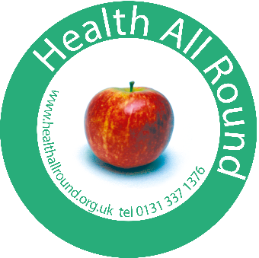

The successful applicant will be aware of the social implications of economic inequalities and share our commitment to building a fairer, more equal society in which all people have a chance to flourish and fulfil their personal potential.

Criteria | Essential | Desirable
Qualifications & Training  Level of education, professional qualifications, training and learning programmes/courses. |  | Educated to degree level in a relevant field e.g. health sciences/health & social care/public health
Personal Qualities | Approachable, positive attitude  Able to work with people with a wide range of abilities, backgrounds and experience  Compassion and the ability to empathise and take a non-judgemental approach to people presenting for support.  Positive outlook, self motivated and flexible
Experience  Length and type of experience, level at which experience gained. | Extensive experience of working with vulnerable people using a social model of health  Experience of working with people with complex health and social needs  Understanding of behaviour change and experience of supporting people to make positive change for health and wellbeing | Understanding/experience of motivational interviewing  Experience of partnership work across the sectors
Knowledge  Depth and extent of knowledge. | Understanding of the impact of social and economic inequalities on communities and individuals  Understanding of professional boundaries and confidentiality  Good understanding and creative approach to evaluation
Skills/Abilities  Range and level of skills  i.e., leadership etc. | Ability to support individuals in psychological distress calmly, safely and sympathetically  Ability to listen, support and motivate individuals  IT skills including the use of databases  Ability to work autonomously, plan workloads, meet deadlines etc
Specific Job Requirements  Environmental conditions, unsociable hours, car driver etc. | The majority of your work will be within office hours and HAR is happy to accommodate family friendly working patterns and/or caring responsibilities. There may, occasionally be a need for evening/weekend work. We require a degree of flexibility in order to meet the needs of local people.  You do not need to be a car driver for this post.

