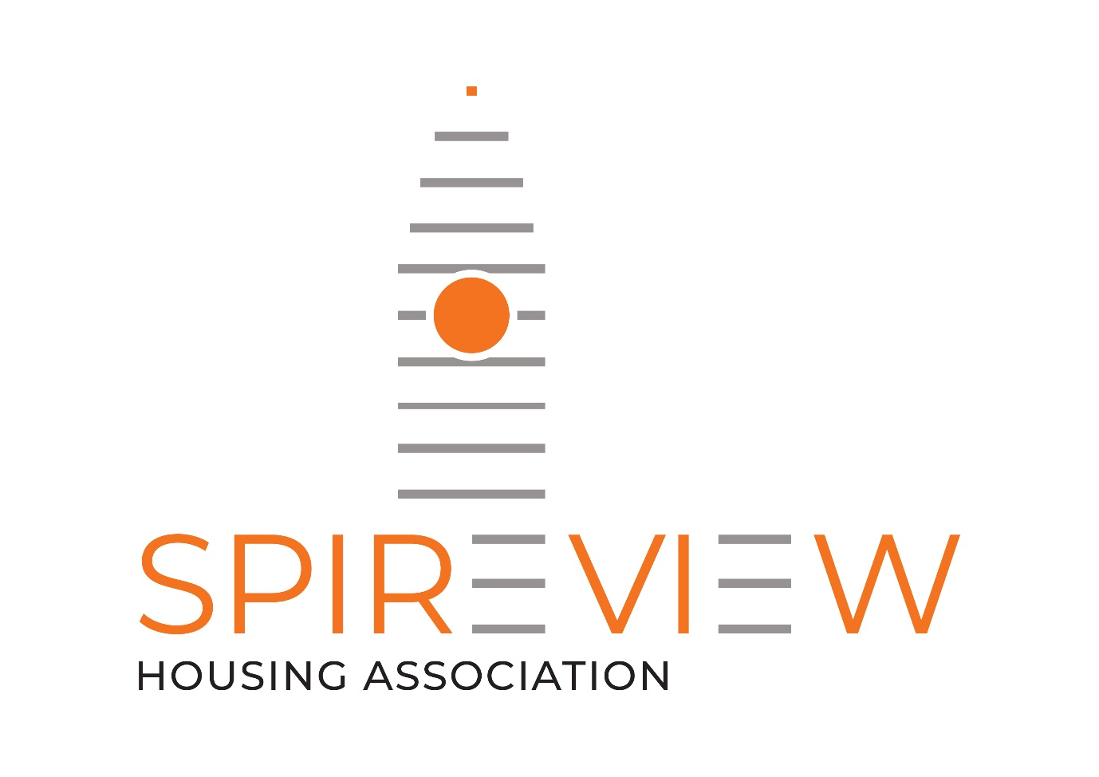

Spire View Housing Association
Working in partnership with Copperworks Housing Association and Blochairn Housing Association

Energy Support Assistant
Royston Community Energy Project

Recruitment Information

November 2022

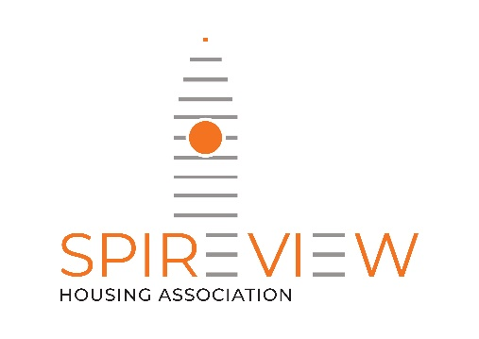

Dear Applicant,

Post of Energy Support Assistant

Thank you for expressing an interest in coming to work with us at Spire View Housing Association as Energy Support Assistant for the Royston Community Energy Project.

I have enclosed the following documents with this letter:

- Job Description
- Person Specification
- Summary of Terms and Conditions
- Fair Processing Notice
- Equal Opportunities Monitoring Form (attached separately)

Please return a copy of your CV along with the equal opportunities monitoring form to recruitment@spireview.org.uk. The closing date for applications is Monday 28th November 2022 at 12noon.

Only those applicants shortlisted for interview will be contacted. Interviews will be held on Monday 5th December 2022.

Best of luck.

Yours sincerely

Fiona Murphy
Director

Energy Support Assistant – Royston Community Energy Project
Spire View Housing Association (SVHA) is a community-based housing association with a wider remit to enable the regeneration of the Roystonhill area. In 2019, we opened the Roystonhill Community Hub, which currently has approximately 2,000 people using it on a monthly basis and is host to a variety of activities and services.
This project is a partnership between Spire View, Copperworks and Blochairn Housing Associations and is available to all households, regardless of tenure. The role will ensure that support is available for the Royston community most vulnerable to the growing impact of energy consumption and fuel prices. The two Energy Support Assistants with the support from our Energy Advisor will provide a service that enables people to access support through a variety of methods, including: community drop-ins, household support and advice, small scale interventions and participation in workshops.
We are looking for two team members to deliver this programme. You will be based within the Roystonhill Community Hub (www.roystonhillcommunityhub.org.uk) and deliver the Royston Community Energy Service which aims to reduce fuel poverty through embedding energy efficiency advice, support and advocacy within our wider community support services.
This service will compliment wider community staff based within the Hub, these include a Volunteer Coordinator, Volunteer Assistant and a Digital Engagement Officer.
This is a part-time post (17.5 hours per week) and may include evening and weekend work.
This post is funded through the Energy Industry Voluntary Redress Scheme until 31st August 2024
A basic diclosure will be required for the successful candidate.
If you would be interested in applying for this post, please submit a CV and return to recruitment@spireview.org.uk .
Closing date: Monday 28 November 2022 @12 noon
Interview date: Monday 5th December 2022

Spire View Housing Association is a Disability Confident Employer

Job Description

Job Description : Energy Support Assistant (x2)

Grade : EVH Grade 5
Starting Salary : £26,071(pro rata)
Hours : 17.5 Hours per week (flexible hours required)
Reporting to : Energy Advisor
Duration : Temporary until 31st August 2024

Job Purpose
To support the delivery of the Royston Community Energy Project in line with the requirements of the funder – the Energy Industry Voluntary Redress Scheme (www.energyredress.org.uk)
The project is a partnership between Spire View, Copperworks and Blochairn Housing Associations and supports the Royston community, located in northeast Glasgow. Based within Roystonhill Community Hub, the project aims to reduce fuel poverty through embedding energy efficiency advice, support and advocacy within our Community Hub.
The role will ensure that support is available for the Royston community most vulnerable to the growing impact of energy consumption and fuel prices. The two part-time Energy Support Assistants will support the Energy Advisor, providing a service that enables people to access this support through a variety of methods, including: community drop-ins, household support and advice, small scale interventions and participation in workshops.
The Energy Support Assistants will work alongside the Energy Advisor and both our Volunteer Coordinator and Volunteer Assistant to support volunteering opportunities and the development of a programme of training that will see us develop a pool of Energy Support Volunteers, necessary to provide a grassroots approach towards empowering the local community, making sustainable changes to energy use.

Main Duties and Responsibilities

Fuel Poverty Advice & Support
- Provide advice surgeries, primarily within The Hub, but also within Blochairn Housing Association offices, (other sites may be identified) offering one-to-one advice, advocacy, support and information to local households.
- Undertake home energy assessments and home visits - supporting households to understand energy usage; make savings to bills, reduce carbon emissions and undertake a series of small practical solutions to reduce energy consumption.
- Support delivery of a series of environmental workshops and talks for community groups and project participants.
- Assist households to better understand and plan their household budgets and identify opportunities for residents to maximise their incomes through a range of cost-saving and behavioural measures.
- Work alongside Housing Association staff and householders to identify and prioritise households for small scale energy efficiency measure. Support provision of these.

Monitoring & Evaluation
- Undertake evaluation, ensuring benchmarking and follow up surveys are undertaken across project beneficiaries, in line with funding requirements.
- Maintain project database, for recording engagement, ensuring that it is kept up to date.

Reporting and Accountability
- Carry out data collection for evaluation and monitoring, contribute to quarterly reports for the funder (Energy Industry Voluntary Redress Scheme) and Management Committees.
- Contribute to quarterly Steering Group meetings, including reports highlighting outputs and outcomes achieved.

Project promotion
- Working alongside Hub staff (Digital Engagement Officer, Volunteer Co-ordinator, Volunteer Assistant) engage with local organisations, local community groups and Hub users to promote the project, encourage referrals and enhance partnerships.
- Support the production of project specific literature and videos to promote the service across the partner Housing Associations – through newsletters, websites and social media.

General
- Undertake all required risk assessments as part of the project delivery.
- Keep up to date knowledge of all areas of advice provision with relevant legislation and policy related to the project and make any necessary modifications to accommodate changes.
- Work positively with colleagues and share knowledge, best practice, and ideas to continually improve the service.
- Attend relevant meetings, forums or conferences to develop relationships with wider Housing Associations delivering similar projects, gain a greater understanding of energy advice work across the housing sector in Scotland and to promote the project.

Corporate Tasks and responsibilities
- Familiarise themselves with the aims and objectives of Spire View Housing Association and always act in the best interest of the organisation.
- Work in partnership with all project staff based within the Hub and wider Housing Association teams across Spire View, Copperworks and Blochairn Housing Association.
- Ensure the delivery of the project complies with Spire View Housing Association’s policies and procedures, and that all work is undertaken in accordance with the relevant codes of practice and legislation.
- Positively represent Spire View Housing Association at any events and meetings.
- Ensure all work and the collation of all data complies with Spire View Housing Association’s Privacy Policy

Person Specification:
Energy Support Assistant – Royston Community Energy Project

The following requirements will be assessed from a combination of information provided from the application form, interview process and references:

Training and Qualifications | Essential | Desirable
City and Guilds Energy Awareness L3, or equivalent qualification |  | √
Skills, Knowledge and Abilities
Up-to-date knowledge and understanding across all areas of advice provision. | √
Experience in delivering face to face advice and advocacy | √
Understanding of the issues facing deprived communities. | √
Understanding of the issues facing the community of Royston |  | √
Ability to negotiate with individuals, organisations and local government officials to secure objectives | √
Ability to foster collective working between organisations; building and maintaining relationships with strategic partners and external organisations. | √
Good verbal, written and communication | √
Good IT skills, experienced in key software packages, database management and social media | √
Good organisational skills and the ability to work with minimum supervision, manage workload, set priorities and meet deadline | √
Good attention to detail | √
Strong interpersonal skills and the ability to deal with a diverse range of people | √
Ability to deal with information in a confidential manner and respond with sensitivity to the opinions of others | √
Experience
An established track record delivering person-centred advice and/or advocacy support | √
Experience in delivering energy advice |  | √
Experience of working across different sectors and developing links with other agencies | √
Experience of contributing effectively as a team member | √
Experience of using evaluation and monitoring tools and techniques | √
Delivery of effective marketing and communication to promote the project | √
Experience of recording detailed information | √
Experience of installation of small-scale energy efficiency measures in homes |  | √
Personal Qualities
Ability to demonstrate an active commitment towards equal opportunities and anti-discriminatory practice | √
Ability to think creatively |  | √
Ability to inspire and motivate others | √
Personal resilience, self-awareness and willingness to learn and adapt | √
Other Requirements
A Disclosure Check will be undertaken for this role – cost will be met by Spire View Housing Association | √
Ability to work evening and weekends on a flexible basis (with time off in lieu) | √
Driving License with access to own vehicle |  | √

Energy Support Assistant – Royston Community Energy Project
Summary of Conditions of Service

Job Title: Energy Support Assistant

Salary Scale: Employers in Voluntary Housing (EVH) Grade 5 £26,071 (pro rata)

Hours of Work: 17.5 hours per week, Monday -Friday
There maybe be a requirement to work out with normal office hours

Leave Entitlement: 25 days annual leave (pro rata)
15 days public holiday (pro rata)

Place of Work: Roystonhill Community Hub
174 Roystonhill
Glasgow, G21 2LG

Or any other necessary location, including partner Housing Associations offices.

Notice Period: 1 months’ notice

Salary Payment: Paid directly on the 28th of the month by BACS

Pensions Arrangements: Defined Contribution Scheme with Life Assurance
Cover. Employers’ contribution is 10.45% and Employee contribution is 5%

Allowances: Casual car mileage

Professional fees: Fees to Professional Bodies will be paid in line with EVH Conditions of Service

Shortlisting & Interview
Closing date for applications | Monday 28 November @ 12noon
Interviews: | Monday 5 December 2022

All CV’s should be submitted by e-mail to recruitment@spireview.org.uk and you will receive an e-mail confirming receipt.
We will notify candidates invited to interview by e-mail.
We are not requesting any presentations as part of the interview. We will want to have a detailed discussion with you around your experience of delivering an energy advice and advocacy project. We will provide more information about specifics we would like to discuss in your interview notification e-mail.
The remaining questions will be based on your CV and the job description included within this pack to determine suitability for the post.

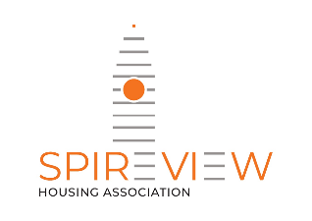

Spire View Housing Association Limited
Fair Processing Notice
(How we use employee information)

This notice explains what information we collect, when we collect it and how we use this. During the course of our activities we will process personal data (which may be held on paper, electronically, or otherwise) about you and we recognise the need to treat it in an appropriate and lawful manner. The purpose of this notice is to make you aware of how we will handle your information.

- Spire View Housing Association Limited (“we” or “us”) is committed to a policy of protecting the rights of individuals with respect to the processing of their personal data and adhere to guidelines published in the UK GDPR and Data Protection Act of 2018 (“the 2018 Act”) together with any domestic laws subsequently enacted. We collect and use personal data for a variety of reasons.

We are registered as a Data Controller with the Office of the Information Commissioner (ICO) under registration number Z6952147 and we are the data controller of any personal data that you provide to us.

Our Data Protection Officer (DPO) is Gillian Spence GillianSpence@spireview.org.uk 0141 559 5644.
Any questions relating to this notice and our privacy practices should be sent to Gillian Spence on GillianSpence@spireview.org.uk 0141 559 5644.

- We collect the following information from you through a variety of resources (i) directly from you; or (ii) third parties (including pensions service):

- Name
- Date of Birth
- Address
- Telephone Number
- E-mail address
- NI number
- Personal characteristics such as gender and ethnic group
- Qualifications and training record
- Absence information
- Hospital appointment documentation
- Emergency contact details
- Eligibility to work in the United Kingdom;
- Driving Licence
- Passport
- Disability and allergy information
- GP’s name
- Job history and salary information
- Appraisals
- References
- Membership of professional bodies
- Trade Union membership

- We collect and use the above information and personal data for:

  - Administration of contracts of employment
  - Payment of salaries
  - Recruitment and selection
  - Pensions and associated benefits, appraisal, training and development
  - Membership of professional bodies
  - Membership of Trade Union

- We may disclose to and share information about you with third parties for the purposes set out in this notice, or for purposes approved by you, including the following:

- To allow your pension provider to process pensions information and handle your pension;
- To allow you to participate in health checks/ immunisation programmes;
- To pay your Trade Union membership dues;
- When we grant third parties controlled access to our electronic network;
- To obtain employment related legal advice;
- To DWP, HMRC and other such third parties;
- To our Auditor to carry out our annual audit;
- If we enter into a joint venture with or is sold to or merged with another business entity, your information may be disclosed to our new business partners or owners.

- Your information will only be stored within the UK.

- When you give us information we take steps to make sure that your personal information is kept secure and safe.

We currently hold personnel files electronically, with some further information held in physical form. Additionally, we retain salary and pension information, as required by law. Any hard copy data of yours we hold is stored securely within locked filing cabinets which can be accessed by the HR function only, or Finance staff if relating to salary and pension information.
We password protect all personnel files, and limit access to those files to the HR function of the association.

- We review our data retention periods regularly and will only hold your personal data for as long as is necessary for the relevant activity, or as required by law (we may be legally required to hold some types of information), or as set out in any relevant contract we have with you.

Data retention guidelines on the information we hold is provided in our Privacy policy within the staff handbook.

- You have the right at any time to:

- ask for a copy of the information about you held by us in our records;
- ask us to correct any inaccuracies of fact in your information;
- request that we restrict your data processing
- data portability
- Rights related to automated decision making including profiling
- make a request to us to delete what personal data of your we hold; and
- object to receiving any marketing communications from us.

These rights are qualified and are not absolute.

- If you would like to find out more about how we use your personal data or want to see a copy of information about you that we hold or wish to exercise any of your above rights, please contact: Gillian Spence on GillianSpence@spireview.org.uk 0141 559 5644.

If you have any complaints about the way your data is processed or handled by us, please contact Gillian Spence on GillianSpence@spireview.org.uk 0141 559 5644 If you remain unsatisfied after your complaint has been processed by us, you also have the right to complain to the Information Commissioner’s Office in relation to our use of your information. The Information Commissioner’s contact details are noted below:

The Information Commissioner’s Office – Scotland
45 Melville Street, Edinburgh, EH3 7HL
Telephone: 0303 123 1115
Email: Scotland@ico.org.uk

The accuracy of your information is important to us – please help us keep our records updated by informing us of any changes to your personal and contact details.

