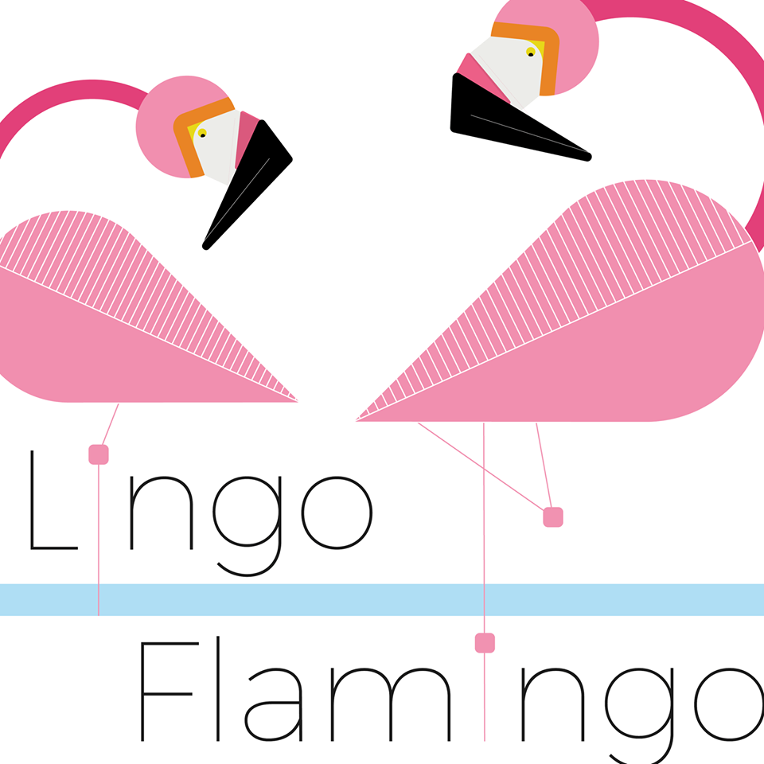

**Role Description – Lingo Flamingo Board Advisor**

**Introduction:**

What we are looking for:

We are a growing, innovative social enterprise who are looking for strong, dynamic individuals with backgrounds in business, finance, or digital sectors to help develop and grow our organisation. Of particular relevance are applicants with a strong financial skill-set, third sector governance knowledge or who have a legal background. We are looking for applicants who have both the experience and the passion to help grow and develop Lingo Flamingo. For more details about the role, please read the job spec (below) and for more details about the organisation please visit [www.lingoflamingo.co.uk](http://www.lingoflamingo.co.uk).

Who are we?

Recent research shows that speaking a foreign language can postpone the effects of dementia by up to 5 years. Lingo Flamingo are a social enterprise who provide tailored outreach language workshops to older adults in care homes and day centres delaying the effects of dementia by keeping older adult’s brains’ fit and active. In addition to our care home classes, we have a language learning nest in Shawlands, Glasgow and also facilitate online lessons via Zoom. These classes are open to all members of public and surplus from these classes is re-invested into our social mission of delivering classes within care home settings.

Why we do this?

If current trends continue and no action is taken, the number of people with dementia in the UK is expected to double to 2 million people by the year 2050. It is this issue that Lingo Flamingo is helping to combat.

Why Language Learning?

At first, it may sound quite surprising to teach languages to older adults but our reasons for teaching foreign languages to older adults are threefold. Firstly, it provides them with an interactive and exciting activity to undertake where they learn a new language, explore a different culture and have a lot of fun doing so. Secondly, we are using language learning as a platform to stimulate the brain- as research shows that speaking a second language can delay the effects of dementia as well as aiding with stroke recovery. Thirdly, our participants have the chance to do an SQA qualification as part of our courses. This provides them with an enhanced sense of achievement and the opportunity to gain a formal qualification.

**Terms & Conditions:**

*Remuneration*: Being a Board Advisor is not accompanied by any financial remuneration, although expenses for travel may be claimed.

*Hours:* 4 board and 2 subcommittee meetings a year. Board Advisors may also be asked to attend some important meetings and events during the year. In addition to meetings, board members will be asked to prepare for board meetings and may also be asked to support the organisation with specific tasks. We also try to incorporate more relaxed meetings to help our board get to know different people and components within the enterprise. This includes a Lingo Flamingo Mingle where the board have the chance to meet staff. Furthermore, we provide training opportunities on areas such as dementia, social care, and good governance. We also like our staff to see what our language sessions are like in real life, both in care homes and in our nest in Glasgow. In total it is a commitment of around 4 hours a month. Board meetings are normally held from 5pm-6.30pm.

*Address:* Meetings normally take place online, but some meetings will be held in person at 155 Deanston Drive, Shawlands, Glasgow, G41 3LP.

*Reporting to:* Executive Director and the Board of Advisors

*How to apply:* Please send a cover letter and a C.V to [robbie.norval@lingoflamingo.co.uk](mailto:robbie.norval@lingoflamingo.co.uk)

We are also happy to have informal conversations with any potential applicants who would like to know more about the role, to facilitate this please get in touch at ([robbie.norval@lingoflamingo.co.uk](mailto:robbie.norval@lingoflamingo.co.uk)) before the deadline and he would be happy to speak to you.

The deadline for applications is the 15th of January 2023. Interviews will take place towards the end of January 2023.

**Board Advisor Job Role**

1. Job Purpose

Board advisors are collectively responsible for the leadership and efficiency of the organisation and ensure that it meets all its social aims and missions.

In doing so a Board Advisor will:

• Observe confidentiality requirements

• Honour their commitment and contribute to the development of the organisation

• Work as an effective team

• Actively participate in meetings and comply with the organisation’s culture, values and behaviours as well as Board meeting style and tone

• Act as an ambassador of the organisation and promote good governance

2. Duties & Responsibilities

Board members are responsible for the strategic direction of the organisation, below is a list of overarching duties regarding the remit of a Lingo Flamingo board member.

• Giving firm strategic direction to the organisation,

• Setting overall policy.

• Defining both social and financial goals and setting targets,

• Evaluating performance against agreed targets.

• Declare interests in proposed transactions or arrangements.

• Specific skills, knowledge and experience are used to help the Board reach sound decisions.

• The safeguarding of the good name and values of the social enterprise.

• The effective and efficient administration of the organisation.

• The financial stability of the social enterprise.

3. General Responsibilities

In addition to the overarching strategic duties and responsibilities of the organisation, here are a list of pragmatic duties which are expected of Lingo Flamingo Board members.

• Attend all meetings of the Board including subcommittee meetings unless there are pressing reasons or the Board gives leave of absence.

• Contribute to and share responsibility for all decisions of the Board and any committee of which they are a member.

• Read and scrutinise Board papers before all meetings that they attend.

• Attend induction, training and performance review sessions and other such sessions or events (e.g., Board Away Days) as are reasonably required by the organisation.

• Represent Lingo Flamingo positively to all external audiences.

• Register all interests that might have a bearing on the work of Lingo Flamingo and declare any potential or actual conflicts of interest as and when these arise.

• Contribute from their specific skills by liaising informally with the appropriate director or other staff member if called upon to do so.