

**Just Transition Campaigner**

**£27,686 - £34,569 pro rata**

**Edinburgh, Head office**

**80-90%FTE (4/4.5 days per week)**

**Location:** Central Edinburgh office (subject to COVID restrictions) with flexibility for hybrid working.

**Reporting to**: Head of Campaigns

**Responsible for:** potential Line Management and / or volunteer management

**Hours:** 28 - 31.5 hours per week   
  
This post may require some work out of office hours, including weekends, for which time off in lieu will be granted. There will be no payment of overtime.

**Duration:** Permanent

**Salary:** £27,686 - £34,569 pro rata (based on a 35-hour week)

New employees typically start at the bottom of the salary range but there is some limited flexibility on this, depending on experience.

**Other:** You will receive 28 days annual leave plus 11 days statutory holidays pro rata. Friends of the Earth Scotland operates a Company Pension Plan with NEST. FoES pension benefits exceed the statutory minimum.

To download an application form please go to [www.foe.scot/jobs](http://www.foe-scotland.org.uk/jobs)

**Closing date:** Monday 23 January 2023 12:00 noon

**Interview date:** Thursday 2 February 2023

**Start date:** February/March 2023

Please note we do not accept CVs as part of a job application.

**About this role**

This is an exciting opportunity to work at Scotland's foremost environmental justice organisation in a key campaigning role. As a core member of our oil and gas transition team you will work closely with the Head of Campaigns and colleagues in campaigns, communications, activism and parliamentary roles to deliver our strategy for a just transition for affected workers and communities. This work sits closely alongside our campaign to phase out oil and gas and oppose industry techno-fixes like carbon capture and hydrogen.

Friends of the Earth Scotland has played a central role in advocating for just transition to be central to the response to the climate crisis. Our work has seen just transition climb the political agenda, with the establishment of a Just Transition Commission and the concept now enshrined in Scots law.

Building on these successes, this role will work with our allies in the Just Transition Partnership and the wider climate movement to build public and political pressure to turn rhetoric on just transition into action.

The ideal candidate will be a strong campaigner with a commitment to social justice, excellent communication skills, and a good knowledge of climate and energy/oil policy. You will have a naturally collaborative working style, and will thrive in a small, creative team. A good knowledge of the Scottish political context would be a significant advantage.

**Duties**

* Work within FoES oil and gas transition team to implement our strategy for a just and rapid phase out of oil and gas production and a just transition for affected workers and communities.
* Develop and deliver campaign plans, identifying opportunities and devising tactics and delivering activities at key moments including public events, stunts, direct advocacy, media work, research.
* Develop and maintain good relationships with key stakeholders and represent FoES in coalitions and partnerships, including the Just Transition Partnership
* Work within the Just Transition Partnership and with other key allies to influence and shape the narrative and our demands on Just Transition, including through monitoring the work of the Just Transition Commission and influencing the creation of sectoral Just Transition Plans.
* Play a leading role in FoES work on Scotland’s next energy strategy to ensure that it provides a framework for a just and rapid phase out of oil and gas production and a just transition for affected workers and communities.
* With the Just Transition Organiser, build support for rapid and deep systemic changes in response to the climate crisis amongst the communities who will be impacted by major industrial change.
* Act as FoES spokesperson for the campaign in the media, advocacy meetings and other external fora.
* Work with FoES Communications Manager to communicate the campaign across all channels – including traditional media, social media and supporter communications.
* Liaise with other campaigners, Head of Campaigns and Director on other campaigns and issues including on air pollution, divestment, and circular economy as required, and help ensure the just transition narrative is reflected across all of FoES campaigns
* Work with FoES Just Transition Organiser and Activism Organiser to support activists and local groups to campaign, including by developing opportunities and materials.
* Write parliamentary briefings and work with FoES parliamentary staff to influence MSPs, identify advocacy opportunities in the Scottish Parliament and occasionally to engage with MPs.
* Research, write and adapt materials for the campaign, including policy positions and responding to relevant consultations, and co-ordinate publication and dissemination
* Keep up to date with relevant policy, political and scientific developments
* Work within the FoEI federation and with international allies to share good examples from Scotland on just transition and use international examples to influence activities in Scotland
* Help with the delivery of fundraising objectives and reporting
* Contribute to FoES's campaigns and support activism
* Supervise volunteers and interns as required
* Contribute to planning and delivery of AGM and Local Groups day, including attendance on the day
* Contribute to the smooth running of the FoES office and undertake assigned organisational activities as requested

**Person specification**

Essential

* At least two years of relevant experience, preferably working in a campaigning role
* Practical experience of planning, running and evaluating campaigns or projects
* Excellent oral and written communication skills
* Ability to quickly absorb new and complex information
* Ability to communicate complex information to a variety of audiences
* Knowledge of the policy and political context around just transition in Scotland
* Demonstrable commitment to environmental and social justice
* Strong organisational skills and experience of working to tight deadlines
* Experience of writing press releases and responding to the media
* Experience of organising events and / or campaign stunts
* Naturally collaborative and a team player

Desirable

* Knowledge of the structure and workings of the Scottish Government and Parliament
* Experience of working in coalitions and alliances
* Experience of working with trade unions, communities, local groups and other stakeholders
* Knowledge of climate and energy policy
* Understanding of and comfortable with strategic use of social media, email, and supporter communications
* Familiarity with Mac computers and software

**About Friends of the Earth Scotland (FoES)**

Friends of the Earth Scotland is Scotland's leading environmental campaigning group, working to help people in Scotland look after the planet for everyone’s future.

We are part of Friends of the Earth International, the world’s largest grassroots environmental network, with groups in 73 countries. We think globally, and act in Scotland, delivering solutions to climate change and other environmental problems, by enabling and empowering people to take individual and collective action.

From stopping dirty fossil fuels and campaigning for a just transition, to reimagining our economy and our places, we are making a real difference.

* We are committed to democracy, accountability and equality
* We strive to work with communities in our campaigning for positive change
* Our work will always be based on objective evidence and a long-term, global perspective
* We believe that everyone has an equal right to a healthy environment and a fair share in the world’s resources.

We have 21 staff and 12 local groups, and are based in central Edinburgh.

**Equal Opportunities**

We would particularly like to encourage applications from people of colour and people most impacted by climate change or impacted by other kinds of environmental, social, and economic injustice who are currently under-represented in the climate and environmental movements in the UK.

The successful candidate will be selected on the basis of how well they fit the person specification, as judged by their application and interview. Where two or more candidates are judged to be of equal merit, priority may be given to a BAME or migrant candidate as these groups are currently under-represented in the climate and environmental movements in the UK.

We are required by law to ensure that all employees are entitled to work in the UK. We cannot consider applications from people who do not already have the right to work in the UK. All prospective employees, regardless of nationality, must be able to produce original documents (such as a passport) before employment starts, to satisfy current immigration legislation.

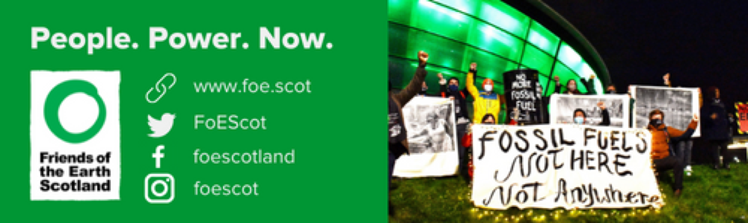

Our vision is of a world where everyone can enjoy a healthy environment and a fair share of the earth's resources. Friends of the Earth Scotland is an independent registered Scottish charity (SC003442).